ORDINANCE NO. ____________
ORDINANCE AMENDING ORDINANCE NO. 121410, THE ZONING ORDINANCE FOR THE TOWN OF MCCORDSVILLE, INDIANA
WHEREAS, the Town Council of the Town of McCordsville, Indiana, has heretofore adopted Ordinance No. 121410 as the Zoning Ordinance; and
WHEREAS, the Town Council of McCordsville, Indiana, has, after a public hearing was held on September 21, 2021, received a ____________ recommendation from the McCordsville Advisory Plan Commission requesting an amendment to the Zoning Ordinance in order to adopt the Jacobi Legacy Farms Planned Unit Development (“PUD”) Ordinance.
THEREFORE BE IT ORDAINED by the Town Council of the Town of McCordsville, Indiana that Ordinance No. 121410 is hereby amended as follows:
Section 1. The real estate more particularly described in the attached “Exhibit A” (the “Real Estate”) is hereby zoned to the PUD designation. The Development and Architectural standards set forth in this Ordinance shall govern the development of the Real Estate, and these standards shall replace all other standards set forth in the Town of McCordsville Zoning and Subdivision Control Ordinances, as amended. Where this Ordinance is silent regarding standards other than Development and Architectural standards, the standards from the McCordsville Zoning and Subdivision Control Ordinances, dated January 2011, as amended, applicable to R3 Zoning, shall apply.
Section 2. Definitions. Capitalized terms not defined in this PUD Ordinance shall have the meaning ascribed to them in the Town of McCordsville Zoning Ordinance.
- Minimum Home Size. The total square feet of a home, excluding garages, rear porches, front porches, basements, and any decks or patios.

- Stone. Shall not be interpreted to include concrete masonry units (CMU).
Section 3. Permitted Uses. The permitted uses, as defined by the McCordsville Zoning and Subdivision Control Ordinances, for the Real Estate are described below, all uses not listed below, shall be considered prohibited.
Permitted Primary Uses:
Single-family Dwellings (Detached Dwellings, Townhouses, etc.)
Two-family Dwellings (Duplex, or other similar attached dwellings)

Permitted Accessory Uses, Incidental Uses, and Structures:
Those permitted pursuant to the Town Ordinance

Permitted Temporary Uses:
Those permitted pursuant to the Town’s Zoning Ordinance

Subject to compliance with all federal and state laws, dwellings in Jacobi Legacy Farms shall be sold and not leased or rented from the builder to the initial purchaser. Any future rentals shall be on a form approved by the HOA and shall follow the rules and guidelines set forth by the HOA. All short-term rentals (less than six (6) months) shall be prohibited.

Section 4. Development Standards. The Jacobi Legacy Farms development shall have one (1) “Town Center Transition Area” for higher density housing, and three (3) Single-family Dwelling Areas with varying housing types and lot sizes as shown on the Preliminary Planned Unit Development Plan/Concept Plan attached hereto as “Exhibit B”.
- The Development Standards shall be as follows:
 | Area A  Town Center Transition Area | Area B  Neo-Traditional Area | Area C  Medium Density Area | Area D  Low Density Area
Minimum Number of Lots | 50 | - | - | 30
Maximum Number of Lots | 100 | 125 | 275 | 40
Minimum Lot Area | 1,000 | 6,600 | 7,700 | 11,000
Minimum Lot Width | 20’ | 53’ | 62’ | 80’
Minimum Lot Frontage² | 20’ | 30’ | 30’ | 30’
Minimum Front Yard Setback | 10’ | 20’ | 25’ | 30’
Minimum Side Yard Setback¹ | 7.5’ | 5’ | 5’ | 4’
Minimum Building Separation | 15’ | 10’ | 10’ | 15’
Minimum Rear Yard Setback | 20’ | 15’ | 15’ | 15’
Minimum Home Size | 1,500 SF | 1,600 SF (1s) 2,100 SF (2s) | 1,800 SF (1s) 2,400 SF (2s) | 2,300 SF (1s) 2,600 SF (2s)
Minimum Ground Floor Living Area | 300 SF | N/A | N/A | N/A
Maximum Lot Coverage | N/A | 55% | 55% | 50%
Maximum Structure Height | 40’ | 35’ | 35’ | 35’
¹Minimum Side Yard Setback applies to Structures.
²Measured at the Street ROW.

The Maximum Gross Residential Density shall be three (3) units per acre.
Lots shall have a maximum of one (1) dwelling unit.
Townhouses shall have a minimum of four (4) units per building and a maximum of eight (8) units per building.
- Architectural Standards. The Architectural requirements for the Real Estate are attached as “Exhibit C”. The Architectural Review Committee may approve elevations that do not meet the architectural requirements outlined in “Exhibit C”. Illustrative architectural exhibits, attached hereto as “Exhibit C-1” for Area A, “Exhibit C-2” for Area B, “Exhibit C-3” for Area C, and “Exhibit C-4” for Area D, are hereby incorporated to illustrate conceptually the elements, anticipated quality and character, and to establish a benchmark for the architecture and design of the residential dwellings within the various areas of the Jacobi Legacy Farms development. The final dwelling designs may vary from the illustrative architectural exhibits; however, the dwellings shall be substantially similar in quality and character to the dwellings shown.

- Perimeter Landscape Standards. The developer shall establish an aesthetic landscape buffer along the frontage on CR 750N and CR 500W. Said buffer shall consist of the following per 100 feet of frontage:

- A minimum 30-foot landscape buffer shall be provided along the right of way of CR 750N and along the right of way of CR 500W. Said buffer shall consist of the following per 100 feet of footage:

  - Three (3) deciduous shade trees with a minimum of 2” caliper.
  - Three (3) evergreen trees a minimum of 6 feet in height.
  - One (1) ornamental tree with a minimum 2” caliper.
  - Six (6) shrubs.
  - 3’-5’ high mounding shall be installed along the perimeter frontage of the development.
  - A farm-style fence shall be provided along a minimum of sixty (60%) of the perimeter street frontage along CR 750N and CR 500W. The fence may be continuous or in segments enhance the other mounding and landscaping features of the buffer.

- Street Tree Standards. Street Trees shall be required as one (1) tree per lot, per frontage, only in tree lawns that are a minimum of ten feet (10’) in width. Townhomes shall be exempt from the Street Tree requirement.

- Tree Conservation Area. A 10’ tree conservation area shall be established along the north boundary of the Real Estate. Within the tree conservation area, no trees with a diameter at breast height (“DBH”) in excess of six inches (6”) or more (the “Protected Trees”) shall be removed unless the tree is damaged, diseased, dead, or is to be removed in order to: (1) comply with the safety requirements of any governmental agency; or (2) to accommodate the installation of drainage utilities, street connections, walking path or other infrastructure. If a Protected Tree is damaged or otherwise removed by the developer or builder, except as permitted to be removed as listed above, then the developer or builder shall reestablish the Protected Tree with a tree or trees of combined equal or greater DBH subject to the availability of space for their healthy growth in the tree conservation area.

- Open Space. Open space shall be as shown on “Exhibit B”. An 8’ asphalt trail system shall be installed, and detention ponds shall have natural pond edges in lieu of rip rap. Various pocket parks shall be provided within the development, connected by the trail system. Pocket parks shall have a variety of included features/designs/uses, as generally illustrated on “Exhibit F” and identified, but not limited to the concepts below:
- Yoga lawn
- Community gardens
- Seating area with bench/picnic tables
- Hardscape with landscaping
- Flower/Butterfly garden
- Trellis or other monumentation
- Prairie grasses and low maintenance plantings

- Multi-Use Paths. There will be a 10’ wide asphalt perimeter path along the project frontage of CR 750N and CR 500W, and 8’ wide asphalt paths internal to the development. Trails shall be provided as shown on “Exhibit B” and as required per the Town’s standards.

- Community Amenities. In addition to the open space features and trail network, Jacobi Legacy Farms shall also include the following amenities:

- A pool with pool house,
- Two (2) play structures
- A minimum of two (2) of the following sports courts:
  - Two (2) half basketball courts
  - Tennis court
  - Pickleball court
  - Bocce ball court
  - Frisbee/Disc golf course (min. three (3) targets/goals)
- A minimum of two (2) of the following passive features:
  - Dog park with waste station(s)
  - Yoga lawn
  - Community gardens
  - Pond-overlooking picnic areas with seating (benches, tables, etc.)

- Lighting, Parking, Pedestrian Accessibility and Signage. Standards of the Town’s Zoning and Subdivision Control Ordinance regarding Lighting, Parking, Pedestrian Accessibility, and Signage applicable to R3 Zoning shall be applicable to the Real Estate with the following exceptions:

- Primary Monuments – The developer shall install entry monumentation including, but not limited to, brick or stone walls and/or columns, landscaping, and sign lighting at either side and/or in the median of the entry on CR 750N and CR 500W. The height of the entry sign shall not exceed 8 feet in height. Columns, posts, or other vertical features or accents of the entry sign may exceed the 8-foot maximum but shall not exceed 12 feet in height.
- Additional columns with signage may be installed at the roundabout connection to the future Town Center site. These columns shall be a maximum of 4’ x 4’ and 6’ in height and may be illuminated.
- Lighting units which shall include a pole, luminaire, and all other necessary parts and equipment, shall be placed at the entrances of the community, interior intersections, the intersection of CR 750N and CR 500W, and along the internal streets consistent with the Town’s standards except for the maximum spacing which shall be three hundred (300) feet, within the Jacobi Legacy Farms development. Lighting units shall be the Town’s standard unit, attached hereto as “Exhibit G”.
- Every house shall have dusk to dawn coach lights at the outermost point of the combined garage door(s), and one (1) dusk to dawn coach light at the front door.
- Area A shall provide on-street parking as generally shown on “Exhibit B”.

- Model Home. Each Area shall be permitted up to two (2) model homes per builder, and at least one (1) model home constructed by each builder shall be one of the four largest square footage floor plans offered by the builder(s) at the time the model home permit is issued. If the builder constructs more than one model, there is no restriction on the size of the second model so long as the first model complies with the above requirement.

- Anti-Monotony Standards. The Jacobi Legacy Farms development shall not construct homes in violation of the Town of McCordsville’ code.

- Snow Removal. The Homeowners Association for Jacobi Legacy Farms shall be responsible for snow removal of all internal streets.

- Miscellaneous. The following standards shall apply:

- Geometric Street Standards, Tangent: Shall be zero (0) feet.
- Geometric Street Standards, Spacing: May be less than 800 feet.
- Street Standards and Requirements: No driveway shall be located within forty-five (45) feet of the intersection of two streets.
- Block Standards: The maximum block length shall be 1,600 feet.
- Lot Standards: Side lot lines may have non-radial or vary from right-angles.
- The east/west street connecting the future town center and CR 500W shall incorporate medians, and incorporate tree lawns (a min. of ten feet (10’) wide) on both sides of the street, as generally shown on “Exhibit B”.
- Fences on individual lots shall be black, wrought iron, aluminum, or its equivalent or like material and be such a style designated and approved by the HOA. Fences shall also maintain a minimum of three feet (3’) of clearance from any AC unit.
- All ponds shall have at least one (1) fountain.
- The Town shall not be responsible for any maintenance or repairs on any alley.
- The Town shall not be responsible for any maintenance of any landscape, signage, or other features installed in the right-of-way. Examples of this are landscaped medians and landscaped curb bulb-outs and islands. .
The development shall generally comply with Section 4.17(B)(2), to the extent they are consistent with the Concept Plan and as otherwise amended by this PUD.
Section 5. This Ordinance shall remain in full force and effect from and after its passage and posting as required by the law within the Town of McCordsville, Indiana.
Section 6. Introduced and filed on the ______ day of ________________, 2021. A motion to consider on First Reading on the day of introduction was offered and sustained by a vote of ____ in favor and ____ opposed pursuant to I.C. 36-5-2-9.8.
Duly ordinated and passed this ______ day of _________________, 2021 by the Town Council of the Town of McCordsville, Hancock County, Indiana, having been passed by a vote of ____ in favor and ____ opposed.

TOWN OF MCCORDSVILLE, INDIANA, BY ITS TOWN COUNCIL:
Voting Affirmative: Voting Opposed:

_____________________________ _____________________________
Barry A. Wood Barry A. Wood
_____________________________ _____________________________
Thomas R. Strayer Thomas R. Strayer
_____________________________ _____________________________
Gregory J. Brewer Gregory J. Brewer
_____________________________ _____________________________
Larry J. Longman Larry J. Longman
_____________________________ _____________________________
Branden D. Williams Branden D. Williams

ATTEST:
_______________________________
Staci A. Starcher, Clerk Treasurer

This is instrument was prepared by Rex Ramage, Pulte Group, 11590 N. Meridian St.,
Carmel, IN 46032.

I affirm, under the penalties for perjury, that I have taken reasonable care to redact each Social Security number in this document, unless required by law. – Rex Ramage

“EXHIBIT A”
LEGAL DESCRIPTION

A part of the Northeast Quarter of Section 25, Township 17 North, Range 5 East and part of the West Half of the Northwest Quarter Section 30, Township 17 North, Range 6 East of the Second Principal Meridian, Vernon Township, Hancock County, Indiana; based upon a survey by HWC Engineering, job number 2021-064, certified by Adam J. Beery, PLS #20700069; more particularly described as follows:

BEGINNING at the southwest corner of the Northeast Quarter of said Section 25 marked by a MAG nail; thence North 00 degrees 07 minutes 52 seconds East (bearings based upon Indiana State Plane East Zone Coordinate System) along the west line of said Northeast Quarter Section a distance of 1978.40 feet; thence North 88 degrees 00 minutes 44 seconds East a distance of 682.64 feet to a point 1,982.60 feet north of the south line of said Northeast Quarter Section; thence North 87 degrees 58 minutes 28 seconds East a distance of 2005.29 feet to a point on the east line of said Northeast Quarter Section 1,996.60 feet north of the southeast corner thereof; thence South 00 degrees 25 minutes 32 seconds West along said east line a distance of 181.60 feet to a point 1,815.00 feet (110 rods per Instrument Number 130001610 as recorded in the Office of the Recorder, Hancock County, Indiana) north of the southeast corner thereof; thence North 89 degrees 29 minutes 13 seconds East parallel with the south line of the West Half of the Northwest Quarter of said Section 30 a distance of 1316.47 feet to the east line of said Half Quarter Section; thence South 00 degrees 02 minutes 16 seconds West along said east line a distance 1814.84 feet to the southeast corner of said Half Quarter Section; thence South 89 degrees 29 minutes 13 seconds West along the south line of said Half Quarter Section a distance of 1328.75 feet to the southwest corner of said Half Quarter Section marked by a MAG nail; thence South 88 degrees 21 minutes 52 seconds West along the south line of the Northeast Quarter of said Section 25 a distance of 2,677.06 feet to the POINT OF BEGINNING, containing 177.401 acres, more or less
“EXHIBIT B”
PRELIMINARY PUD PLAN/CONCEPT PLAN
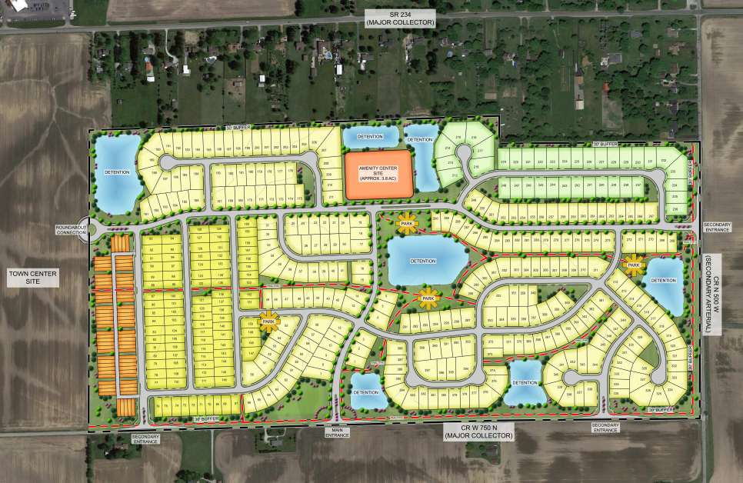
“EXHIBIT C”
ARCHITECTURAL STANDARDS

- Shingles. Architectural or dimensional shingles shall be required on all dwellings/units.
- Roof Pitch. The primary roof pitch for two (2) story homes shall be 6:12 or greater, ancillary roofs may be less than 6:12. For one (1) story or one and a half story (1.5) homes (includes loft), or townhouses, the primary roof pitch shall be 5:12. No more than ten percent (10%) of the homes in Area B, Area C, and Area D, each calculated individually per area, may have a lesser roof pitch, provided that the elevations are of the “Prairie” architectural style, as determined by the ARC. The Architectural Review Committee may approve a home with a lesser roof pitch.
- Overhangs. Minimum roof overhang of eleven (11) inches on all sides of a structure as measured from the exterior wall framing to the fascia board.
- Vents. Exhaust vents shall not be visible from the front elevation of the home. Additionally, no wall-mounted vent or louver shall be located on the first-floor exterior of a front elevation (excluding gable areas).
- Siding. All siding shall be brick, stone, wood, cement fiber board or stucco.
  - Vinyl siding is prohibited.
  - All townhouse buildings shall have a minimum of three (3) materials, colors, or patterns on the front façade, one of which shall be brick or stone.
- Masonry Requirements.
  - Area A: All townhouse buildings shall have a minimum of 50% of brick or stone on any façade facing a street (not including an alley) exclusive of windows, doors, garage doors and areas above the roof line. Buildings may have less than 50% brick or stone on such façade if the elevation is consistent with the character and quality of the elevation shown on “Exhibit C-1”. The ARC may also approve townhouse buildings to have less than 50% depending on the architectural style of the building. In no case shall a building have less than a brick or stone wainscot on such façade. The masonry percentage requirements may vary from unit to unit but shall be achieved across the entire building or structure. All detached units shall have a minimum of seventy-five percent (75%) of the homes shall have a front elevation of at least fifty percent (50%) brick or stone, exclusive of windows, doors, garage doors and areas above the roof line. The remaining homes may have less than fifty percent (50%) brick or stone provided they contain a minimum of a 30” brick or stone wainscot and contain a minimum of two (2) siding colors or two (2) of the following materials on the front elevations: horizontal lap siding, vertical siding, board and batten, and shake.
  - Area B: A minimum of seventy-five percent (75%) of the homes shall have a front elevation of at least fifty percent (50%) brick or stone, exclusive of windows, doors, garage doors and areas above the roof line. The remaining homes may have less than fifty percent (50%) brick or stone provided they contain a minimum of a 30” brick or stone wainscot and contain a minimum of two (2) siding colors or two (2) of the following materials on the front elevations: horizontal lap siding, vertical siding, board and batten, and shake.
  - Area C: A minimum of seventy-five percent (75%) of the homes with frontage along the east/west connector road shall have a front elevation of at least fifty percent (50%) brick or stone, exclusive of windows, doors, garage doors and areas above the roof line. A minimum of fifty percent (50%) of the homes without frontage along the east/west connector road shall have a front elevation of at least fifty percent (50%) brick or stone, exclusive of windows, doors, garage doors and areas above the roof line. The remaining homes may have less than fifty percent (50%) brick or stone provided they contain a minimum of a 30” brick or stone wainscot and contain a minimum of two (2) siding colors or two (2) of the following materials on the front elevations: horizontal lap siding, vertical siding, board and batten, and shake.
  - Area D: All homes shall have a minimum of a 30” brick or stone wainscot on all four (4) sides of the home and contain a minimum of two (2) siding colors or two (2) of the following materials on the front elevations: horizontal lap siding, vertical siding, board and batten, and shake.
- Articulation. The front elevation of all homes shall contain one (1) two-foot or greater step back and either two (2) ridgelines or one (1) gable. Townhouses shall have a minimum offset of two feet (2’) from unit to unit, and townhouse buildings shall include multiple roof planes in combination with gables, hips, dormers and other features consistent with the style of the structure.
- High Visibility Enhancements. The first lot/building on both sides of the street at an entrance from CR 750N, CR 500W, and from the Town Center connection shall contain a minimum of a 30” brick or stone wainscot on all four (4) sides of the home/building.
- Rear Façade Articulation. Rear elevations of all homes on lots identified with a red dot on “Exhibit D” shall contain at least one (1) of the following: (i) four sides 1st floor brick wrap, (ii) four sides brick wainscot (min. 30”) wrap, (iii) covered porch, (iv) screened-in porch, (v) 1st floor rear façade extension a min. of 4’ (café, gathering room, morning room, three-season room, etc.), or other rear façade extension approved by the Architectural Review Committee.
- Exterior chimneys for fireplaces shall be made entirely of brick or stone.
- Columns. Unless approved by the ARC, the front porch columns shall be a minimum of 6” by 6”.
- Windows.
  - All one (1) story or one and a half story (1.5) homes (includes loft) shall contain a minimum of two (2) windows on the front façade, a minimum of one (1) window on all side facades, and a minimum of three (3) windows on the rear façade, with the exception of a façade facing a public street which shall contain a minimum of two (2) windows. On a case-by-case basis, the ARC may approve a front door or garage service door with a window, set of 3 “bullet” windows a min. of 1’ x 1’ each, and/or a transom window a min. of 1’ x 4’, and/or a decorative garage door with windows to count as one (1) window.
  - All two-story homes shall contain a minimum of three (3) windows on the front façade, a minimum of two (2) windows on the side facades, and a minimum of three (3) windows on the rear façade, with the exception of a façade facing a public street which shall contain a minimum of three (3) windows. On a case-by-case basis, the ARC may approve a front door or garage service door with a window, set of 3 “bullet” windows a min. of 1’ x 1’ each, a transom window a min. of 1’ x 4’, and/or a decorative garage door with windows to count as one (1) window.
  - All townhouses shall contain a minimum of three (3) windows on the front, exposed side, and rear façades. Each side façade that faces a public street or is noted with an X on the Concept Plan shall include a minimum of 2 windows per floor. Window requirements shall be in aggregate and may be located anywhere on the elevation. On a case-by-case basis, the ARC may approve a front door or garage service door with a window, set of 3 “bullet” windows a min. of 1’ x 1’ each, a transom window a min. of 1’ x 4’, and/or a decorative garage door with windows to count as one (1) window.
  - For purposes of these window standards, a façade facing a public street shall include the side elevation that faces a street and is separated only by common area.
- Window Treatment. With the exception of large picture windows, casement windows, and small accent windows which do not open, all windows on a façade facing a public street shall have shutters, mullions, or window grids.
  - For purposes of these window treatment standards, a façade facing a public street shall include the side elevation that faces a street and is separated only by common area.

- Trim. Unless adjacent to brick or stone wrap, all windows, doors and corners shall have a minimum nominal one inch by six-inch (1” x 6”) wood or vinyl surround, shutters, decorative trim, or headers.
- Garages. All homes shall contain a minimum of a two (2) car garage with a minimum width or depth of 20’ or shall incorporate additional interior garage storage space a minimum of 4’ x 4’, for a total to be no less than 415 SF. Townhouses shall contain a minimum of a two (2) car garage with a minimum width or depth of nineteen feet (19’), for a total to be no less than 380 SF.
  - Any front-loading garage that protrudes eight (8) feet or more in front of the front elevation shall feature at least one window on each side elevation of the garage. These windows shall not count towards any other window requirement. No front-loading garage shall protrude more than ten (10) feet in front of the front elevation. Garage protrusion shall be measured by determining the distance between the farthest protruding front façade of the garage and the widest portion of the front façade of the front elevation. Any front-loading garage that protrudes a minimum of eight feet in front of the front elevation shall feature a minimum of eight shrubs along the foundation of side elevation (nearest the side-yard property line) of the garage.
  - Any side-load, rear-load, or courtyard garage shall contain a minimum of two (2) windows in the garage façade facing a street.
  - Front-loading garages shall contain a decorative garage door similar to those depicted on “Exhibit E”. Decorative shall mean the inclusion of hardware, windows, or both.
  - For any three (3) car garage that faces a street, at least one of the bays must have a separate door and be recessed a minimum of two (2) feet from the other bays.
  - For the front-loading garages, the garage doors shall not comprise greater than fifty percent (50%) of the width of the front elevation for a two (2) car garage and sixty percent (60%) for a three (3) car garage. This standard shall not apply to Townhouses or rear loaded garages.
  - All homes in Area A shall have rear load garages.
  - Seventy-Five percent (75%) of the homes in Area B shall have a garage setback a min. of four feet (4’) from the front porch.
  - All homes in Area D shall have a 3rd car garage or tandem garage for 3rd car interior storage.
  - Fifty percent (50%) of all homes in Area D shall have a side-load or courtyard garage.
  - For purposes of these garage standards, a façade facing a public street shall include the side elevation that faces a street and is separated only by common area.
- Mailboxes. All homes shall include individual mailboxes with uniform design. Townhouses shall utilize cluster mailboxes.
- Lot Landscaping.
  - All homes shall be landscaped with a minimum of (1) deciduous tree, two (2) ornamental trees and twelve (12) shrubs planted along the front foundation of the primary structure. A minimum of two (2) trees and eight (8) shrubs shall be located in the Front Yard.
  - All homes on corner lots shall also include a minimum of one (1) deciduous tree and one (1) ornamental tree planted in the secondary Front Yard, and eight (8) shrubs planted along the foundation of the side elevation of the structure. For purposes of this standard, a lot shall be deemed a corner lot with street frontage on two (2) sides, OR lots where the side elevation faces a street and is separated only by common area. Corner lot trees required in the secondary Front Yard may be planted in the adjacent common area.
  - All homes shall have sod installed in the Front Yard, and the rest of the yard shall be seed & blanket. Corner Lots shall also have sod in both Front Yards.
- All townhouse units shall have a concrete walk from the front door to the sidewalk/path.
- Driveways.
  - All driveways shall be concrete.
  - All townhouse units shall have a minimum driveway length of twenty feet (20’) from the garage door to the alley.
- Basements.
  - All basement-eligible homes in Area C shall offer basements as an option, subject to soil suitability.
  - All homes in Area D shall offer basements as an option, subject to soil suitability. The model home in Area D shall have a full basement, subject to soil suitability.
- All homes in Area B shall have a front porch a min. of four feet (4’) in depth or twenty-four square feet (24 SF).

“EXHIBIT C-1”
ILLUSTRATIVE ARCHITECTURAL EXHIBIT (AREA A)

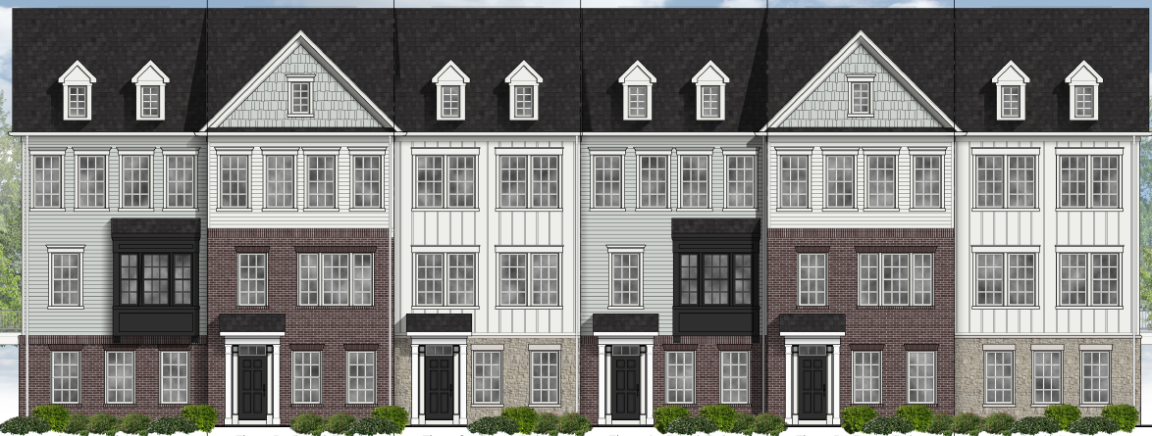

“EXHIBIT C-2”
ILLUSTRATIVE ARCHITECTURAL EXHIBIT (AREA B)
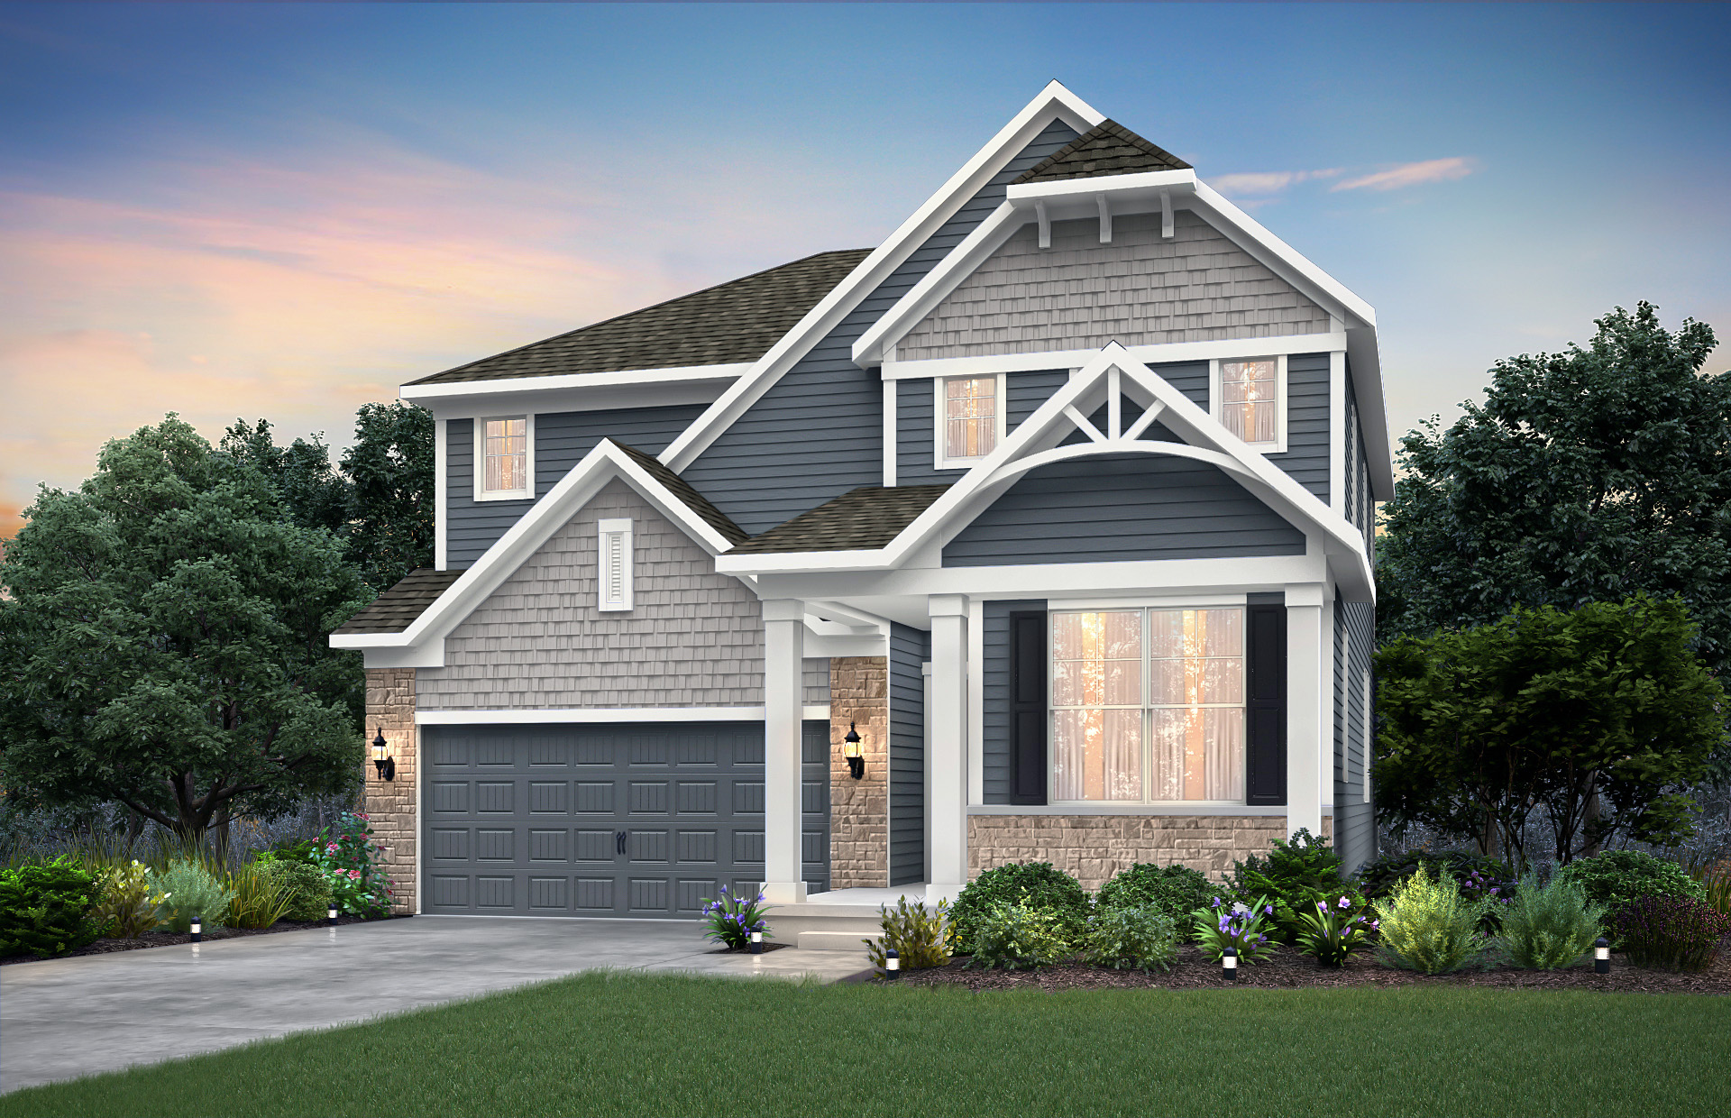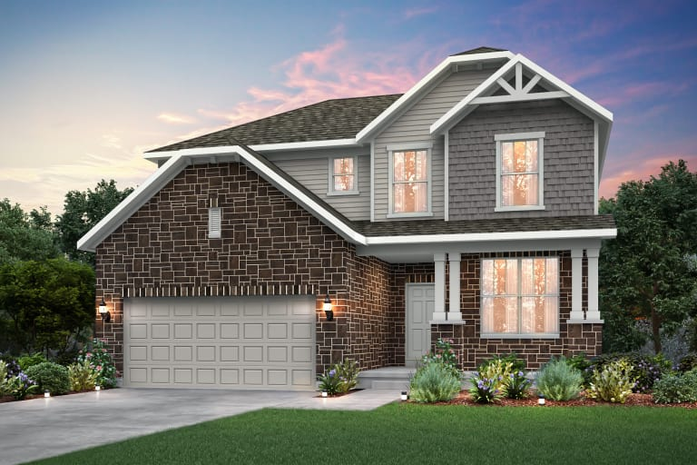
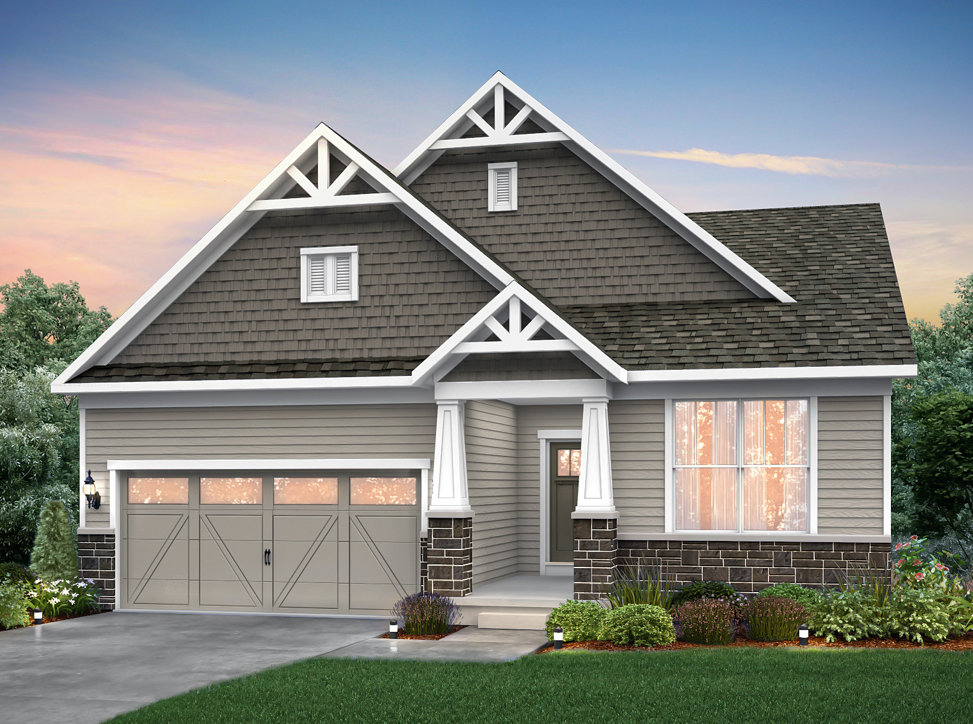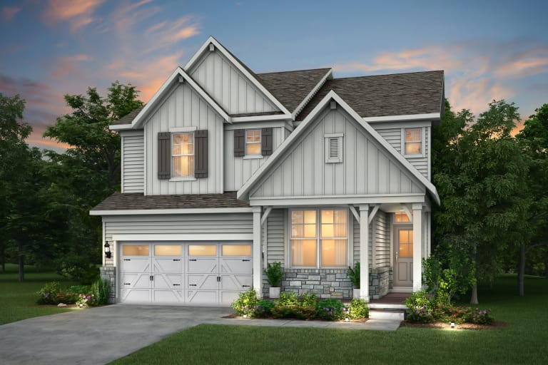
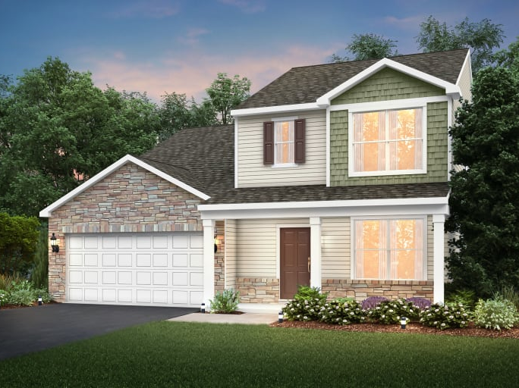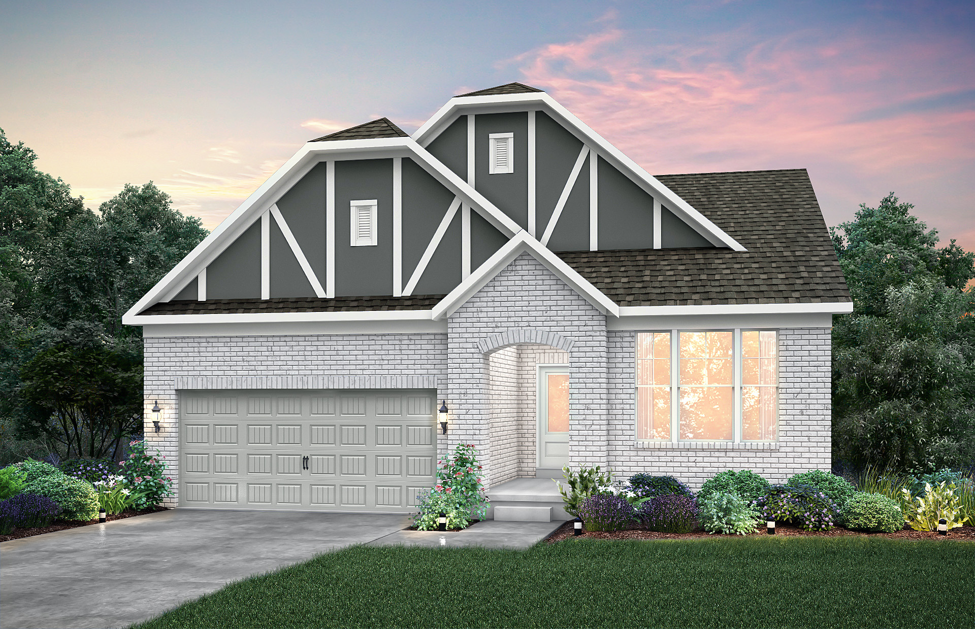
“EXHIBIT C-3”
ILLUSTRATIVE ARCHITECTURAL EXHIBIT (AREA C)

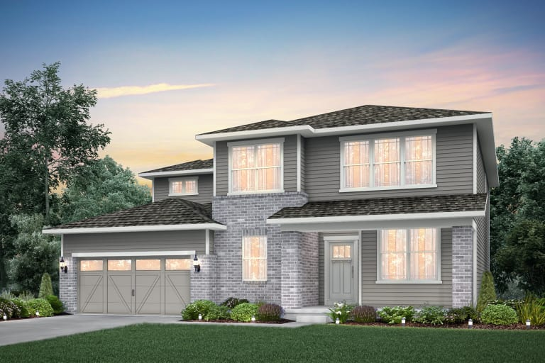
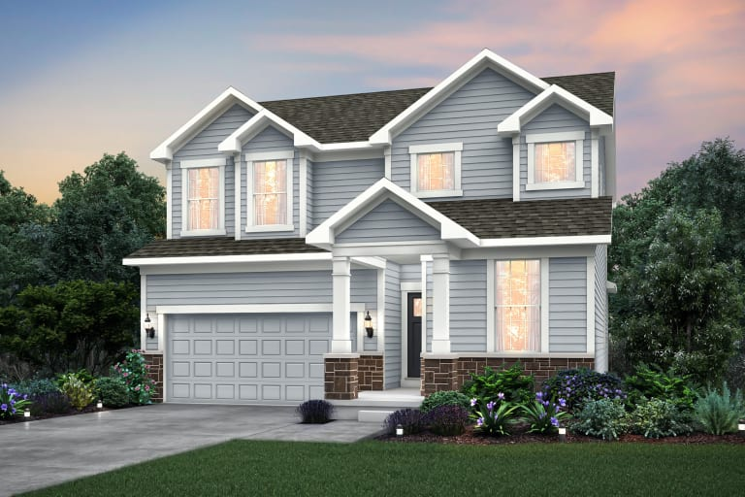
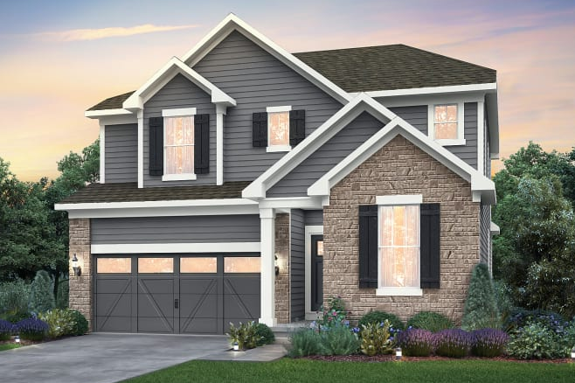
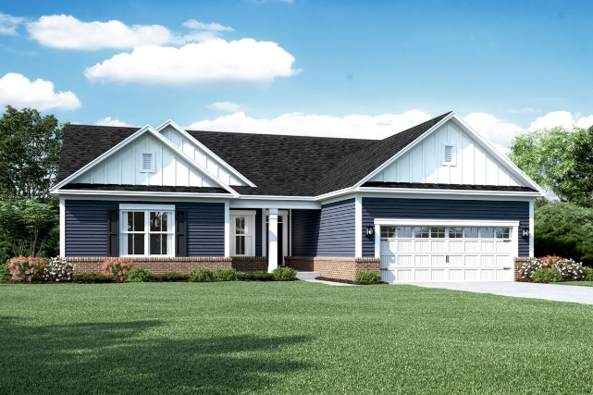
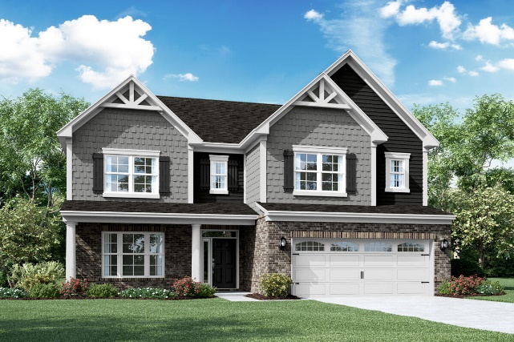
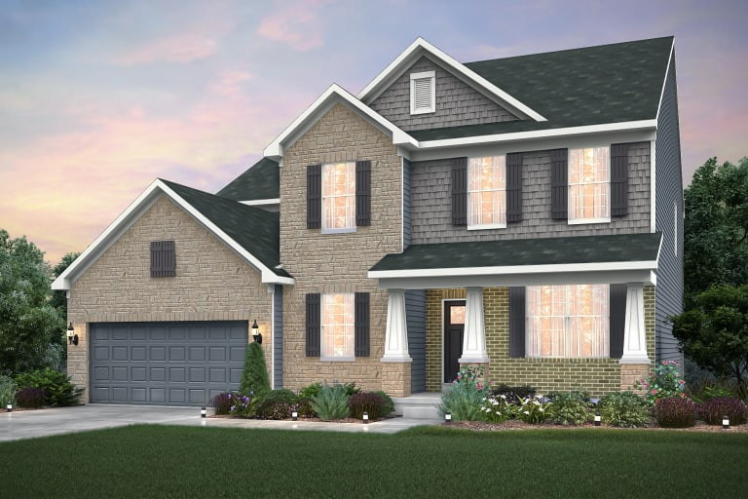
“EXHIBIT C-4”
ILLUSTRATIVE ARCHITECTURAL EXHIBIT (AREA D)
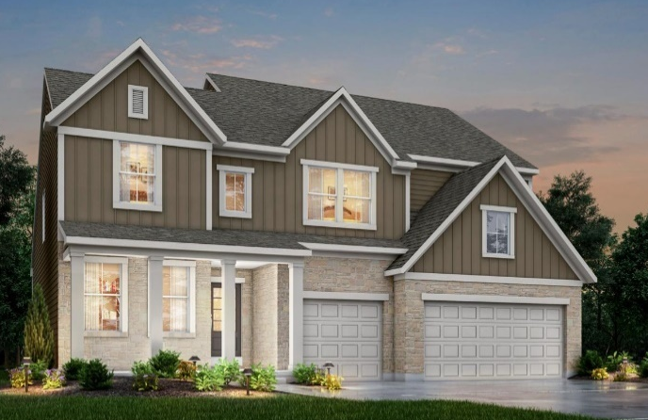
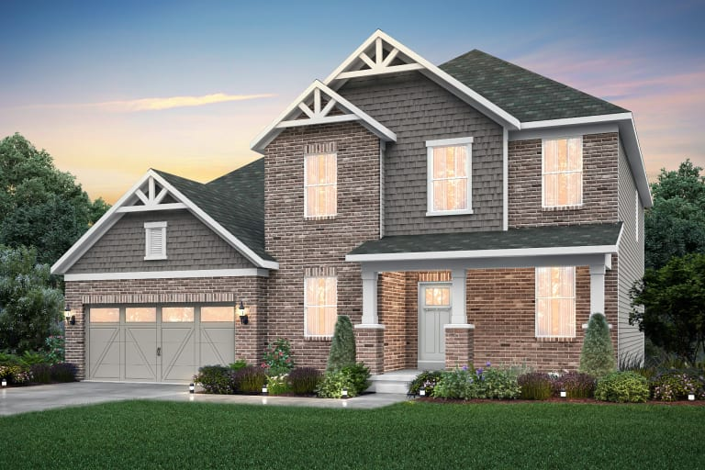
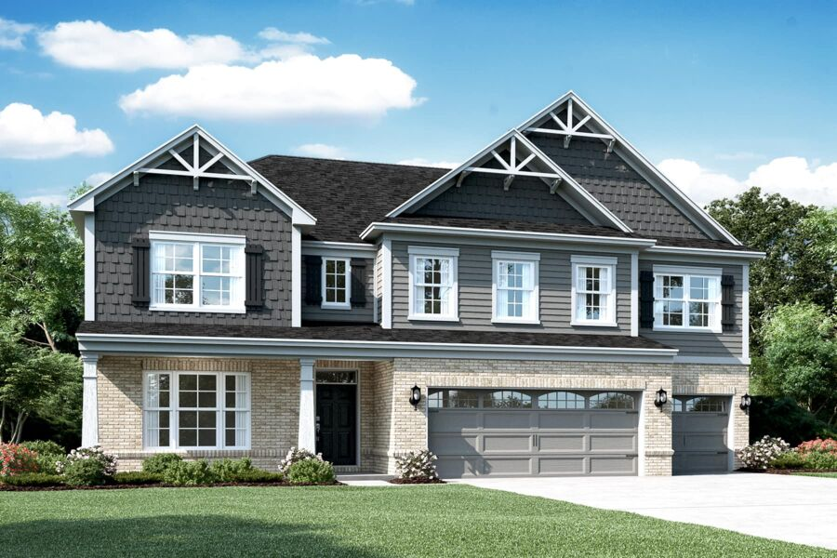
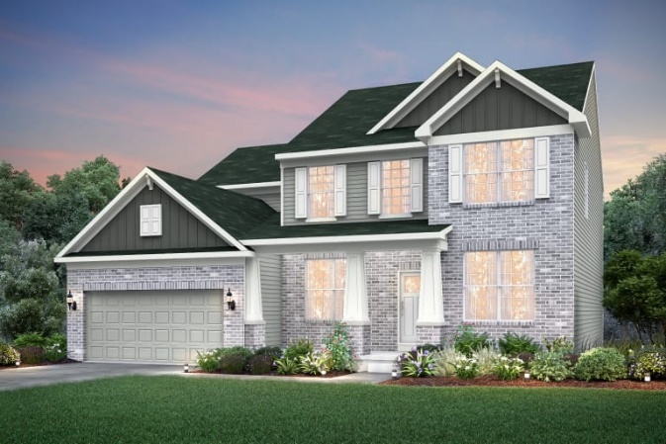
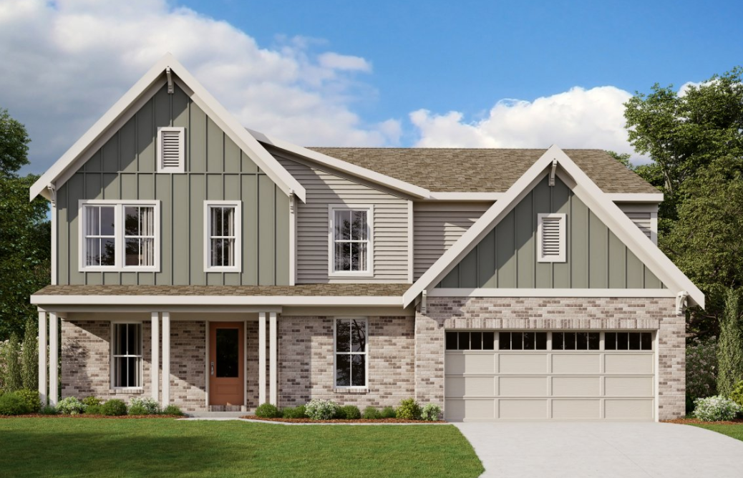
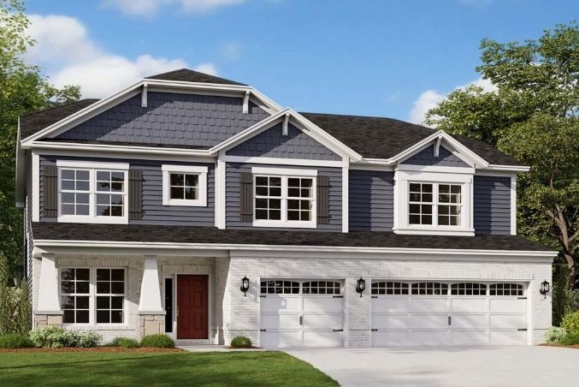
“EXHIBIT D”
REAR FAÇADE TREATMENT EXHIBIT
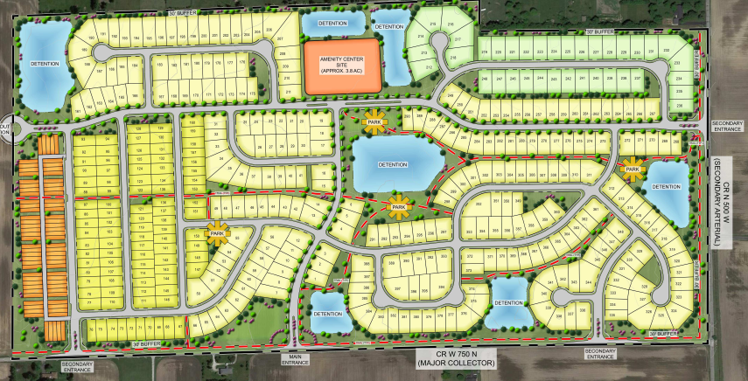
x
x
x
x
x
x
“EXHIBIT E”

DECORATIVE GARAGE DOORS

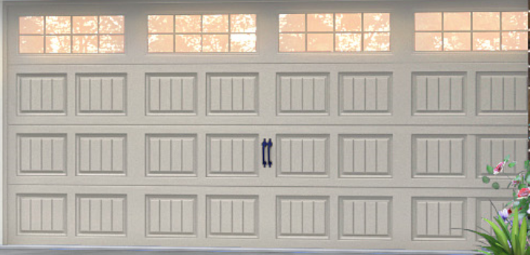

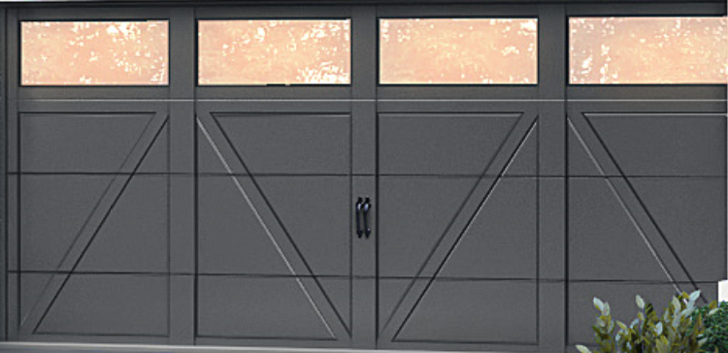

“Exhibit F”

ILLUSTRATIVE OPEN SPACE EXHIBIT
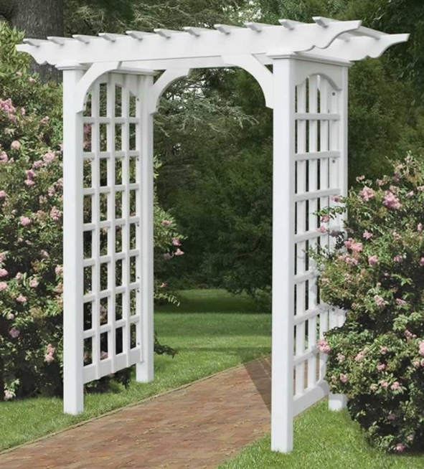

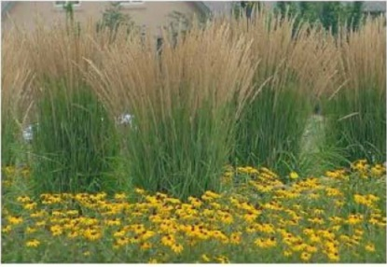
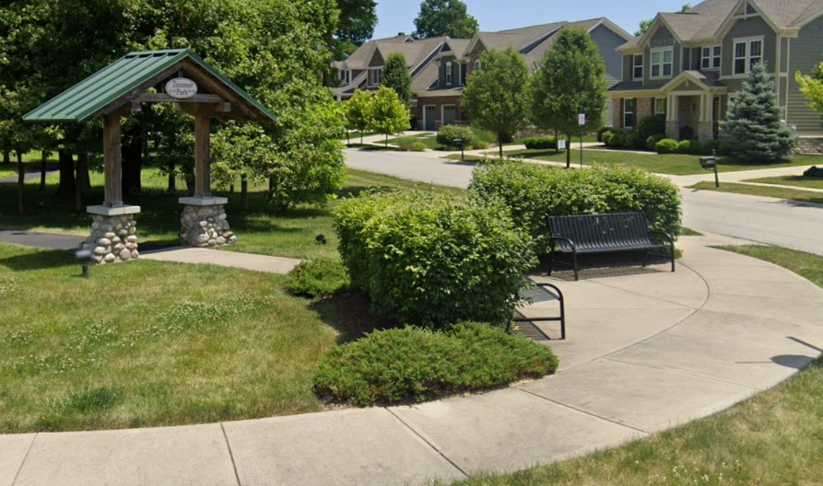
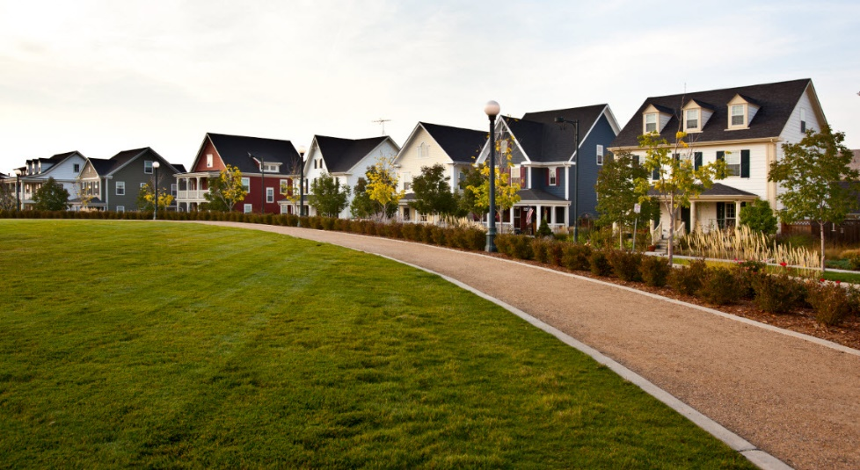
“Exhibit G”

LIGHTING UNIT EXHIBIT

