VERNON TOWNSHIP FIRE DEPARTMENT
LADDER TRUCK ANALYSIS
May 2, 2023

I.PURPOSE
To educate all stake holders and generate discussion concerning our current lack of internal apparatus to engage fires in structures more than 2 stories in height.
II. PRESENT SITUATION
Vernon Township Fire Department (VTFD) is analyzing the need for a ladder truck, a fire engine equipped with ladders capable of rapid response, ventilation, extinguishment and rescue operation for fighting fires in structure exceeding two stories in McCordsville, Fortville and the unincorporated portion of Vernon Township.
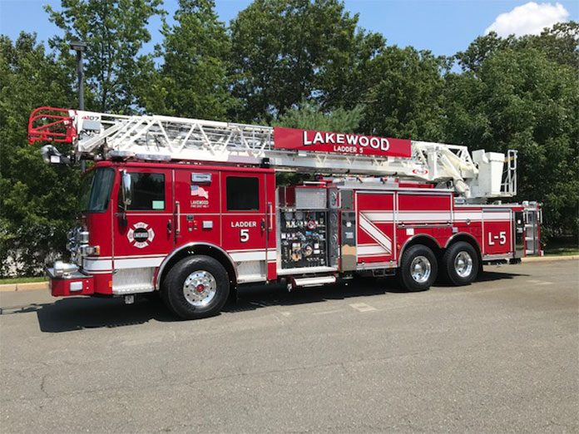
VTFD presently doesn’t have ladder or aerial capabilities. We are dependent on mutual aid to respond to those fire incidents requiring use of a ladder truck within our fire district.
Since 2020 VTFD has responded to 62 reported structure fires. Of those 21 incidents involved fire personnel extinguishing fires at subdivision homes in McCordsville, Main Street businesses in Fortville and other locations.
In the 2021 Insurance Service Office (ISO) Fire Suppression Rating there were 17 buildings in the towns of Fortville and McCordsville that met the ladder truck requirement. Additional buildings have been built and approved since 2021 that also meet this requirement.
III. DEFINING NEED
ISO states that “Individual ladder/service response areas with at least 5 buildings of 3 stories or 32 feet or more in height (ground to eaves) or with at least 5 buildings that have a needed fire flow greater than 3500 GPM or with at least 5 buildings meeting any combination of those criteria must have a ladder company.” In addition to the 17+ buildings in the two towns, there are several grain bins and barns, such as the Kingen round barn on CR 600 N, in the farming
community that should also be taken into consideration.

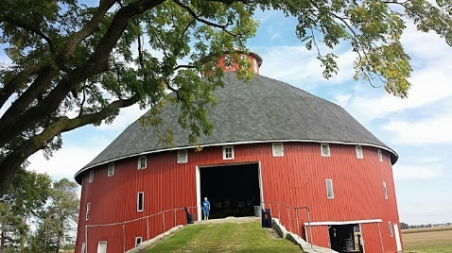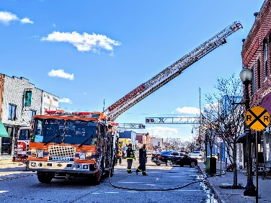

Why is a ladder truck important?
1. Rescue capabilities
Buildings where occupants are trapped on the third floor or higher
need to be rescued from a mechanical ladder instead of ground ladders. The ladder also
provides a second avenue of escape for firefighters operating on these floor levels.
2. Exposure Protection and elevated water stream
This is accomplished by use of an elevated water stream coming from the tip of the ladder. Smaller hand lines used on most fires flow between 125 and 180 gallons per minute. Larger fires where the ladder is needed require larger amounts of water usually applied from above. Water flow from these master streams is in the amount of 500 to 1200 gallons per minute.
3. Ventilation
It is imperative to fire suppression operations that a fire be ventilated so that heat and smoke can be removed from the building. This is usually accomplished by ventilating the building as high up as possible, as in chopping a hole in the roof of a structure.
IV. FINANCIAL DISCUSSION:
A Ladder Truck ordered in 2023 will cost approximately $1.8 million with equipment costs of $160,000 or for a total of $1.96 million. The Ladder Truck will be delivered approximately 2 years after it is ordered.
Staffing for the ladder truck would require hiring 9 people at a cost of approximately $900,000 per year.
There will be additional specialized training required and we are pricing the cost of training options.
V. BUDGET:
Vernon Township Fire Department was formed by the Township in 2019. The Fire Territory was formed in 2020 via interlocal with the towns of McCordsville and Fortville. The two towns and township adopted identical fire levies.
In the past four years, VTFD has replaced 20–30-year-old volunteer department fire engines, self-contained breathing apparatus (air packs), two ambulances and turn-out gear. We have converted from all volunteers to combination full time/part time staffing. And we have built two 24/7 fire stations.
Above and beyond the Territory interlocal agreement, Vernon Township is providing an additional $550,000 in LIT in 2023 that is equivalent to 13% of total revenue. The township has also sold equipment that has added an additional $144,680. These funds allowed VTFD to pay off the first ambulance early and will also allow VTFD to make additional equipment payoffs in the future to decrease interest payments.
Vernon Township Fire Department has successfully managed conservative, balanced budgets since the formation of the Territory. VTFD has a healthy balance in reserve to pay off (if allowed) the second Ambulance when it is received in 2024. Our Capital Plan will also reflect the VTFD apparatus replacement program.
VI. CONCERNS
What happens if we don’t run a ladder truck?
1. Limits VTFD capabilities to adequately respond to fire incidents involving structure exceeding two stories.
2. Wait for Mutual Aid to respond to incidents.
3. Difficult to improve insurance cost to our residents. ISO ratings are diminished by not meeting this requirement.

VII. OPPORTUNITIES FOR DISCUSSION
1. Short term staffing option
A short-term option would be to hire 1 person qualified to operate a ladder truck per shift and running a split crew with medic/ladder. The staffing cost per year would be approximately $318,000 (projected for 2025).
2. Used Ladder Truck
A used ladder track might be another short-term option. Still expensive as competitive to bid on and hard to find. Concerns about getting parts and high cost of maintenance on used apparatus. Consider as a stop gap option?
3. Additional Contributions
a. The township is providing LIT funds (nearly $550,000) above and beyond the levy for Fire Operations.
b. The towns received additional TIF monies due to the formation of the Fire Territory. As the towns approve TIF districts and consider their RDC budgets for future years, can they consider an annual contribution to the purchase of a ladder truck?
c. Or are there other options?

2027 LADDER TRUCK PURCHASE SCHEDULE
850 days build time = 2.3 years

DATE | PAYMENT | AMOUNT
7/1/2024 | 1 | $81,082.19 | Interest Only
1/1/2025 | 2 | $52,763.00 | Interest Only
7/1/25 | 3 | $52,763.00 | Interest Only
1/1/26 | 4 | $52,763.00 | Interest Only
7/1/26 | 5 | $268,126.86
1/1/27 | 6 | $268,126.86
7/1/27 | 7 | $268,126.86
1/1/28 | 8 | $268,126.86
7/1/28 | 9 | $268,126.86
1/1/29 | 10 | $268,126.86
7/1/29 | 11 | $268,126.86
1/1/30 | 12 | $268,126.86
TOTALS |  | $2,384,386.07

