ORDINANCE NO. 051325E

ORDINANCE AMENDING ORDINANCE NO. 121410, THE ZONING ORDINANCE

FOR THE TOWN OF MCCORDSVILLE, INDIANA

WHEREAS, the Town Council of the Town of McCordsville, Indiana, has heretofore adopted Ordinance No. 121410 as the Zoning Ordinance; and

WHEREAS, the Town Council of McCordsville, Indiana has, after a public hearing was held on April 15, 2025, received a favorable recommendation from the McCordsville Advisory Plan Commission requesting an amendment to the Zoning Ordinance in order to adopt the Old Town Cigar Bar Planned-Unit Development (PUD) Ordinance.

THEREFORE, BE IT ORDAINED by the Town Council of the Town of McCordsville, Indiana that Ordinance No. 121410 is hereby amended as follows:

**Section 1.** The real estate more particularly described in the attached “Exhibit A” (the “Real Estate”) is hereby zoned to the PUD designation. The Development and Architectural standards set forth in this Ordinance shall govern the development of the Real Estate, and these standards shall replace all other standards set forth in the Town of McCordsville Zoning and Subdivision Control Ordinances, as amended. Where this Ordinance is silent regarding standards other than Development and Architectural standards, the standards from the McCordsville Zoning and Subdivision Control Ordinances, dated January 2011, as amended, applicable to CN Zoning, shall apply.

**Section 2. Intent.** The Old Town Cigar Bar provides strict design requirements which are compiled with the intent to produce the following:

1. To allow for an indoor/outdoor cigar bar/lounge meeting the definition of a cigar bar in the Town of McCordsville Zoning Ordinance, as further defined and regulated herein.

**Section 3. Permitted Uses.** The permitted uses, as defined by the McCordsville Zoning and Subdivision Control Ordinances, for the Real Estate are described below, all uses not listed below, shall be considered prohibited.

Permitted Primary Uses:

See Exhibit “D”

Permitted Accessory Uses, Incidental Uses, and Structures:

Those permitted pursuant to the Town Ordinance

Permitted Temporary Uses:

Those permitted pursuant to the Town’s Zoning Ordinance

**Section 4. Development Standards.** The Old Town Cigar Bar shall be developed to comply with the standards written herein and as generally shown on the Concept Plan attached hereto as “Exhibit B”:

1. **The Development Standards**
2. Minimum Lot Area 1 acre
3. Minimum Lot Width 100 feet
4. Minimum Front Yard Setback 50 feet (building)

15 feet (parking)

1. Minimum Side Yard Setback 10 feet
2. Minimum Rear Yard Setback 20 feet
3. Minimum Building Separation 10 feet
4. Maximum Lot Coverage 65 %
5. Maximum Height-Principal 35 feet
6. Maximum Height-Accessory 15 feet
7. **Architectural Standards:**

The Architectural Standards for the Real Estate are attached as “Exhibit C”.

1. **Landscaping Standards:**

Standards of the Town’s Zoning and Subdivision Control Ordinance regarding Landscaping shall be applicable to the Real Estate with the following exceptions:

1. A perimeter landscape area, at least fifteen (15) feet in width, shall be provided along the right-of-way of W Broadway. This landscape area will be cleared of gravel, and topsoil will be added to a depth to support turf grass and shrub plantings. The petitioner shall install the topsoil, turf grass (seed), and shrubs (planted in compliance with the town’s perimeter parking lot landscape standards). This area shall also be permitted to feature a sidewalk, streetlighting, and other necessary infrastructure, as determined by the Town.
2. A perimeter landscape area, at least twenty (20) feet in width, shall be provided along the south property line. If the existing vegetation remains, no additional landscaping is required. In the event the existing vegetation is removed, a small buffer-yard, as detailed in the Town of McCordsville Zoning Ordinance, shall be required.
3. Foundation plantings, in the form of shrubs and ornamental grasses, shall be provided along the north façade of the building. Foundation plantings shall be planted in in-ground beds, and said bed(s) shall be a minimum of five (5) feet in width.
4. Trash Enclosures shall be screened with landscaping.
5. Interior parking lot landscaping shall not be required.
6. Perimeter parking lot landscaping shall not be required except as noted above, along W Broadway.
7. Buffer-yards: Section 6.11(A)(2) shall not apply, and therefore buffer-yards are not required, except as noted above.
8. **Pedestrian Accessibility:**

Standards of the Town’s Zoning and Subdivision Control Ordinance regarding Pedestrian Accessibility shall be applicable to the Real Estate with the following exceptions:

* 1. A minimum five (5) foot wide concrete sidewalk shall be provided along W Broadway, as required by the McCordsville Zoning Ordinance. This sidewalk shall be located in the above noted landscape area and be a minimum of five (5) feet from back-of-curb. This sidewalk shall be installed no later than two (2) years from the date a certificate of occupancy is issued for the cigar bar; however, the installation may be coordinated and completed in conjunction with the Town of McCordsville’s sidewalk installation projects, subject to approval by the Town.
  2. To provide protection for the sidewalk, a chairback curb shall be installed along the W Broadway roadway for the width of the lot, excluding curb cuts as approved by the Town of McCordsville. This curb shall be installed at the same time as the above noted sidewalk.
  3. A public access easement or right-of-way shall be granted to the Town for the purpose of public access to the above-required sidewalk, and to allow the Town to install streetlighting and other necessary infrastructure in the future. The exact dimensions and location of this easement or right-of-way will be determined prior to the issuance of a Certificate of Occupancy.

1. **Lighting, Parking, and Signage:**

Standards of the Town’s Zoning and Subdivision Control Ordinance regarding Lighting, Parking, and Signage shall be applicable to the Real Estate with the following exceptions:

1. Street Lighting: Streetlighting not be required.
2. Parking Lot Lighting: The parking lot and vehicular entrance shall be illuminated. All lighting shall comply with the Zoning Ordinance, except that all free-standing parking lot lights shall be limited to no more than twenty (20) feet in height (from grade).
3. All free-standing lighting fixtures shall be black in color.
4. All exterior lighting shall be:
   1. LED illumination
   2. 4000k color temperature
5. The parking lot and drive aisles shall be paved with asphalt, in accordance with the requirements of the McCordsville Zoning Ordinance. This pavement shall be installed no later than two (2) years from the date a certificate of occupancy is issued for the cigar bar.
6. Any wall signage shall be non-illuminated or externally illuminated. Internal illumination is prohibited on wall signs.
7. **Roadway:**

Standards of the Town’s Zoning and Subdivision Control Ordinance regarding Streets, Roadways, and Right-of-way shall be applicable to the Real Estate with the following exceptions:

1. Any portion of the existing W Broadway roadway not in existing right-of-way, shall be dedicated to the Town of McCordsville.
2. The Real Estate shall be limited to one (1) curb cut onto W Broadway. This curb-cut shall feature a concrete apron.
3. **Miscellaneous**
4. The Old Town Cigar Bar PUD shall be required to provide a minimum 35% open space.
5. An outdoor patio shall be provided. This patio shall meet the McCordsville Zoning Ordinance requirements for an outdoor dining area.
6. The existing, wooden trash receptacle enclosure may remain on-site. This enclosure shall be rehabbed and kept in good repair, including the addition of a functional, opaque, wooden gate. In the event, the existing trash receptacle is removed, any new enclosure shall meet the Town’s requirements for trash receptacle enclosures.
7. Outdoor storage is prohibited except as provided below:
   1. The existing shipping containers on the site shall be removed, and one (1) lean-to structure with surrounding walls shall be constructed as part of the initial phase of site improvements. A building permit for the lean-to and walls must be obtained and construction initiated prior to, or concurrently with, the first building permit issued for any other improvements on the site. The lean-to and walls must be located in the area designated on the approved site plan and shall be designed and maintained in a neat and orderly appearance. The materials and colors of the lean-to and walls shall match or complement the primary structure, as determined by the Zoning Administrator.
   2. The lean-to structure shall be the only permitted area for storage on the property.
   3. No shipping containers or other detached storage buildings shall be permitted on the property at any time.
   4. The lean-to storage area shall be used solely for storage purposes related to the business and shall not be accessible to the general public.
8. A minimum of one (1) commercial grade, walk-in, humidor shall be in operation during business hours.
9. Cigars must be sold on-site and on-site consumption of cigars, purchased on-site, must be permitted at all times during business hours.
10. A ventilation system shall be required and in-use at all times during business hours. Said ventilation system shall meet the requirements of the State of Indiana for “smoking lounges”.
11. The hours of operation shall be limited to 9:00am – 10:00pm Sunday through Thursday, and 9:00am – 12:00am Friday and Saturday.
12. The terms of this ordinance shall apply only to Parcel ID: 30-01-26-100-008.000-018, and with adoption of this Ordinance, the landowner commits to re-platting Parcel 30-01-26-100-008.000-018, in a manner which adjusts the west parcel line so that it no longer straddles the building, primary located on, Parcel ID: 30-01-26-101-008.001-018. Said re-platting shall occur prior to a Certificate of Occupancy for the building located on Parcel 30-01-26-100-008.000-018, and may require new addressing, as determined by the Town.
13. In the event that a new primary structure is built on the Real Estate, the standards of the McCordsville Zoning Ordinance and MCR-OL Overlay Ordinance shall apply, and said standards shall over-write the standards of this PUD.
14. No noise in the form of music, whether it is live or played over speakers, is permitted to be heard outside, after 10:00pm.
15. The Town’s Special Event Permit shall apply to the Real Estate.
16. **Definitions:**
17. Stone: shall not be interpreted to include concrete masonry units (CMU).
18. Cigar Bar: An establishment specializing in serving cigars for consumption on the premises, along with serving of alcohol and food for consumption on the premises. Such an establishment may also sell or offer cigar accessories to aid in the on-premises consumption of cigars. Such an establishment must provide proper ventilation for indoor air quality. For the purposes of administering and enforcing this Ordinance the phrase “Cigar Bar” shall not be interpreted to be the same as Cigar Shop, Bar, Tavern, or Night Club.

**Section 5.** This Ordinance shall remain in full force and effect from and after its passage and posting as required by the law within the Town of McCordsville, Indiana.

**Section 6.** Duly ordained and passed this ___ day of ___________, 2025 by the Town Council of the Town of McCordsville, Hancock County, Indiana, having been passed by a vote of _ in favor and _ opposed.

**TOWN OF McCORDSVILLE, INDIANA, BY ITS TOWN COUNCIL:**

Voting Affirmative: Voting Opposed:

____________________________________  
Gregory J. Brewer Gregory J. Brewer

____________________________________  
Scott Jones Scott Jones

____________________________________  
Dr. Bryan Burney Dr. Bryan Burney

____________________________________  
Chad D. Gooding Chad D. Gooding

____________________________________  
Dr. John Price Dr. John Price

ATTEST:

_________________________________  
Stephanie Crider, Clerk-Treasurer

**“Exhibit A”**

**LEGAL DESCRIPTION**

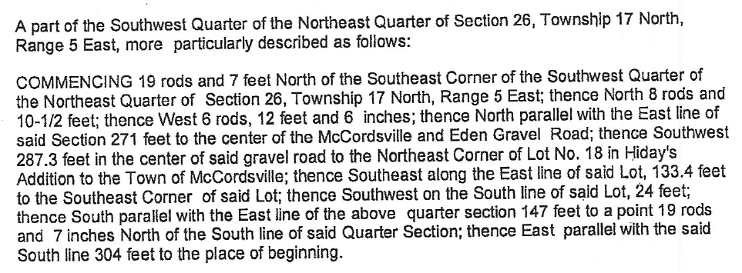

**“Exhibit B”**

**Concept Plan**

**“Exhibit C”**

**Architectural Standards**

1. The existing primary structures on the property shall be renovated to meet the the following minimum standards:
2. The black/charcoal color, as shown in the petitioner’s illustrative architectural exhibit shall be a permitted exterior color. Otherwise, all colors shall be muted tones which are compatible with the surrounding structures. No fluorescent, neon, or other high intensity colors shall be used as a building color.
3. Mechanical equipment (ie. RTUs, wall-mounted, or ground mounted) shall be screened from view. Wall and ground-mounted equipment shall be screened with a wall, fence, or landscaping. Roof-mounted equipment shall be screened from the view by parapets, dormers, portion of roof, or other screens. The material of all such screens shall be consistent with the exterior materials used on the façade of the primary building, unless use of such material is deemed not logical or feasible by the ARC, in which case the ARC may approve an alternative material. All roof-top equipment screens shall be constructed so that the equipment screen fully obscures the view of the equipment from all points of abutting property lines and all points of the farthest right-of-way line of any adjacent public or private street. The line of site measurements shall be taken at a height of eight (8) feet from grade along the applicable property line or right-of-way line. The Town may require multiple line of site exhibits depending upon existing or proposed conditions, including but not limited to distance from equipment and changes in grade. Mechanical and utility equipment not shown on plans (due to unknown location or other reasons) or mechanicals added that were not originally planned for do not remove the developer’s responsibility to comply with these standards.
4. The north façade shall feature a covered porch, covered entry, or pergola, similar to that shown in Exhibit C-1. This feature shall utilize warm wood tones and materials.
5. Exterior siding materials shall be limited to fiber cement, LP siding, brick, stone, wood, and EIFS. The existing metal siding may remain and may be repaired if damaged, but metal siding shall not be permitted as a new material. However, black metal siding or skin may be used if installed at the outset of the project, subject to review and approval by the ARC.
6. Roofing materials shall be limited to three-dimensional asphalt shingles, copper, or slate. The existing metal roofing may remain and may be repaired if damaged, but metal roofing shall not be permitted as a new material. However, black metal roofing may be used if installed at the outset of the project, subject to review and approval by the ARC.
7. There shall be a minimum of two (2) separate window openings on the north façade. At least one window opening shall be added to the west and east facades.
8. The north façade gable shall feature a decorative detail similar to that shown in Exhibit C-1.
9. All new primary structures on the property shall be required to meet the requirements of the Neighborhood Commercial Zoning District and the MCR-OL Overlay.

**“Exhibit C-1”**

**Illustrative Architectural Exhibit**

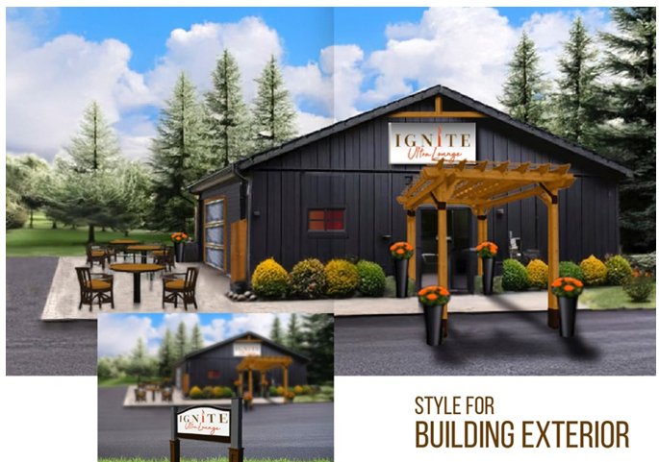

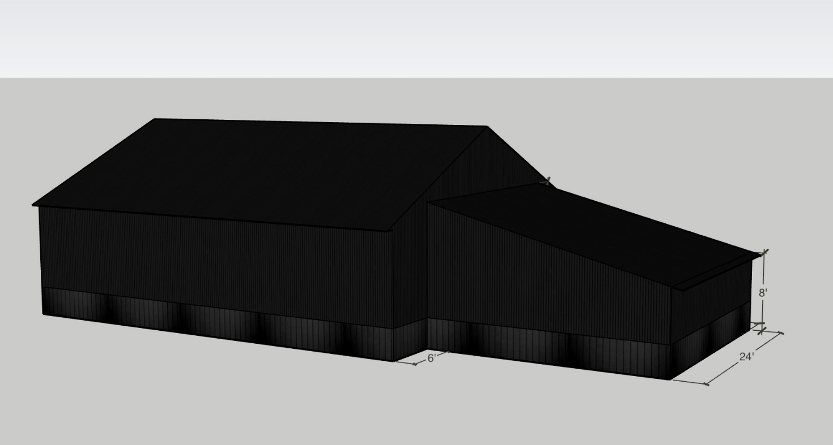

**”Exhibit D”**

**Schedule of Uses**

*Permitted Uses*

* Professional Business Office
* Cigar Bar – as defined by the McCordsville Zoning Ordinance, and as further defined and regulated in this Ordinance. Furthermore, this land use shall run with only the petitioner, Michelle Miller, and only for Ignite Ultra Lounge. This land use does not run with the land.

# COMMITMENT CONCERNING DEVELOPMENT OF REAL ESTATE

Document Cross Reference Instrument No. .

**WHEREAS,** Petitioner filed Ordinance 051325E, titled *An Ordinance Amending Ordinance No. 211410, The Zoning Ordinance For the Town of McCordsville, Indiana* (the “Ordinance”) with the Area Plan Commission (“APC”) and the McCordsville Town Council (“Town”), proposing to amend the McCordsville Zone Map.

**WHEREAS,** Petitioner is willing and has requested the Council consider approval of the Ordinance subject to the following commitment (the “Commitment”):

**Section 1. Commitment**. The Real Estate shall be subject to the following Commitment:

1. No variances or special exceptions will be permitted. If Petitioner wants to modify or amend the Ordinance, Petitioner agrees to follow the rezoning process.
2. Should Ignite Ultra Lounge cease to operate for a period of thirty (30) or more days, Cigar Bar should no longer be a Permitted Use under Ordinance 051325E.

**Section 2**. **Modification of Commitment**. This Commitment shall continue and be in effect until modified or terminated in writing. This Commitment shall only be modified or terminated by the Council.

**Section 3.** **Subsequent Ordinances**. This Commitment may be superseded if the Council adopts differing standards that affect the relevant zoning district.

**Section 4**. **Effective Date**. This Commitment shall be effective upon the Council’s approval of the Petition.

**Section 5**. **Recording**. This Commitment shall be recorded with the Office of the Recorder of Hancock County, Indiana within thirty (30) days of the Council’s approval of the Petition.

**Section 6**. **Enforcement**. This Commitment may be enforced by the Town.

[REMAINDER OF PAGE LEFT INTENTIONALLY BLANK]

**IN WITNESS WHEREOF**, Petitioner has caused this Commitment to be executed as of the date identified below.

“Petitioner”

Signature: _____________________________________

Print: _____________________________________

Title: _____________________________________

Date: _____________________________________

STATE OF INDIANA )

) SS:

COUNTY OF HANCOCK )

|  |
| --- |
|  |

Before me, a Notary Public in and for said County and State, personally appeared _____________________, who acknowledged the execution of the foregoing document on behalf of Petitioner.

Witness my hand and Notarial Seal this ____ day of ______________, 2025.

My Commission Expires:

(Signature)

My County of Residence:

(printed name) Notary Public

This instrument was prepared by Beth A. Copeland, Copeland Law, LLC, 11650 Olio Road, Suite 1000-184, Fishers, IN 46037

I, affirm, under the penalties for perjury, that I have taken reasonable care to redact each Social Security number in this document, unless required by law. *Beth A. Copeland*