ORDINANCE NO. 041123_

ORDINANCE AMENDING ORDINANCE NO. 121410, THE ZONING ORDINANCE
FOR THE TOWN OF MCCORDSVILLE, INDIANA

WHEREAS, the Town Council of the Town of McCordsville, Indiana, has heretofore adopted Ordinance No. 121410 as the Zoning Ordinance; and

WHEREAS, the Town Council of McCordsville, Indiana has, after a public hearing was held on March 21, 2023, received a favorable recommendation from the McCordsville Advisory Plan Commission requesting an amendment to the Zoning Ordinance in order to adopt the Morningside Planned-Unit Development (PUD) Ordinance.

THEREFORE, BE IT ORDAINED by the Town Council of the Town of McCordsville, Indiana that Ordinance No. 121410 is hereby amended as follows:

Section 1. The real estate more particularly described in the attached “Exhibit A” (the “Real Estate”) is hereby zoned to the PUD designation. The Development and Architectural standards set forth in this Ordinance shall govern the development of the Real Estate, and these standards shall replace all other standards set forth in the McCordsville, Indiana Zoning Ordinance and Subdivision Control Ordinance, as amended. Where this Ordinance is silent regarding standards other than Development and Architectural standards, the standards from the McCordsville, Indiana Zoning and Subdivision Control Ordinances, dated January 11, 2011, as amended, applicable to R3 Zoning for District A, CN Zoning for District B, I-1 Zoning for District C, and MF-2 Zoning for District D, shall apply.

Section 2. Definitions. Capitalized terms not defined in this PUD Ordinance shall have the meaning ascribed to them in the Town of McCordsville Zoning Ordinance.

- Minimum Home Size. The total square feet of a home, excluding garages, rear porches, front porches, basements, and any decks or patios.
- Decorative Garage Door: Garage doors with windows shall be considered decorative garage doors. Two illustrative examples are included in Exhibit C-1. Exhibit C-1 shall not be interpreted to represent the actual decorative garage doors that will be used in this project but rather the types of garage doors that constitute decorative garage doors.
- Maintenance Included: Front yard shall be irrigated and maintained by HOA. For the purposes of front-yard irrigation, the front-yard shall be considered any part of the yard from side lot line to side lot line and from the front elevation of the home to the right-of-way line. The HOA shall also be responsible for maintenance of the grass strip between the sidewalk and curb-line, and any portion of the yard (inclusive of rear and side yards) that are not fenced in. Maintenance includes, at a minimum, the following: mowing, fertilization, and weed control of grass, and maintenance of any builder installed shrubbery and trees. Other plantings installed by a homeowner shall not be the responsibility of the HOA, unless otherwise agreed to by the HOA. Snowplowing shall also be included in HOA maintenance.
Section 3. Permitted Uses. The permitted uses, as defined by the McCordsville, Indiana Zoning Ordinance and Subdivision Control Ordinance, for the Real Estate are described below. All uses not listed below shall be considered prohibited.

- Permitted Primary Uses:
- District A – Dwelling, Single-Family with Maintenance Included
- District B – All uses permitted in the CN Zoning District, together with the additional uses identified in Exhibit G
- District C – All uses permitted in the I-1 Zoning District, together with the additional uses identified in Exhibit G
- District D – Dwelling, Multi-Family

- Permitted Accessory Uses, Incidental Uses, and Structures:
Those permitted pursuant to the McCordsville, Indiana Zoning Ordinance.

- Permitted Temporary Uses:
Those permitted pursuant to the McCordsville, Indiana Zoning Ordinance.

Section 4. Development Standards. The Morningside PUD shall have four (4) Districts as shown on the District Map attached hereto as “Exhibit B”. The Real Estate shall be developed in substantial compliance with the Preliminary Concept Plan attached hereto as “Exhibit C”. The following development standards shall apply in each respective District:

- The Development Standards for District A shall be as follows:

- Maximum Number of Lots 61 Lots
- Minimum Lot Area 6,000 Square Feet
- Minimum Lot Width at Building Line 50 feet
- Minimum Lot Depth 120 feet (as generally shown on the Concept Plan)
- Minimum Front Yard Setback 25 feet
- Minimum Side Yard Setback 5 feet
- Minimum Rear Yard Setback 15 feet
- Minimum Livable Floor Area 1,500 square feet (single story)
1,800 square feet (1.5 or multi-story)
- Maximum Lot Coverage 75%
- Maximum Height-Principal 35 feet
- Maximum Number of Units per Lot: 1
- Maximum Size of District 20 acres

- The Development Standards for District B shall be as follows:

- Maximum Number of Lots N/A
- Minimum Lot Area 1 acre
- Minimum Front Yard Setback
  - Along CR 600W 50 feet
  - Along any other 25 feet
- Minimum Side Yard Setback 10 feet
- Minimum Rear Yard Setback 15 feet
- Minimum Ground Floor Area 2,500 square feet
- Maximum Lot Coverage 75%
- Maximum Height-Principal 35 feet
- Minimum Size of District 10 acres

- The Development Standards for District C shall be as follows:

- Maximum Number of Lots N/A
- Minimum Lot Area 1.0 acre
- Minimum Front Yard Setback 30 feet
- Minimum Side Yard Setback 35 feet
- Minimum Rear Yard Setback 35 feet
- Minimum Floor Area of
Self-storage Office 3,000 square feet
- Minimum Ground Floor Area of
Any other structure 3,250 square feet
- Maximum Lot Coverage 75%
- Maximum Height-Principal 35 feet
- Maximum Size of District 9 acres

- The Development Standards for District D shall be as follows:

- Maximum Number of Units 240
- Minimum Lot Area per Unit N/A
- Minimum Front Yard Setback
  - Golden Lane 30 feet
  - Honey Crisp Drive 50 feet
  - Internal* 30 feet from drive lane
- Minimum Side Yard Setback 15 feet
- Minimum Rear Yard Setback 20 feet
- Minimum Building Separation 32 feet or equal to the height of the
building (excluding roof), whichever is greater
- Minimum Livable Floor Area
  - Studio unit 850 square feet
  - 1-bedroom unit 850 square feet
  - 2-bedroom unit 910 square feet
  - 3-bedroom unit 1,200 square feet
- Maximum Lot Coverage 75%
- Maximum Height-Principal 48 feet
- Maximum Number of Units per Building: 16
- Maximum Size of District 20 acres
- Maximum Number of Studio &
1-bedroom Units 40% of total unit count in District
- Maximum Density 13 units per acre
- Maximum Number of Accessory Structures** 3
* Front-yard setback shall be measured from the closest façade (or portion thereof) to the nearest street curb, parking lot curb, or internal sidewalk.
** Examples of accessory structures are pool-houses, clubhouses, maintenance shops, and the like. Athletic courts, trash enclosures, mail kiosks, detached garages, pergolas, and the like shall not be considered accessory structures for the purpose of this quantity limitation but shall be considered accessory structures for all other purposes. Carports shall not be permitted.

The Morningside PUD will provide a minimum of 25% open space as generally shown on the Concept Plan. Drainage facilities shall be permitted as part of the open space calculation.

- Architectural Standards:

The Architectural Standards for the Real Estate are attached as “Exhibit D”. The Approved Elevations and Illustrative Architectural Exhibits, attached hereto as Exhibits D-2 through D-5, are hereby incorporated to illustrate conceptually the elements and anticipated character of, and to establish a benchmark for, the architecture and design of the improvements located within each District. The final improvement designs may vary from what is depicted in the Illustrative Architectural Exhibits; however, all improvements within the Morningside PUD will be substantially similar in quality and character as the improvements shown in Exhibits D-2 through D-5.

- Perimeter Landscaping, Buffering and Screening Standards:

Standards of the McCordsville, Indiana Zoning Ordinance and Subdivision Control Ordinance regarding Landscaping, Buffering and Screening applicable to R3, CN, I-1, and MF-2 zoning districts shall be applicable to the respective Districts within the Real Estate with the following exceptions or additions*:

- District A
  - Both entry points to the District shall have an enhanced landscape package consisting of trees, shrubs, and perennials, as determined by the Town’s Planning and Building Department staff in cooperation with the developer, in order to denote the gateway/entry to the District.
- District B
  - Apple Valley Way shall feature a landscaped median with a minimum landscape bed width of twelve (12) feet. This bed shall feature turf grass and mulch areas. It shall feature trees, flowers and shrubs. This median shall extend from CR 600W to the Golden Lane intersection.
  - Golden Lane shall feature a landscaped median with a minimum landscape bed width of eight (8) feet. This bed shall feature turf grass and mulch areas. It shall feature trees, flowers and shrubs. This median shall extend from Aurora Way to the Honey Crisp Drive intersection. There shall be an opening permitted for access to the self-storage site.
  - Apple Valley Way, Honey Crisp Drive, and Golden Lane shall feature a ten (10) foot wide grass strip between the sidewalk and back-of-curb, on both sides of the street, and street trees (from the list below) shall be planted every forty (40) feet on center.
      - American Hornbeam
      - Green Hawthorn
      - Hophornbeam
      - Paperbark Maple
      - Common Hornbeam
      - Princeton Elm
      - American Elm
      - Yellowwood
      - Ginkgo (male only)
      - Street Keeper Honeylocust
      - Skyline Honeylocust
      - Riverbirch
      - London Planetree
      - Zelkova
      - Bald Cypress
      - Or as otherwise approved by the Zoning Administrator
  - The common areas at both entrances from CR 600W shall be irrigated.
  - The Town’s buffer-yard requirements for a commercial land use adjacent to a multi-family residential land use shall not apply along the west perimeter of the District.
- District C
  - The Town’s foundation planting standards shall only apply to exterior facing facades of perimeter buildings of any self-storage facility.
  - Golden Lane shall feature a ten (10) foot wide grass strip between the sidewalk and back-of-curb.
  - Street trees (from the list above) shall be planted every forty (40) feet on center along any roadway within a ten (10) wide grass strip between the street and sidewalk/trail, or any street without a sidewalk/trail.
  - The Town’s buffer-yard requirements for an industrial land use adjacent to a commercial land use shall not apply along the east perimeter of the District.
  - The Town’s buffer-yard requirements for an industrial land use adjacent to a multi-family residential land use shall not apply along the north perimeter of the District, and instead the following shall apply:
      - Five (5) trees per one hundred (100) lineal feet shall be installed between the self-storage (or other permitted use) and Honey Crisp Drive. These trees shall be a mix of deciduous and evergreen trees, arranged in an informal pattern creating visual interest, as determined by the Zoning Administrator. These trees are in addition to any required street trees.
  - The Town’s buffer-yard requirements for an industrial land use adjacent to a single-family residential land use shall not apply along the west perimeter of the District, and instead the following shall apply:
      - A double row of evergreen trees placed thirty (30) feet on center along the west perimeter of the storage facility (or other permitted use), and undulating mounding of at least three (3) feet in height.
  - A double row of evergreen trees placed thirty (30) feet on center along the south property of the District, and undulating mounding of at least three (3) feet in height.

- District D
  - The Town’s buffer-yard requirements for a multi-family residential land use adjacent to a single-family residential land use shall not apply along the west perimeter of the District, and instead the following shall apply:
      - Five (5) trees per one hundred (100) lineal feet shall be installed between the multi-family use and Pond 2 (as identified in the Concept Plan). These trees shall be a mix of deciduous and evergreen trees, arranged in an informal pattern creating visual interest, as determined by the Zoning Administrator. These trees are in addition to any required street trees.
  - The Town’s standards for perimeter and interior parking plantings in the CN Zoning District shall apply to parking lots in this District.
  - Honey Crisp Drive and Golden Lane shall feature a ten (10) foot wide grass strip between the sidewalk/trail and back-of-curb, on both sides of the street, and street trees (from the list above) shall be planted every forty (40) feet on center.
  - The south and east perimeters of the District shall be planted with four (4) trees and eight (8) shrubs per one hundred (100) lineal feet, along with undulating mounding of at least three (3) feet in height. Mounding is not required when directly adjacent to a wet detention facility.
  - Where large parking fields existing between buildings, similar to the parking field shown on the Concept Plan between Buildings A5-A7, a median landscape island shall be required to break up the large expansion of asphalt/concrete. An example of an acceptable treatment is shown in Exhibit H.
  - All buildings shall feature a minimum of ten (10) foot deep landscape area between the building and any parking lot or sidewalk. This does not apply where a garage(s) has been incorporated into the structure.
* In the event of a direct conflict between the landscaping, buffering and screening requirements in the McCordsville, Indiana Zoning Ordinance or Subdivision Control Ordinance and the provisions of this Ordinance, the provisions of this Ordinance shall control.

- Pedestrian Accessibility:

Standards of the McCordsville, Indiana Zoning Ordinance and Subdivision Control Ordinance regarding pedestrian accessibility within R3, CN, I-1, and MF-2 zoning districts shall be applicable to the respective Districts within the Real Estate with the following exceptions or additions*:

- Minimum ten (10) foot wide asphalt trail shall be installed along CR 600W.
- Minimum six (6) foot wide concrete sidewalk shall be installed along the north side of Aurora Way.
- Minimum six (6) foot wide concrete sidewalk shall be installed along both sides of Apple Valley Way.
- Minimum six (6) foot wide concrete sidewalk shall be installed along both sides of Golden Lane, with the exception that no sidewalk is required south of the self-storage facility parking lot.
- Minimum ten (10) foot wide asphalt trail shall be installed along the north side of Honey Crisp Drive. This trail shall meander and shall incorporate the landscaping required elsewhere in this Ordinance to produce a linear park feel. This trail shall continue between the commercial out-lots to create a direct connection to the trail along Mt. Comfort Road. This trail connection shall be placed in a public access easement and may be located within the setbacks of the commercial out-lots. It shall be landscaped on both sides throughout District B.
- Minimum five (5) foot wide sidewalks shall be provided along both sides of all streets within District A.
- The Mt. Comfort Overlay requirement for sidewalks connecting a perimeter sidewalk/trail to building foundation sidewalks shall apply and shall apply to all frontages in the case where a commercial lot in District B has more than one frontage.
- Minimum five (5) foot wide sidewalks shall be provided along all multi-family buildings featuring an entrance, along all parking lots in District D, and connecting all parking lots to buildings in District D.
- Notwithstanding the requirements above, any path which is located back-of-curb without a grass strip between the pedestrian facility and the curb shall be concrete.
- All truncated domes (ADA warning surfaces) shall be black in color.
- Where the above noted sidewalks and trails do not fit within the public ROW prescribed in this Ordinance, the sidewalk or trail shall be placed in a pedestrian access easement. In those instances, the Town will not be responsible for maintenance of the sidewalk or trail.
* In the event of a direct conflict between the requirements of the McCordsville, Indiana Zoning Ordinance or Subdivision Control Ordinance with respect to pedestrian accessibility and the requirements of this Ordinance, the requirements of this Ordinance shall control.

- Amenities & Public Spaces:

Standards of the McCordsville, Indiana Zoning Ordinance and Subdivision Control Ordinance regarding amenities and public spaces within R3, CN, I-1, and MF-2 zoning districts shall be applicable to the respective Districts within the Real Estate with the following exceptions or additions*:

- Section 5.04(D)5(e) Public Spaces shall only apply to District B and shall apply to the District wholly, not on individual lots.
- District D shall provide the following amenities to the multi-family residents:
  - Pool with showers, work-out facilities, meeting areas, dog park, and EV charging stations.
- District A shall provide the following amenities to the single-family residents:
  - Walking paths around the development and to commercial development that will provide access to shopping and restaurants.
  - Wet ponds that allow for fishing by residents.
- Amenities shall be in keeping with the quality and character shown in Exhibit E.
* In the event of a direct conflict between the requirements of the McCordsville, Indiana Zoning Ordinance or Subdivision Control Ordinance with respect to amenities and public spaces and the requirements of this Ordinance, the requirements of this Ordinance shall control.

- Lighting, Parking, and Signage:

Standards of the McCordsville, Indiana Zoning Ordinance and Subdivision Control Ordinance regarding Lighting, Parking, and Signage applicable to R3, CN, I-1, and MF-2 zoning districts shall be applicable to the respective Districts within the Real Estate with the following exceptions or additions*:

- Primary Sign Entry Monuments: The developer shall install entry monumentation including, but not limited to, brick or stone walls, landscaping and street lighting at both entrances on CR 600W.
- Secondary Sign Entry Monuments: The developer shall install secondary entry monumentation including, but not limited to, brick or stone walls and/or columns, fencing, landscaping and street lighting at the following locations:
  - Both entrances into District D
  - Both entrances into District A
- Primary & Secondary Entry monumentation is meant to identify the overall development name (i.e., Morningside), not individual tenants, users, or businesses. However, the secondary entry monumentation for District A & D may be specifically for those uses (i.e., name of apartment complex, name of subdivision) and the requirement for such entry monumentation shall count towards the Zoning Ordinance’s sign allowances.
- All such monumentation and other ground signage shall share a consistent theme. The theme and materials shall be approved by the Architectural Review Committee (ARC).
- If the developer of District B elects to install a “Unified Development Sign” as described in Section 154.148(A)(1)(a)(A-B) of the McCordsville Zoning Ordinance, District C shall be permitted sign space on the unified development sign. If the developer of District B elects all out-lot users to install their own ground signage under the requirements of Section 154.148(A)(2) of the McCordsville Zoning Ordinance, District C shall be permitted up to a maximum of twenty (20) square feet of sign area on a ground sign structure along the Mt. Comfort Road. This sign area shall be placed on a ground sign structure that is shared with another entity that is permitted to have ground signage along Mt. Comfort Road. In this case, the total sign area for this shared ground sign shall be fifty (50) square feet. All other aspects of the shared sign shall be in compliance with the McCordsville Zoning Ordinance.
* In the event of a direct conflict between the requirements of the McCordsville, Indiana Zoning Ordinance or Subdivision Control Ordinance with respect to lighting, parking and signage and the requirements of this Ordinance, the requirements of this Ordinance shall control.

- Model Homes:

District A shall be permitted up to two (2) model homes and at least one (1) model home constructed shall be one of the two (2) largest square footage floor plans offered by the builder at the time the model home permit is issued. If the builder constructs more than one model, there is no restriction on the size of the second model so long as the first model complies with the above requirement.

- Anti-Monotony Standards:

In District A, the same front elevation shall not be repeated unless it is separated by two (2) homes on either side of the subject home and three (3) homes immediately across the street from the subject home. There shall not be more than ten (10) percent of the houses in the subdivision with the same front elevation.

- Roadways:

- Rights-of-way (ROW) shall be dedicated to the Town as denoted below:
  - Minimum half-width ROW of seventy (70) feet on CR 600W
  - The portion of the minimum full width ROW of seventy-five (75) feet for Aurora Way that is a part of the Real Estate.
  - Minimum full width ROW of fifty-four (54) feet on Honey Crisp Drive, Golden Lane, and all public streets within District A.
  - Minimum full width ROW of ninety-two (92) feet on Apple Valley Way.
  - Additional ROW will be dedicated at the northwest corner of CR 600W and Aurora Way for the future round-a-bout.
- The Owner’s Association for Morningside shall be responsible for snow removal of all internal streets, both public and private.
- The Town shall not be responsible for any maintenance on any landscaping, fencing, or signage located in the public right-of-way.
- The Town shall not be responsible for any maintenance of any roadway either not built to Town standards and/or not dedicated to the Town as public right-of-way.
- The following traffic improvements shall be constructed:
  - Acceleration and deceleration lanes, in conformance with Town standards, at all access points into the development from any collector, and/or arterial roadway.
  - Passing blisters or left-turn lanes, in conformance with Town standards, at all access points as required by the Town Engineer.
- Street name signage and traffic control signage shall be installed consistent with the quality and character shown on Exhibit “F”.
- Honey Crisp Drive, Apple Valley Way, Golden Lane, and Aurora Way shall feature chair-back curb.
- Macintosh Way, Cortland Court, La Manzanita Court, and Philadelphia Drive shall feature roll curb.
- Entrance drives in District C shall feature roll curb from the perimeter street to where the drive enters the storage facility. Entrance drives, drive aisles, and parking areas in Districts B & D shall feature roll or chairback curb.
- The maximum block length shall be 1,200 feet. Any block length equal to or greater than 800 feet in length shall feature traffic calming measures, including but not limited to:
  - Street trees
  - Traffic circles
  - Neck-downs for pedestrian crossings
  - Chicanes
  - 90 degree turns with eyebrows
  - Other features as approved by the Town Engineer.
- Road Impact Fees: The developer agrees to pay any Road Impact Fees (RIF) adopted by the Town. Such fees shall become payable on any building permit after the effective date of the RIF Ordinance, regardless of when a Primary Plat, Detailed Development Plan, or Development Plan were filed. Any future increases in the fee by the Town shall be adopted in accordance with state law.
- A four (4) inch yellow thermoplastic stripe shall be placed on the top of the curb adjacent to any fire hydrant within the development. This stripe shall extend ten (10) feet out from the hydrant in both directions.
- The developer and/or property owner of the Real Estate shall provide a street stub of Golden Lane to the north property of the Real Estate.
- It is anticipated that some of the proposed internal roadways will be private streets and not dedicated to the Town. In such instances, these roadways shall be subject to an easement allowing access by public and quasi-public vehicular traffic and shall be designed to adequately accommodate emergency response and emergency vehicles as determined by the Zoning Administrator, in consultation with emergency providers.
  - If private street(s), with a width less than that of public streets is proposed, such streets shall be required to prohibit on-street parking. Additionally, any limitation or prohibition of on-street parking shall be privately enforced and the appropriate language codifying those regulations shall be listed in the appropriate covenants and restrictions, and where applicable, lease documentation. This shall not apply to perpendicular, angled, or parallel parking located along a private street which is outside of the private street’s thru-lanes.
- A construction entrance shall be provided from Mt. Comfort Road. Construction traffic shall not access the Real Estate from Philadelphia Drive.
- District A shall have vehicular access from Mt. Comfort Road prior to the issuance of any certificate of occupancy for a home in District A.

- Miscellaneous:

- Section 4.17 applies to the extent that it is not superseded by the standards of this Ordinance.
- Fountains shall be installed in all wet detention facilities. The largest pond shall feature a minimum of two (2) fountains. At least two of the ponds shall feature illuminated fountains, one of which shall be the largest pond.
- In District A, fencing on residential lots shall be limited to ornamental black fencing featuring a “wrought-iron” style. Privacy fences may be permitted only along lots along the west and south property line. Fences shall not be located closer to the street than the rear corners of the home.
- Garages within District D shall not face the east perimeter, and a maximum of one building may have garages facing the south perimeter. This restriction shall not apply if there is another building between the garage(s) and the perimeter.
- No home in District A shall be rented for a period of at least thirty-six (36) months from the last date of transfer or sale, except when renting to a family member or in a case of financial hardship that is approved by the Homeowner’s Association (HOA). This language shall also be added to the HOA Covenants and Declarations.
- The final site design, including, but not limited to, the large perimeter common area along the north side of Red Key, and the wet detention facilities, shall be in keeping and as generally shown on the Concept Plan.
- The Districts shall not be permitted to move locations within the Real Estate, nor shall any be permitted to make any substantial changes in size.
- All applicable setbacks apply to both buildings and parking.
- Developer commits to creating an owner’s association that will manage and maintain the common spaces. In lieu of an owner’s association, developer can hire a property management company to manage and maintain the common spaces.
- Kiosks and vending machines are not permitted unless they are located within a building. Examples of such items are beverage/snack machines, automated machines, and the like. Open-air enclosures shall not be considered as being located within a building. This shall not apply to mail kiosks or package lockers. Mail kiosks shall feature masonry materials matching the primary structure(s).
- Trash enclosures shall be 100% masonry, matching the primary structure(s). The enclosure walls shall be at least one (1) foot taller than the tallest trash receptacle. The gate shall be opaque and constructed of metal framework but may have a wood exterior. There shall be a pedestrian access to trash receptacle separate from the vehicle gate. These standards shall also apply to trash compactors. All enclosures shall be in keeping with the illustrative examples in Exhibit I.
- Outdoor storage of materials, equipment, and the like is prohibited.
- Renting of Rooms: The renting of individual rooms, or any portion of a dwelling unit, but not the entirety of a dwelling unit, is strictly prohibited. This restriction shall also apply to sub-leases. A dwelling unit shall only be rented/leased to a resident as defined within this Ordinance.
- Resident: A Resident and/or Resident Group does not include any society, club, fraternity, sorority, or group living in a boarding house, hotel, motel, bed and breakfast facility, lodging house, rooming house, or club, any group of individuals whose association with each other is seasonal, or any individuals who are in group living arrangements as a result of criminal activity. The Zoning Administrator may request documentation proving authorized residents, as described above. That documentation shall be by official government documents and be provided within 10 days of being requested to do so.
- Any self-storage facility hours shall be limited to 5:00am to 10:00pm. No access or operations shall occur outside this time period, Monday-Sunday. Other non-residential land uses shall be compliant with Section 4.09 of the Zoning Ordinance.

Section 5. This Ordinance shall remain in full force and effect from and after its passage and posting as required by the law within the Town of McCordsville, Indiana.

Section 6. Introduced and filed on the 11th day of April, 2023. A motion to consider on the first reading on the day of introduction was offered and sustained by a vote of 5 in favor and 0 opposed pursuant to I.C. 36-5-2-9.8.

Duly ordained and passed this _____ day of ______________, 2023 by the Town Council of the Town of McCordsville, Hancock County, Indiana, having been passed by a vote of ____ in favor and ____ opposed.

TOWN OF McCORDSVILLE, INDIANA, BY ITS TOWN COUNCIL:

Voting Affirmative: Voting Opposed:

____________________________________
Gregory J. Brewer Gregory J. Brewer

____________________________________
Larry J. Longman Larry J. Longman

____________________________________
Bryan Burney Bryan Burney

____________________________________
Scott Jones Scott Jones

____________________________________
Branden D. Williams Branden D. Williams

ATTEST:

_________________________________
Stephanie Crider, Clerk-Treasurer

“Exhibit A”

LEGAL DESCRIPTION

A part of the East Half of the Northeast Quarter of Fractional Section 1, Township 16 North,
Range 05 East in Buck Creek Township, Hancock County, Indiana, said part being more
particularly described as follows:

COMMENCING at an iron pin marking the southeast corner of said northeast quarter
section; thence north 88 degrees 12 minutes 10 seconds west (assumed bearing) along the
south line of said northeast quarter section a distance of 30.02 feet to the southwest corner
of a 0.234 acre exception described in a Warranty Deed recorded as Instrument Number
120001477 in the Office of the Recorder of Hancock County, Indiana, said point being the
POINT OF BEGINNING of this description; thence continuing north 88 degrees 12 minutes
10 seconds west along said south line a distance of 1836.22 feet to the southeast corner of
Easton At Stansbury - Section II, as per plat thereof recorded as Slide 81in Plat Cabinet C in
the Office of said Recorder; thence north 00 degrees 11 minutes 22 seconds west along the
east line of said plat and the east line of Easton At Stansbury - Section 1, Phase I as per plat
thereof recorded as Slide 45 in Plat Cabinet C in the Office of said Recorder a distance of
1936.75 feet to the southwest corner of a 2 acre parcel described in Instrument Number
99-7313 recorded in the Office of said Recorder; thence north 88 degrees 57 minutes 02
seconds east along the south line of said 2 acre parcel and the south line of a 0.555 acre
parcel described in Instrument Number 201513195 recorded in the Office of said Recorder
and along the south line of the “Gene & Bernice Apple - Minor Subdivision No. 2 a part of
S01-T16N-R05E, in Buck Creek Township, Hancock County, Indiana” as per plat thereof
recorded as Slide 8 in Plat Cabinet B in the Office of said Recorder a distance of 509.43 feet
to the southeast corner of said Minor Subdivision plat, said point being on the west line of
the east half of said northeast quarter section; thence south 00 degrees 10 minutes 51
seconds east along the east line of said half quarter section a distance of 662.27 feet to the
southwest corner of a 26.825 acre parcel described in a Warranty Deed recorded as
Instrument Number 02-00810 in the Office of said Recorder; thence north 87 degrees 56
minutes 25 seconds east along the south line of said 26.825 acres and along an existing
fence a distance of 1117.58 feet to the northwest corner of the “Gene and Bernice Apple
Minor Subdivision a part of S01-T16N-R05E, in Buck Creek Township, Hancock County,
Indiana” as per plat thereof recorded as Slide 4 in Plat Cabinet B in the office of said
Recorder; (the next two (2) calls are along the west and south lines of said plat) (1) south
00 degrees 09 minutes 52 seconds east a distance of 275.54 feet; (2) south 87 degrees 28
minutes 27 seconds east a distance of 203.00 feet to the northwest corner of said 0.234 acre
parcel, said point being the point of curvature of a non-tangent curve concave southwesterly
whose radius point bears south 84 degrees 08 minutes 49 seconds west a distance of
1403.39 feet from said point; (the next two (2) calls are along the west line of said 0.234
acre parcel) (1) southerly along the arc of said curve through a central angle of 05 degrees
41 minutes 17 seconds a distance of 121.24 feet; (2) south 00 degrees 09 minutes 52
seconds east a distance of 877.66 feet to the POINT OF BEGINNING. Containing 61.630
acres, more or less. Subject to all legal highways, rights-of-way, easements and restrictions of record

“Exhibit B”

DISTRICT MAP

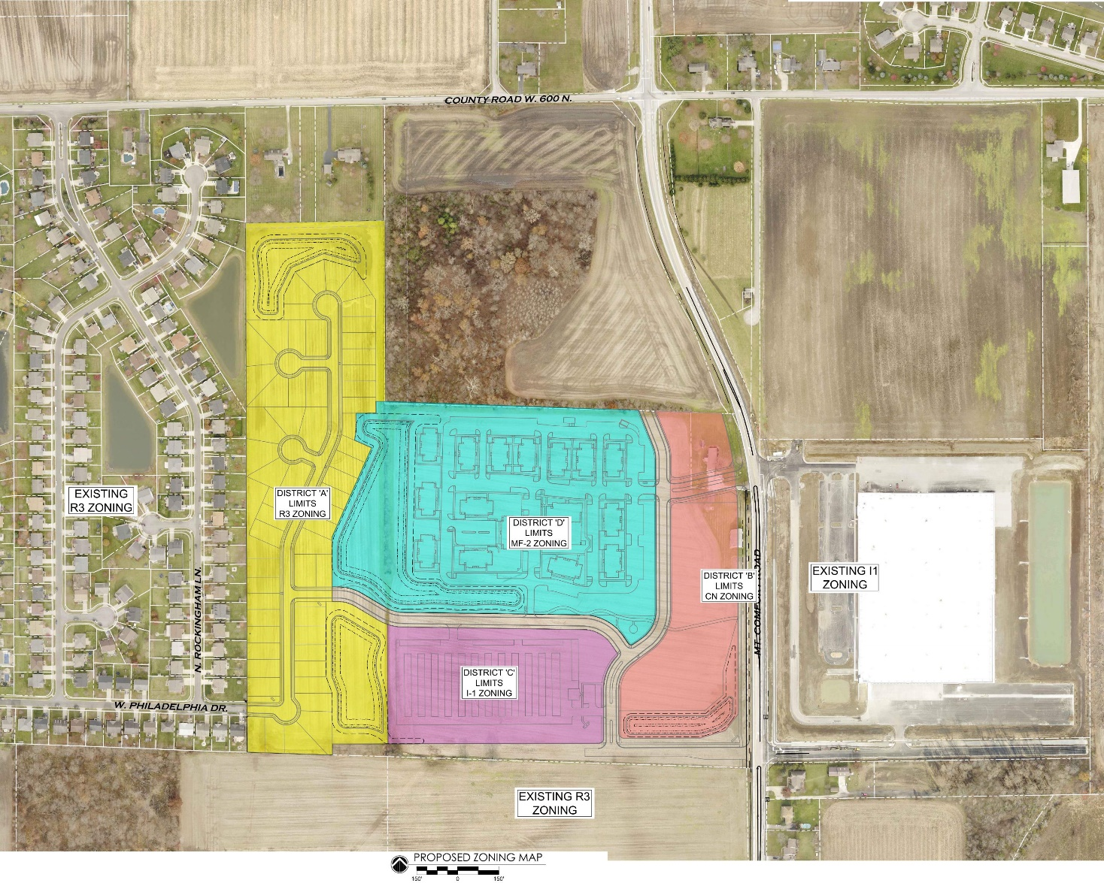

“Exhibit C”

CONCEPT PLAN

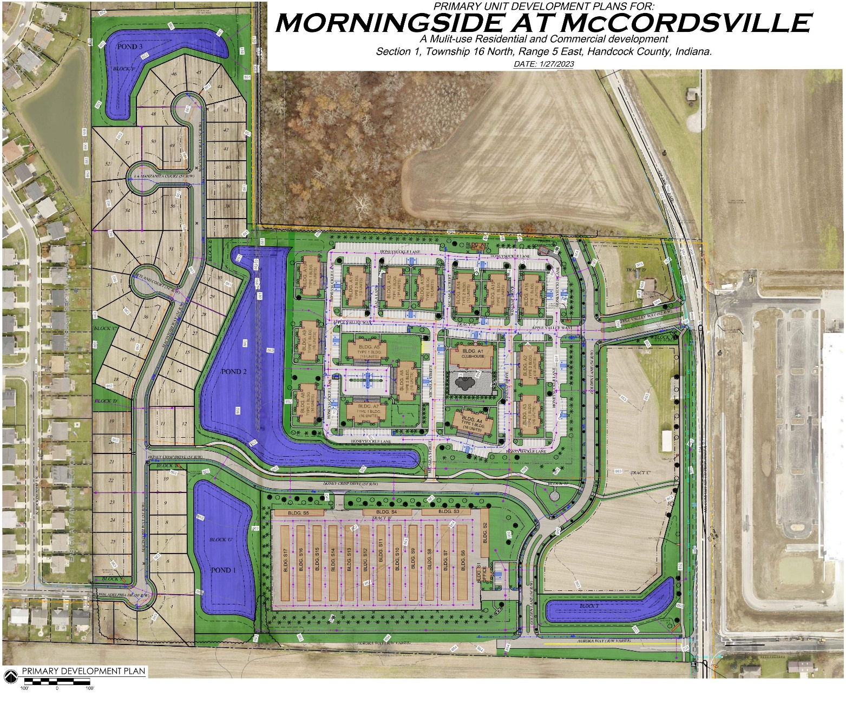

“Exhibit D”

ARCHITECTURAL STANDARDS

The following standards shall apply to the Real Estate as described below:

I. All Structures
- The permitted roofing materials shall be dimensional shingles, copper, slate, and stone. High-quality, standing seam metal roofing, in a matte finish, may be permitted by the Architectural Review Committee (ARC) if they conclude the material is in keeping with the architectural style of the structure and/or produces an aesthetic improvement over the other permitted roof materials.
- Main roof pitch and gable pitches shall be 6:12 or greater, unless otherwise required herein. The ARC may approve a structure with a lesser roof pitch if the architectural style of the structure lends itself to a shallower roof pitch.
- Satellite dishes and the like are prohibited from being located on front facades and/or front roof planes.
- Window A/C units and the like are prohibited.
- The heavier material shall always be used below a lighter material.
- In the absence of stricter standards elsewhere in Exhibit D, no exterior wall of any structure shall have less than a brick or stone wainscot.

    - District A – Single-Family Dwellings
- A minimum of three (3) colors will be offered for all roofing materials.
- Exhaust vents shall not be visible from the front elevation of a home.
- All siding shall be brick, stone, wood, cement fiber board, or stucco.
- Along Aurora Way, the exterior material of front elevation returns shall match the exterior material of the adjacent front facing façade.
- Brick solely on front elevations shall wrap the corners to a minimum depth of 24”.
- The front elevation of any home shall have a gable or front-facing hip, and any two-story home shall also contain one (1) one-foot or greater step back.
- No wall-mounted vent or louver shall be located on the first floor of a front elevation (excluding gable areas).
- Minimum roof overhang of eleven (11) inches on all sides of a house as measured from the frame.
- Exterior chimneys for fireplaces shall be made entirely of brick or stone.
- Unless approved by the ARC, all porch columns shall be a minimum of six (6) inches by six (6) inches.
- Except for large picture windows, casement windows and small accent windows which do not open, all windows on a façade facing a public street shall have shutters, mullions or window grids.
- Unless adjacent to brick or stone wrap, all front windows, doors, and corners shall have a minimum nominal one inch by six-inch wood or vinyl surround, shutters, decorative trim, or headers.
- All homes shall contain a minimum of one (1) window on all four sides with the exception of a façade facing a public street which shall contain a minimum of three (3) windows.
- Lots identified as a High Visibility Lot on the attached Exhibit D-6 shall feature the following:
        - Side High Visibility Lots
i. Minimum brick or stone wainscot wrap on all elevations
ii. Minimum of three (3) siding materials for a gable end side elevation. Minimum of two (2) siding materials for hip end side elevation. If the homeowner selects a full first floor brick wrap, the additional material requirements is not required.
- Rear High Visibility
i. A minimum of one (1) point of wall plane articulation that is at least two (2) feet in depth and ten (10) feet in width on rear elevation;
ii. A minimum of one (1) gable on rear elevation.
        - A minimum of a brick or stone wainscot wrap on all elevations.
- All homes shall contain a minimum of a two-car garage with a minimum size of four hundred and forty (440) square feet.
- Front-loading garages shall contain a decorative garage door with windows.
- Front-loading garages shall be offset from the front elevation of the home a minimum of two (2) feet.
- For any three-car garage that faces a street, at least one of the bays must have a separate door and be recessed a minimum of two (2) foot from the other bays.
- For front-loading garages, the garage doors shall not comprise greater than forty-five percent (45%) of the width of the front elevation for a two (2) car garage and fifty percent (50%) for a three (3) car garage.
- Any front-loading garage that protrudes eight (8) feet or more in front of the front elevation shall feature at least one (1) window, or architectural feature as approved by the ARC,on the side of the garage nearest the front door. This window shall not count towards any other window requirement. No front-loading garage shall protrude more than ten (10) feet in front of the front elevation of the home. Garage protrusion shall be measured by determining the distance between the farthest protruding façade of the garage and the widest portion of the front façade of the home. Any such garage shall also feature a minimum of eight (8) shrub plantings along the façade of the garage facing the side property line.
- Any side-load, courtyard-load, or rear-load garage shall feature a minimum of two (2) windows in the garage façade facing the street. These windows shall not count towards any other window requirement.
- All homes shall include mailboxes with uniform design.
- All homes shall be landscaped with a minimum of one (1) deciduous tree, two (2)
ornamental trees, and twelve (12) shrubs planted along the front foundation of the primary structure.
- All homes on corner lots shall also include a minimum of one (1) deciduous tree, one (1) ornamental tree, eight (8) shrubs planted along the foundation of the primary structure, and sod in the side yard facing the side street.
- All homes shall feature dusk to dawn controlled light fixtures flanking the garage door(s). A front porch light may also be added.
- There shall be no more than fifteen percent (15%) of the same front elevation in the subdivision.
- The same front elevation shall not be repeated unless it is separated by two (2) homes on either side of the subject home and three (3) homes immediately across the street from the subject home.
- Elevation Approval: The Town's ARC reviewed and approved a set of home plan elevations that are on file with the Town's Planning and Building Department (the "Approved Elevations"). The Approved Elevations are hereby incorporated as Exhibit D-2. Homes in the Approved Elevations do not need further review by the ARC except for anti-monotony purposes.
- All homes not included in the Approved Elevations shall comply with the standards set forth in Exhibit D of this Ordinance and shall be substantially similar in quality and character to the homes in the Approved Elevations. The Director of Planning and Building (“Director”), including his or her designees, shall review home elevations at the time of filing for a building permit for compliance. Such home(s) deemed in compliance with Exhibit D and determined to be in substantially similar in quality and character shall then be an Approved Elevation by the ARC.
- If a proposed home does not comply with Exhibit D of this Ordinance, then the proposed home may be submitted for review by the ARC. The ARC may approve an elevation if it is determined the elevation is similar in quality and character to the homes in the Approved Elevations and is consistent with the spirit and intent of the PUD, as determined by the ARC. The ARC may also deny elevations in which they feel are not substantially similar in quality and character.

III. District B – Commercial Out-lots
- CN Zoning District Architectural Standards, as amended, shall apply. This includes any standards within the Mt. Comfort Road Overlay, as amended.
- The Illustrative Architectural Exhibit, attached hereto as “Exhibit D-3”, is hereby incorporated to illustrate conceptually the elements and anticipated character of and to establish a benchmark for the architecture and design of the buildings in the District. The buildings shall be substantially similar in quality and character to the buildings shown in the Illustrative Architectural Exhibit.
- The architrectural style of buildings to be constructed with the intent to be primarily occupied with retail or restauarant tenants shall be more in keeping with the first example in D-3, while the style of buildings to be constructed with the intent to be occupied primarily with office or commercial service tenants shall be more in keeping with second example in D-3. The ARC shall make all determinations regarding compliance with this requirement.
- Concrete masonry units (CMU) are prohibited as an exterior material.
IV. District C – Self-Storage
- Architectural standards set forth in this Ordinance shall govern the development of this District. Where this Ordinance is silent regarding architectural standards, the standards from the McCordsville, Indiana Zoning Ordinance for the I-1 Zoning District, as amended, shall apply.
- The Illustrative Architectural Exhibit, attached hereto as “Exhibit D-4”, is hereby incorporated to illustrate conceptually the elements and anticipated character of and to establish a benchmark for the architecture and design of the buildings in the District. The buildings shall be substantially similar in quality and character to the buildings shown in the Illustrative Architectural Exhibit.
- The permitted materials shown in the exhibit are as follows:
  - Exterior buildings: brick, stone, EIFS, and glass. Under no circumstance shall a perimeter façade of an exterior building feature less than 40% brick or stone, exluding windows and doors, unless otherwise approved by the ARC.
  - Interior buildings: brick and metal siding
4. The ARC shall approve all structures within the District and shall make all determinations regarding compliance with this requirement.
5. Perimeter fencing along the west and south perimeters of any self-storage facility shall be comprised of decorative, black fencing, wrought-iron in style, with brick and/or stone columns (matching the primary structure) spaced no more than every forty (40) feet on center.
6. No gap between buildings or masonry walls along the north or east perimeters of any self-storage facility shall be wider than twenty-four (24) feet. There shall be no more than three (3) such gaps. Gaps created for the sole purpose of a gate shall not count against the number of gaps, but there shall be a maximum of two (2) gates. The width of gate gaps shall be limited to what is necessary for gate function, as determined by the Zoning Administrator.
7. A solid brick and/or stone wall (matching the primary structure) shall be placed from the south gate (along Golden Lane) and shall extend to the south corner of the east perimeter. This wall shall continue along the south perimeter to at least the east edge of the second interior building.
- A dimensional cornice shall extend across all portions of any perimeter wall of a perimeter building of a self-storage facility. This cornice shall be generally consistent with the diagram shown in Exhibit D-4, as determined by the ARC. This shall not apply to a structure or portion of a structure with a pitched roof of at least 6:12.
- Any perimter wall of a self-storage facility shall include stone or concrete cap.
- The roofs of the interior self-storage buildings shall not be visible from the north and east perimeters.
- Any perimter wall used to screen the self-storage facility shall be a minimum height to screen the roofs of the interior buildings.
- The minimum roof pitch for the office building shall be 6:12. The developer may also choose to use a flat-roof design, incorproating parapets and cornices meeting the requirements of this Ordinance.
- The office building shall feature the following materials: brick, stone, glass, and a fourth (4th) material. Under no circumstance shall any front or side façade of an office structure feature less than 80% brick or stone, exluding windows and doors.
- The periemter façade of the storage buildings along the north and east perimeters shall feature windows (or faux windows) with awnings matching the style of awnings used on the office building windows.
- Any end-cap of an interior building which is visible from the perimeter of the District, as determined by the ARC, shall be 100% brick or stone matching the primary structure.
- All roof materials, including the interior building roofs shall be black or a nuetral color. For the purposes of this standard, any shade of white shall not be considered nuetral. Roof materials shall be limited to dimensional shingles or a high, quality standing seam metal roofing.
- Bold colors shall be limited to use as trim and accent colors as described in the Industrial Architectural Standards in the McCordsville, Indiana Zoning Ordinance.
- Any side façade of a perimter storage building or office building that is visible from the perimeter, as determined by the Zoning Administrator, shall utilize the same design and materials as the front elevation or shall be 100% brick or stone.
- The front façade of the office elevations shall feature accent lighting.
- Unless otherwise required by this Ordinance, interior facing elevations may be vertical seam metal siding.

          - District D – Multi-Family Dwellings
- Architectural standards set forth in this Ordinance shall govern the development of this District. Where this Ordinance is silent regarding architectural standards, the standards from the McCordsville, Indiana Zoning Ordinance for the M-2 Zoning District, as amended, shall apply.
- The Illustrative Architectural Exhibit, attached hereto as “Exhibit D-5”, is hereby incorporated to illustrate conceptually the elements and anticipated character of and to establish a benchmark for the architecture and design of the buildings in the District. The buildings shall be substantially similar in quality and character to the buildings shown in the Illustrative Architectural Exhibit.
- The permitted materials are brick, stone, fiber cement, LP siding, and glass. Under no circumstance shall any façade feature less than a full first floor brick or stone wrap and at least 50% brick or stone on the second floor level.
- The minimum primary roof pitch shall be 6:12; however, gable, dormer, and porch pitches may vary to achieve various architectural styles, as determined by the ARC. The ARC may approve a lesser primary roof pitch if the ARC finds the lower pitch is in keeping with the architectural style of the building.
- All building facades shall feature at least three (3) colors, including trim color(s), unless the façade features at least 75% brick or stone.
- All building entrances (excluding entrances to individual units) shall feature a weather covering, in the form of an awning, canopy, overhang, or the like, as determined by the ARC.
- Architectural detailing, horizontal/vertical off-sets, window details, and other architectural features shall be provided on all facades.
- All buildings, regardless of size or number of stories, shall use scale and design elements, such as but not limited to special lighting, awnings, trees, and other elements, to visually relate the building to the pedestrian scale and visually anchor the building to the ground/street level, consistent with the conceptual elevations attached as Exhibit H. Exceptions may be granted by the ARC for buildings featuring architectural styles which lend themselves to less variation. Exhaust vents shall be placed on the building in an organized pattern and color matched to exterior building material.
- Exterior chimneys for fireplaces shall be made entirely of brick or stone.
- Concrete masonry units (CMU) are prohibited as an exterior material.
- All structures shall incorporate a minimum of four (4) of the features noted in Section 6.04(B)(5) of the Zoning Ordinance on front elevations. Side and rear elevations shall feature at least one such feature.
- Flat roofs shall feature articulation that coincides with the wall plane articulation, and a three-dimensional cornice.
- Roof access shall be located within the interior space of the building.
- All sloped roofs shall be covered in one of the following materials: 30-year dimensional shingles, copper, or slate. High quality standing seam metal may be used as an accent roofing material as determined by the ARC.
- Overhangs are required along all facades. No overhang shall extend less than twelve (12) inches from the exterior siding material.
- A minimum of two roof planes (excluding a roof plane for a gable or dormer) shall be visible from all building elevations.
- Each façade over seventy (70) feet in length shall feature a minimum of two (2) gables in the roof line.
- Unless adjacent to brick/stone wrap, all windows, doors and corners shall have a minimum nominal one inch by six-inch wood or fiber-cement surround or shutters, decorative trim or headers.
- Except for large picture windows, casement windows and small accent windows, which do not open, all windows on a façade facing a public street shall have shutters, mullions or window grids.
- Windows shall be provided consistent with that shown in Exhibit D-5.
- All garage doors shall be decorative garage doors, consistent with Exhibit D-1, as determined by the ARC.
- Mechanical screening shall be provided. All ground mounted equipment shall be screened with landscaping. Wall mounted equipment is prohibited from being located in front of or along a front façade. Roof-top mechanical units shall be screened in accordance with the Zoning Ordinance’s standards for commercial roof-top units.
- The Illustrative Architectural Exhibit, attached hereto as “Exhibit H”, is hereby incorporated to illustrate conceptually the elements and anticipated character of and to establish a benchmark for the architecture and design of the buildings on the Real Estate. The final designs may vary from the Illustrative Architectural Exhibit; however, the buildings shall be substantially similar in quality and character to the buildings shown in the Illustrative Architectural Exhibit.
- Accessory structures, such as pool-houses, clubhouses and the like shall be required to comply with the architectural standards noted above, and shall have a similar design, theme, materials, and compatible architecture as the multi-family structures.
- Mailboxes shall be grouped together in the form of kiosks. Each kiosk shall be of uniform design and shall include masonry base matching that of the primary structures.
- All ground floor entries shall include weather protection in the form of an awning, canopy or other like structure or feature.

“Exhibit D-1”

DECORATIVE GARAGE DOORS

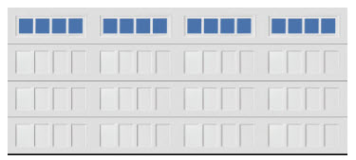

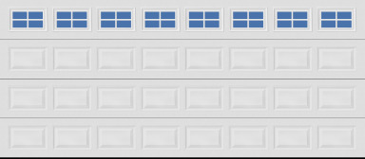

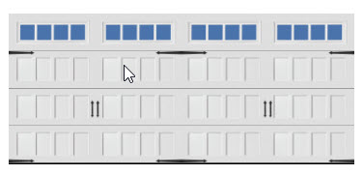

“Exhibit D-2”

Approved Elevations for District A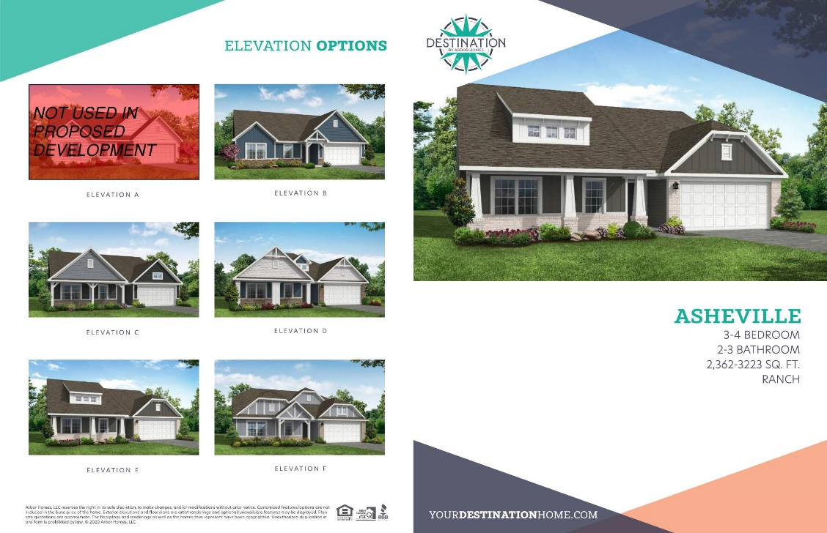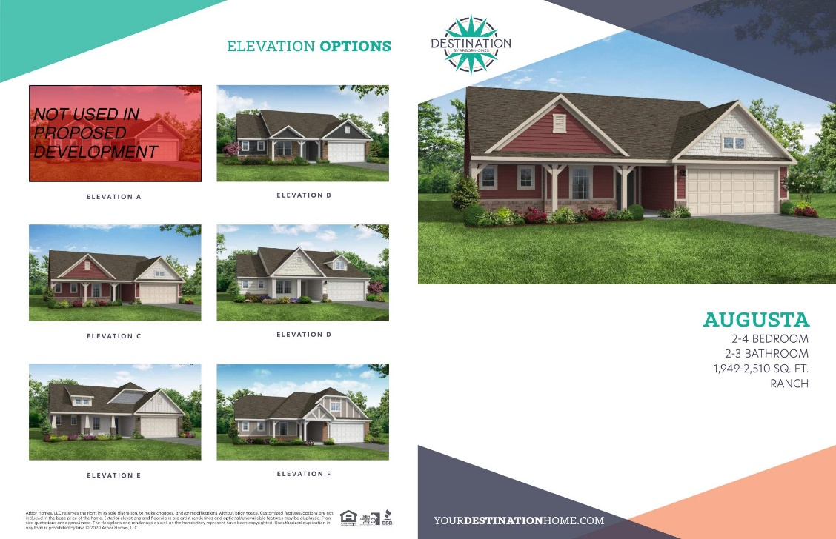

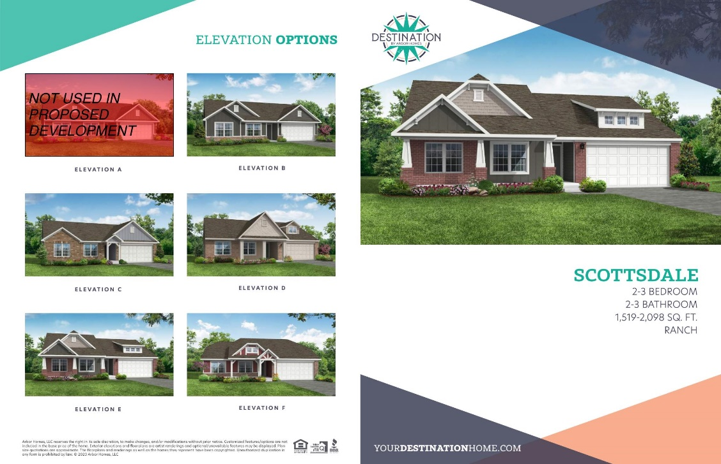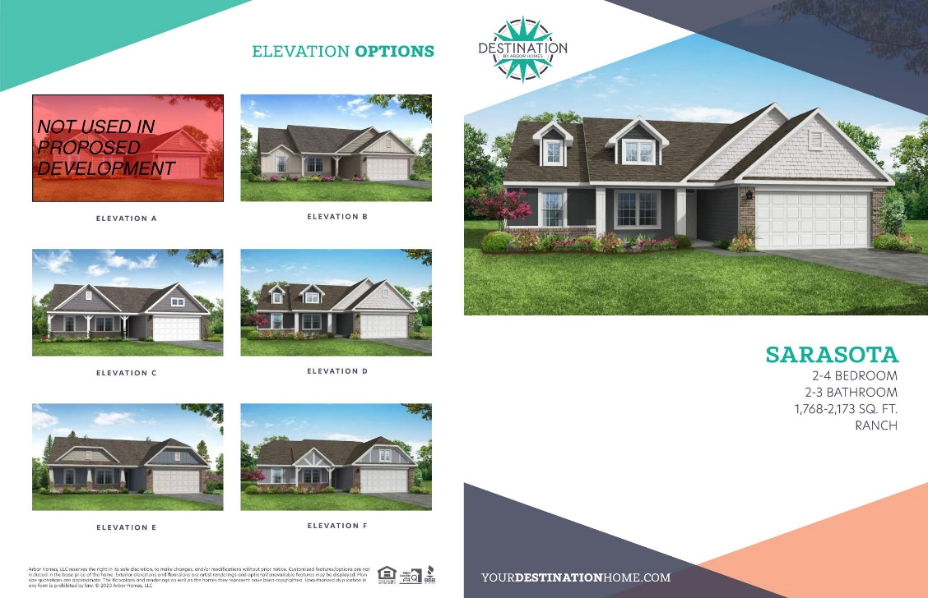

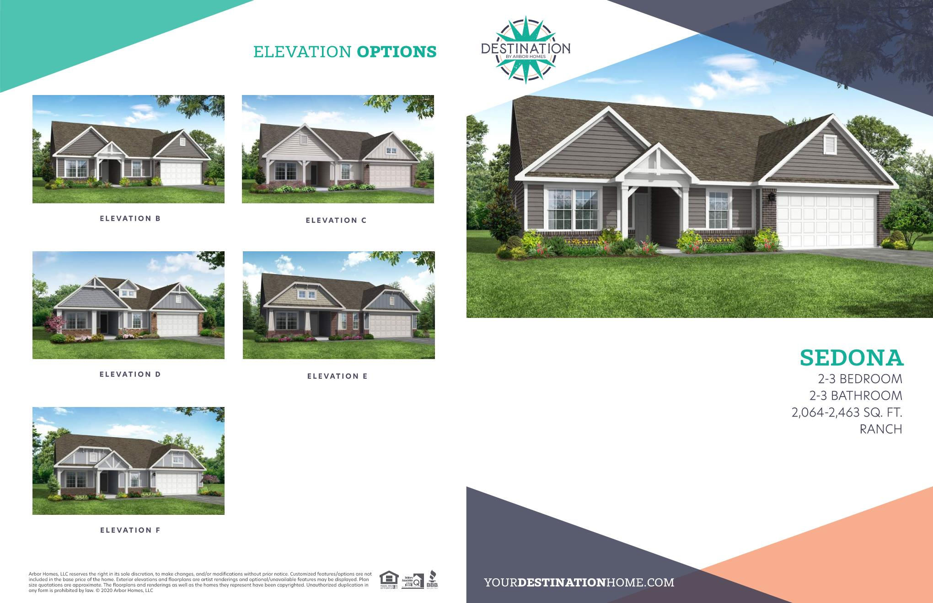

“Exhibit D-3”

Illustrative Architectural Exhibit for District B

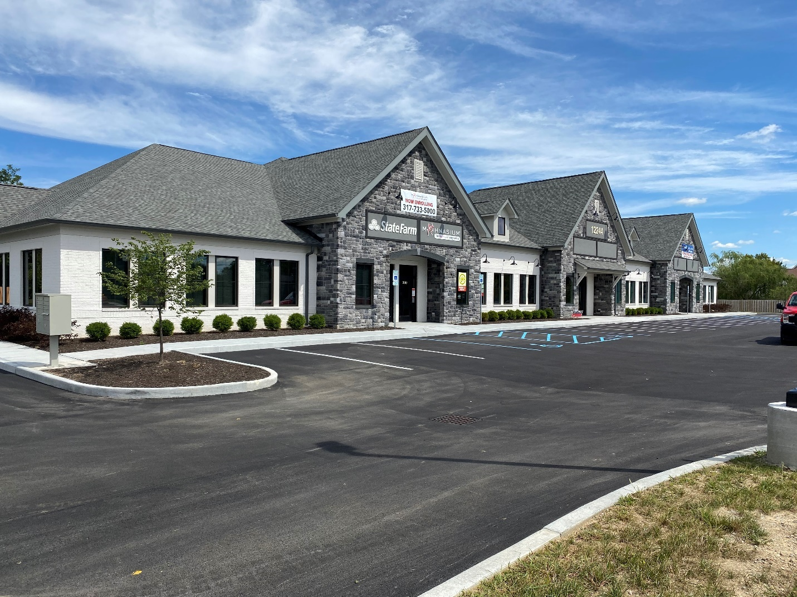

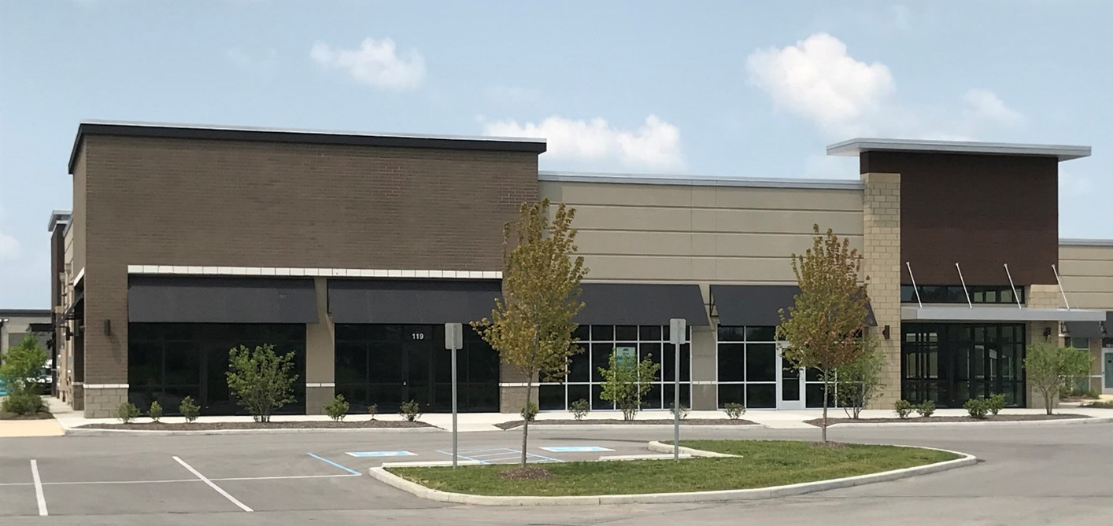

“Exhibit D-4”

Illustrative Architectural Exhibit for District C

Interior Buildings

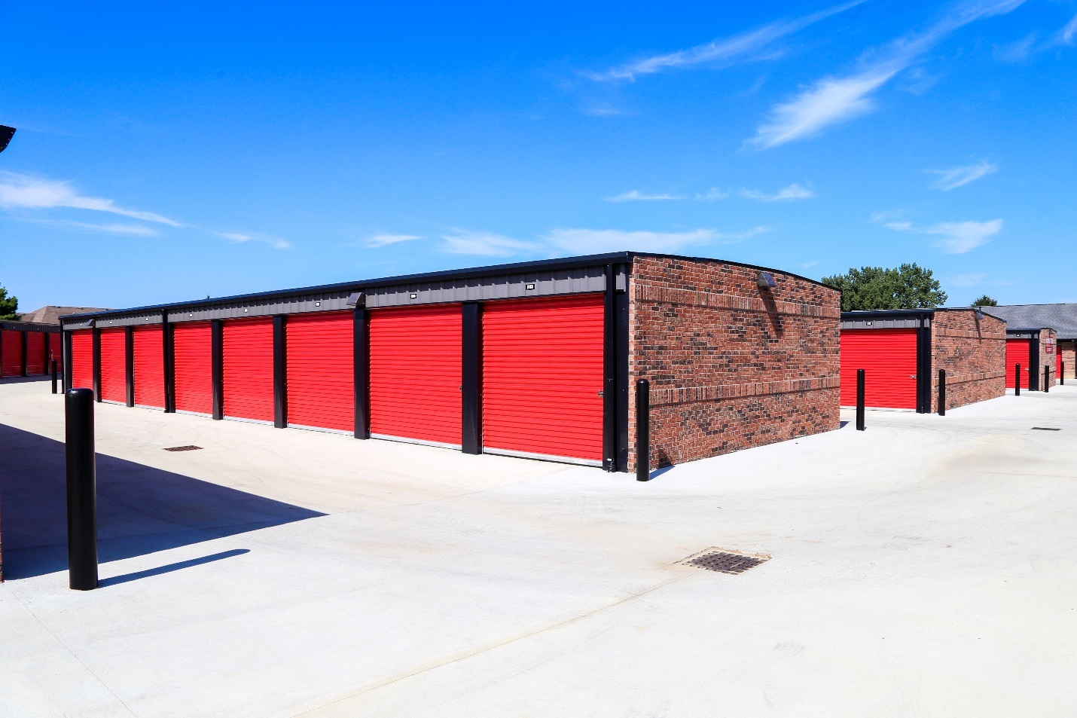

Exterior Buildings

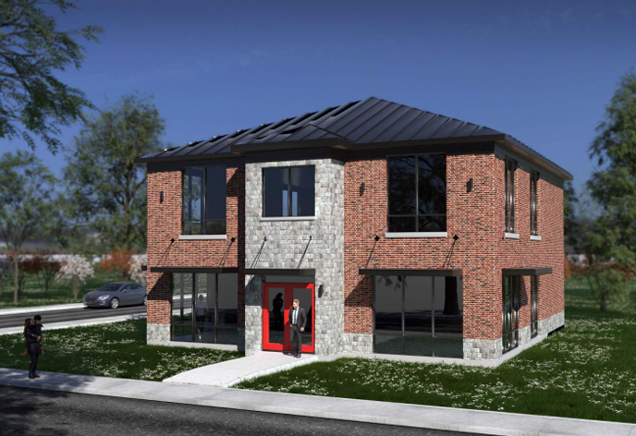

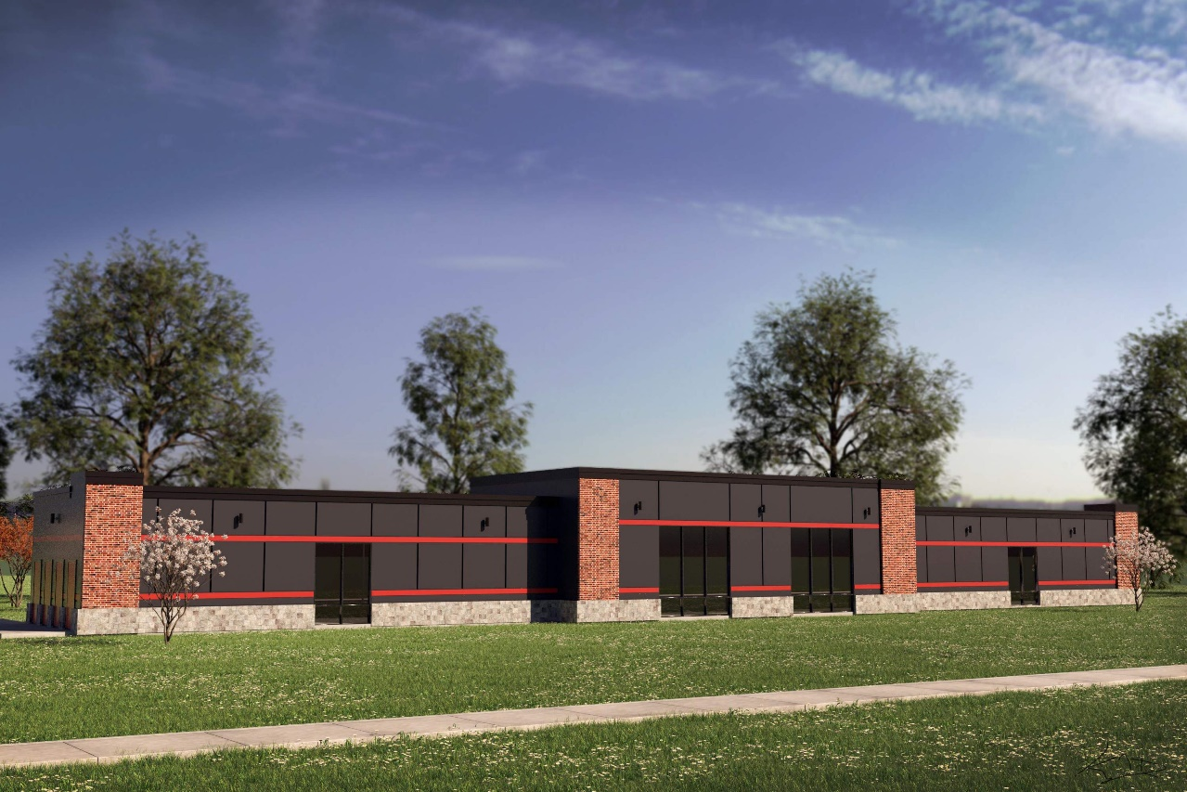
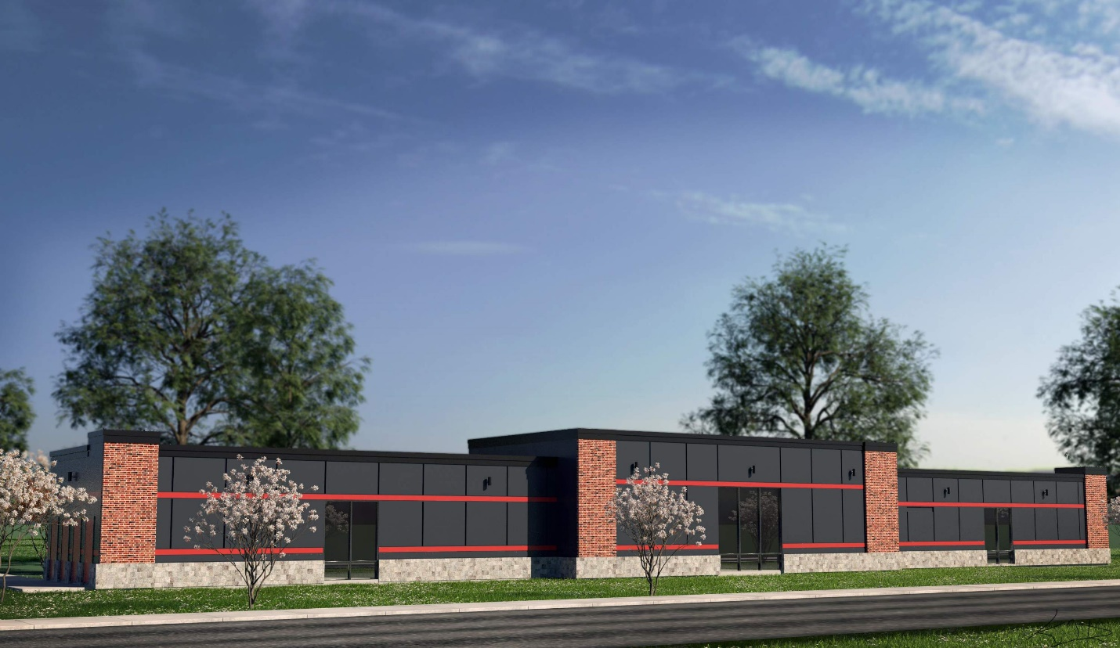
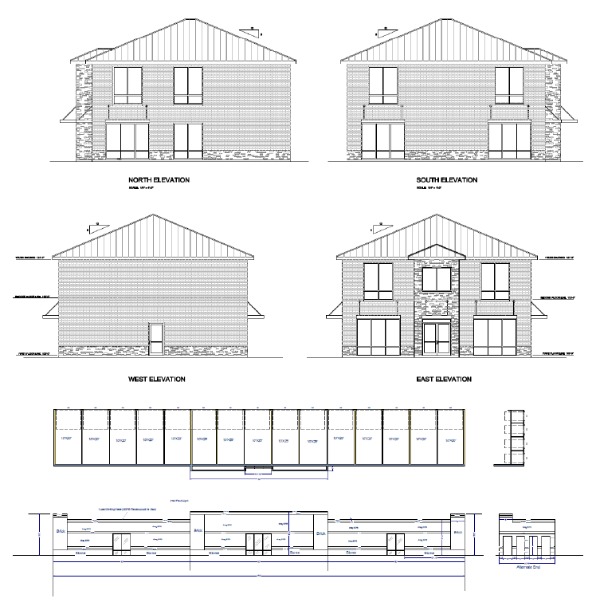

Cornice/Building Cap

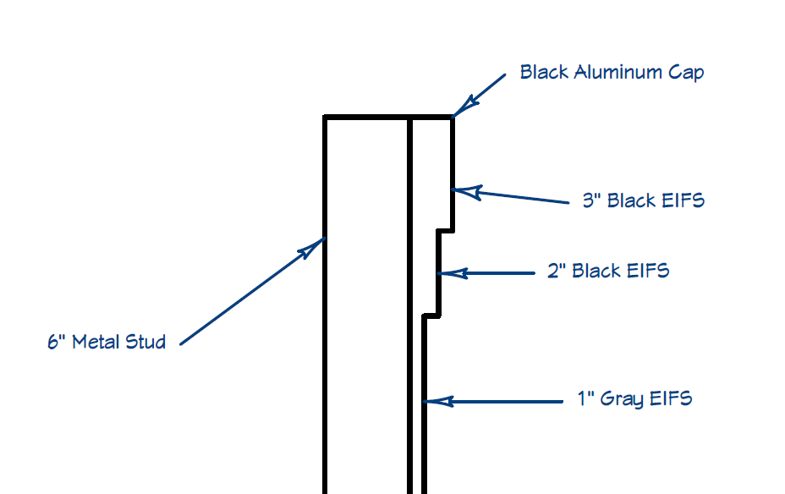

“Exhibit D-5”

Illustrative Architectural Exhibit for District D

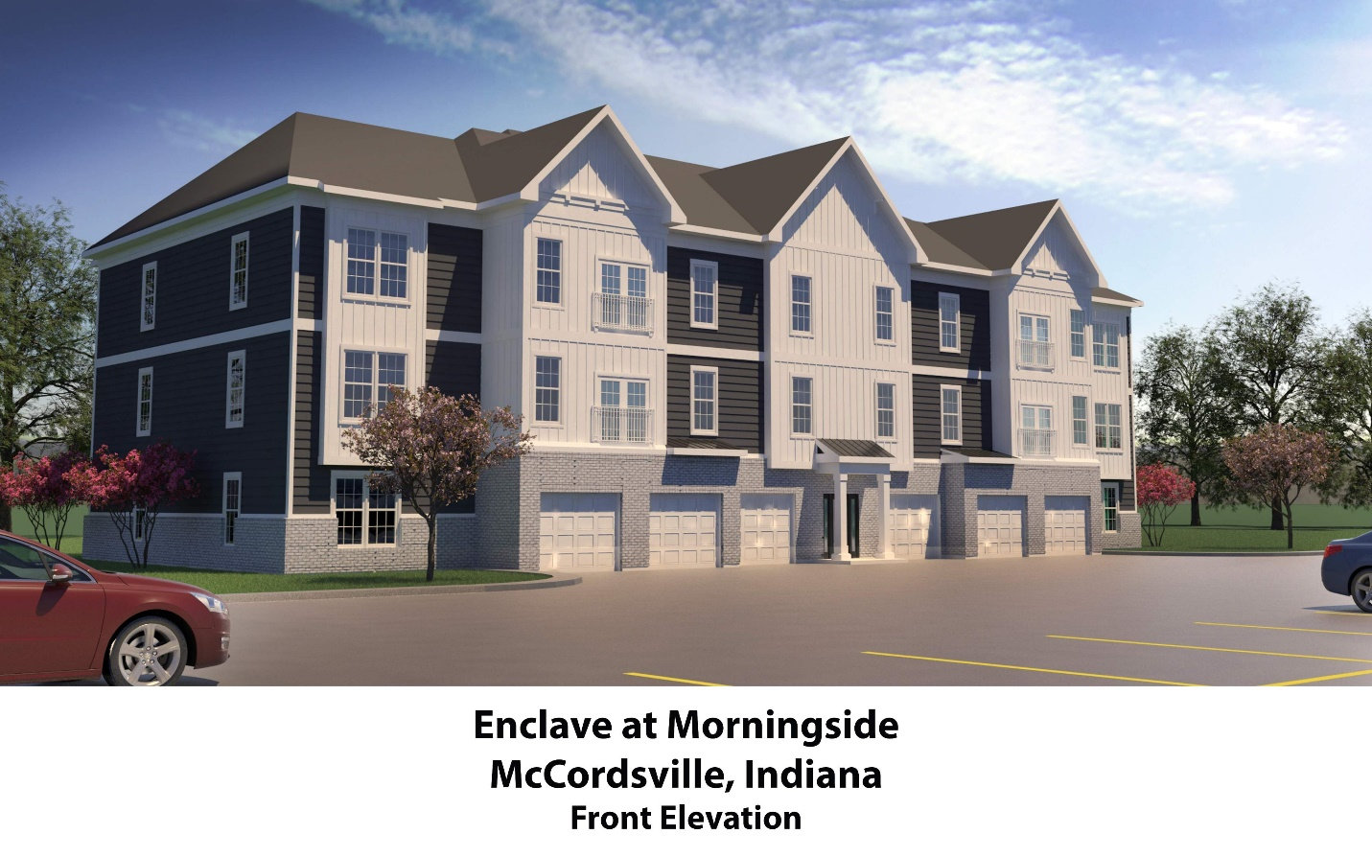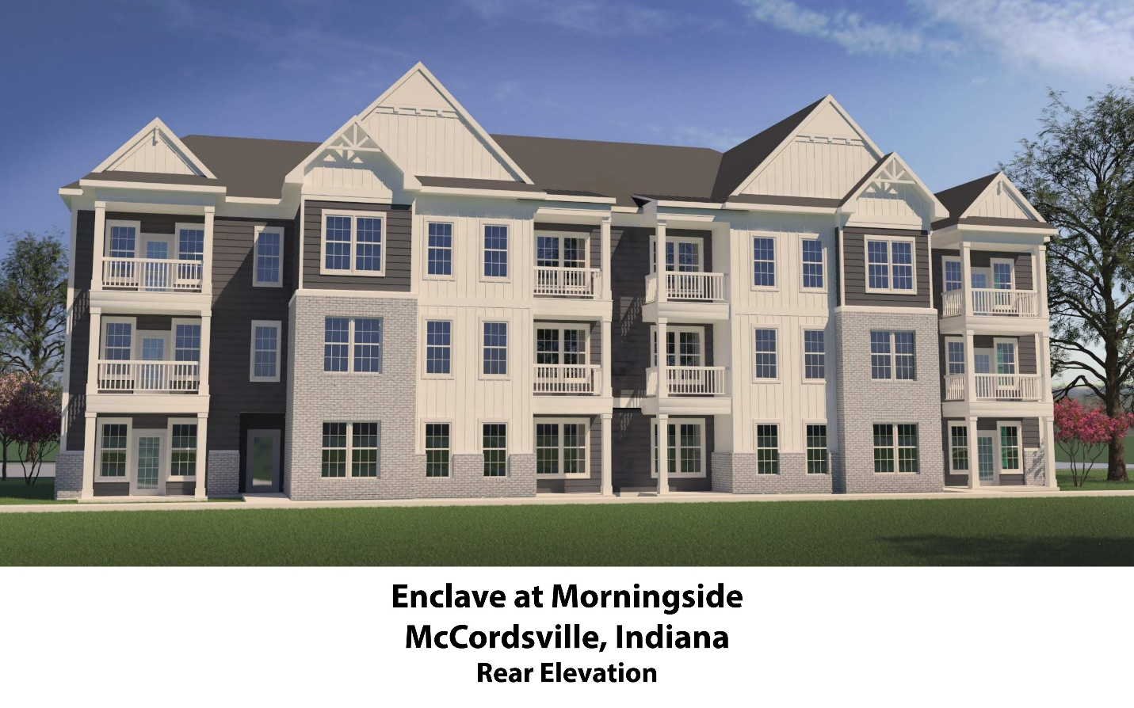

“Exhibit D-6”

High Visibility Lots
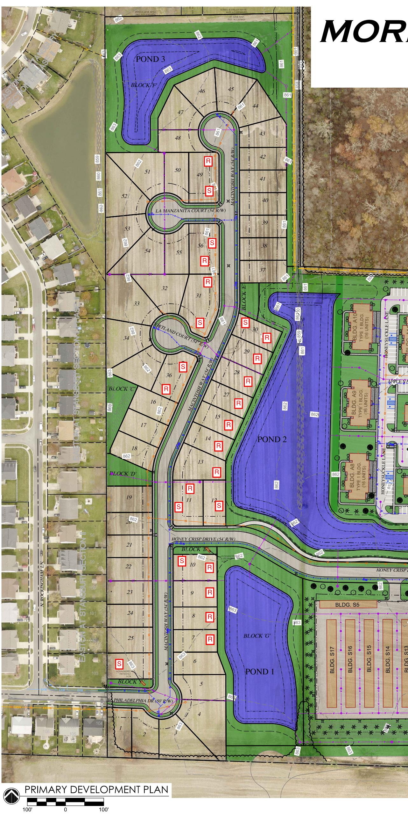

“Exhibit E”

Amenity Features Illustrative Exhibit

District D - Clubhouse

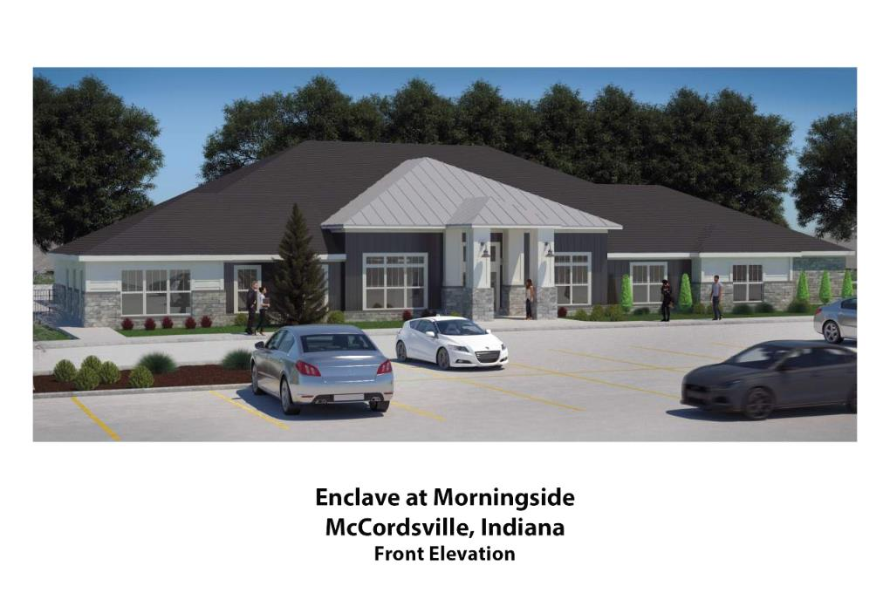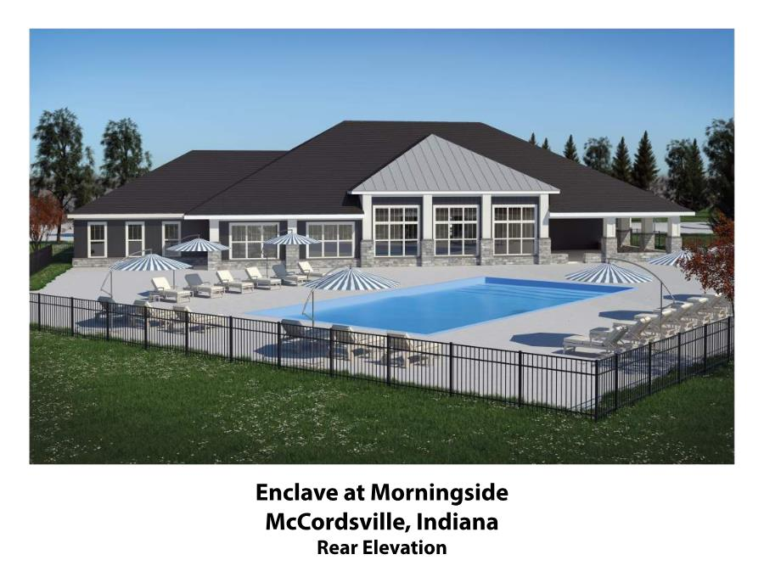

“Exhibit F”

Street Sign Exhibit

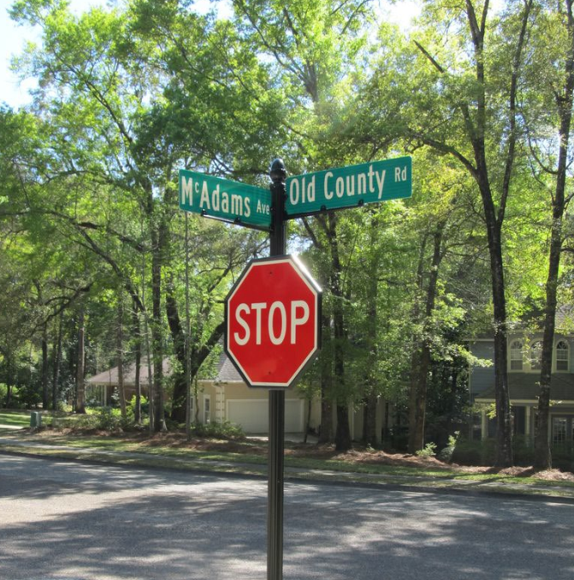

“Exhibit G”

Land Uses
District A
R3, Single Family Residential –low-maintenance single family residential houses with associated amenities include sidewalk, common areas, wet ponds.

District B
CN, Neighborhood Commercial – Intended to accommodate
smaller areas of land suitable for convenience stores, services, and amenities
within close proximity to residential areas. This district should be free of larger
retailers, such as “big box” stores or other regional retail uses with 7,500 or more
square feet in gross floor area, that do not serve the immediate needs of the
neighborhood

District C
Self-storage facility shall be permitted by right. All other uses shall be considered Special Exceptions:

District D
MF-2, Multi-Family Residential – Intended to accommodate multi-tenant apartment homes. Units will vary in size of bedrooms and square footages. Each unit to include a private entrance. Each tenant will have access to apartment complex amenities such as, sidewalks, clubhouse, meeting rooms, pool, dog park, and workout facilities.

“Exhibit H”

Enhanced Parking Lot Landscaping

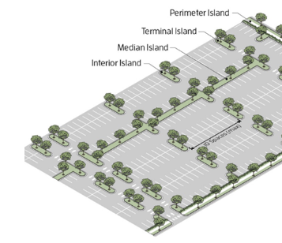

“Exhibit I”

Trash Enclosure Exhibit

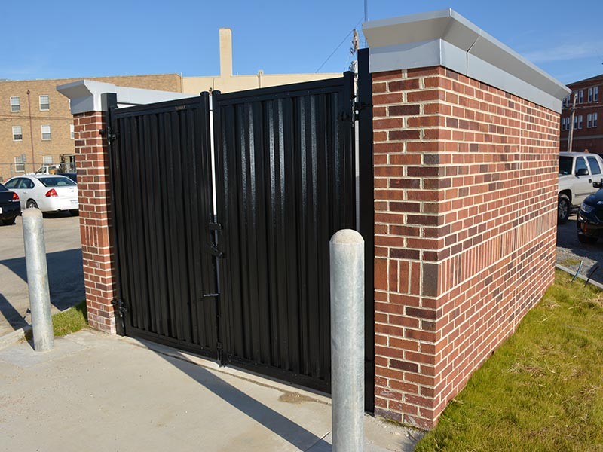

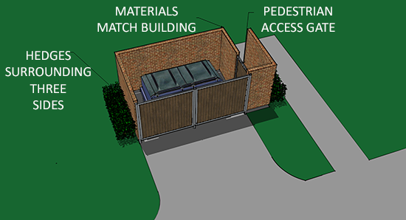

“Exhibit J”

District Legal Descriptions

District A

A PART OF THE NORTHEAST QUARTER OF FRACTIONAL SECTION 1, TOWNSHIP 16 NORTH, RANGE 05 EAST IN BUCK CREEK TOWNSHIP, HANCOCK COUNTY, INDIANA, BEING DESCRIBED AS FOLLOWS:
COMMENCING AT THE SOUTHEAST CORNER OF THE NORTHEAST QUARTER OF SAID SECTION 1, AND RUNNING THENCE NORTH 88 DEGREES 12 MINUTES 12 SECONDS WEST, ON AND ALONG THE SOUTH LINE OF THE NORTHEAST QUARTER, A DISTANCE OF 1555.18 FEET TO THE POINT OF BEGINNING OF THIS DESCRIPTION; THENCE CONTINUING ALONG SAID SOUTH LINE NORTH 88 DEGREES 12 MINUTES 12 SECONDS WEST A DISTANCE OF 311.10 FEET; THENCE NORTH 0 DEGREES 11 MINUTES 22 SECONDS WEST A DISTANCE OF 272.68 FEET; THENCE NORTH 0 DEGREES 12 MINUTES 10 SECONDS WEST A DISTANCE OF 67.23 FEET; THENCE NORTH 0 DEGREES 10 MINUTES 30 SECONDS WEST A DISTANCE OF 60.19 FEET; THENCE NORTH 0 DEGREES 11 MINUTES 22 SECONDS WEST A DISTANCE OF 61.00 FEET; THENCE NORTH 0 DEGREES 11 MINUTES 32 SECONDS WEST A DISTANCE OF 61.00 FEET; THENCE NORTH 0 DEGREES 11 MINUTES 13 SECONDS WEST A DISTANCE OF 59.00 FEET; THENCE NORTH 0 DEGREES 11 MINUTES 22 SECONDS WEST A DISTANCE OF 59.00 FEET; THENCE NORTH 0 DEGREES 12 MINUTES 26 SECONDS WEST A DISTANCE OF 69.00 FEET; THENCE NORTH 0 DEGREES 10 MINUTES 31 SECONDS WEST A DISTANCE OF 85.41 FEET; THENCE NORTH 0 DEGREES 11 MINUTES 22 SECONDS WEST A DISTANCE OF 214.65 FEET; THENCE NORTH 0 DEGREES 13 MINUTES 27 SECONDS WEST A DISTANCE OF 138.79 FEET; THENCE NORTH 0 DEGREES 08 MINUTES 51 SECONDS WEST A DISTANCE OF 114.74 FEET; THENCE NORTH 0 DEGREES 11 MINUTES 22 SECONDS WEST A DISTANCE OF 318.46 FEET; THENCE NORTH 0 DEGREES 10 MINUTES 42 SECONDS WEST A DISTANCE OF 355.10 FEET; THENCE NORTH 88 DEGREES 53 MINUTES 17 SECONDS EAST A DISTANCE OF 509.37 FEET;

THENCE SOUTH 00 DEGREES 10 MINUTES 51 SECONDS EAST A DISTANCE OF 662.27 FEET; THENCE SOUTH 89 DEGREES 48 MINUTES 23 SECONDS WEST A DISTANCE OF 35.00 FEET; THNCE SOUTH 0 DEGREES 10 MINUTES 51 SECONDS EAST A DISTANCE OF 42.99 FEET; THENCE SOUTH 89 DEGREES 48 MINUTES 41 SECONDS WEST A DISTANCE OF 72.99 FEET; THENCE SOUTH 0 DEGREES 11 MINUTES 25 SECONDS WEST A DISTANCE OF 45.23 FEET; THENCE ON AND ALONG A RADIAL CURVE TO THE RIGHT A DISTANCE OF 54.12 FEET, SAID CURVE HAVING A RADIUS OF 227.00 FEET AND AN INTERNAL ANGLE OF 13 DEGREES 39 MINUTES 35 SECONDS; THENCE SOUTH 66 DEGREES 10 MINUTES 14 SECONDS EAST A DISTANCE OF 73.70 FEET; THENCE SOUTH 23 DEGREES 49 MINUTES 46 SECONDS WEST A DISTANCE OF 368.63 FEET; THENCE SOUTH 0 DEGREES 11 MINUTES 28 SECONDS EAST A DISTANCE OF 169.52 FEET; THENCE SOUTH 0 DEGREES 02 MINUTES 17 SECONDS EAST A DISTANCE OF 54.00 FEET; THENCE NORTH 89 DEGREES 48 MINUTES 28 SECONDS EAST A DISTANCE OF 19.86 FEET; THENCE ON AND ALONG A RADIAL CURVE TO THE RIGHT A DISTANCE OF 66.28 FEET, SAID CURVE HAVING A RADIUS OF 123.00 FEET AND AN INTERNAL ANGLE OF 30 DEGREES 52 MINUTES 27 SECONDS; THENCE SOUTH 59 DEGREES 19 MINUTES 05 SECONDS EAST A DISTANCE OF 100.42 FEET; THENCE ON AND ALONG A RADIAL CURVE TO THE LEFT A DISTANCE OF 35.47 FEET, SAID CURVE HAVING A RADIUS OF 177.00 FEET AND AN INTERNAL ANGLE OF 11 DEGREES 28 MINUTES 51 SECONDS; THENCE SOUTH 00 DEGREES 17 MINUTES 27 SECONDS EAST A DISTANCE OF 437.13 FEET; THENCE SOUTH 89 DEGREES 52 MINUTES 37 SECONDS WEST A DISTANCE OF 203.08 FEET; THENCE SOUTH 00 DEGREES 11 MINUTES 28 SECONDS EAST A DISTANCE OF 40.00 FEET TO THE POINT OF BEGINNING OF THIS DESCRIPTION, CONTAINING IN ALL 20.199 ACRES, MORE OR LESS.

District B

A PART OF THE NORTHEAST QUARTER OF FRACTIONAL SECTION 1, TOWNSHIP 16 NORTH, RANGE 05 EAST IN BUCK CREEK TOWNSHIP, HANCOCK COUNTY, INDIANA, BEING DESCRIBED AS FOLLOWS:
COMMENCING AT THE SOUTHEAST CORNER OF THE NORTHEAST QUARTER OF SAID SECTION 1, AND RUNNING THENCE NORTH 00 DEGREES 09 MINUTES 52 SECONDS WEST A DISTANCE OF 111.24 FEET TO A POINT ON THE EAST LINE OF SAID NORTHEAST QUARTER; THENCE SOUTH 89 DEGREES 49 MINUTES 19 SECONDS WEST A DISTANCE OF 207.48 FEET TO THE POINT OF BEGINNING OF THIS DESCRIPTION; THENCE SOUTH 89 DEGREES 49 MINUTES 19 SECONDS WEST A DISTANCE OF 280.28 FEET; THENCE ON AND ALONG A RADIAL CURVE TO THE RIGHT A DISTANCE OF 31.38 FEET, SAID CURVE HAVING A RADIUS OF 20.00 FEET AND AN INTERNAL ANGLE OF 89 DEGREES 53 MINUTES 14 SECONDS; THENCE NORTH 00 DEGREES 17 MINUTES 27 SECONDS WEST A DISTANCE OF 156.21 FEET; THENCE ON AND ALONG A NON-RADIAL CURVE TO THE RIGHT A DISTANCE OF 118.97 FEET, SAID CURVE HAVING A RADIUS OF 122.89 FEET, AN INTERNAL ANGLE OF 55 DEGREES 28 MINUTES 05 SECONDS, AND A BEGINNING RADIAL BEARING OF NORTH 89 DEGREES 40 MINUTES 59 SECONDS EAST; THENCE NORTH 55 DEGREES 07 MINUTES 29 SECONDS EAST A DISTANCE OF 76.82 FEET; THENCE ON AND ALONG A RADIAL CURVE TO THE LEFT A DISTANCE OF 170.80 FEET, SAID CURVE HAVING A RADIUS OF 177.00 FEET AND AN INTERNAL ANGLE OF 55 DEGREES 17 MINUTES 15 SECONDS; THENCE NORTH 00 DEGREES 09 MINUTES 46 SECONDS WEST A DISTANCE OF 626.96 FEET; THENCE ON AND ALONG A RADIAL CURVE TO THE RIGHT A DISTANCE OF 50.62 FEET, SAID CURVE HAVING A RADIUS OF 123.00 FEET AND AN INTERNAL ANGLE OF 23 DEGREES 34 MINUTES 56 SECONDS; THENCE NORTH 23 DEGREES 25 MINUTES 10 SECONDS EAST A DISTANCE OF 55.08 FEET; THENCE SOUTH 87 DEGREES 56 MINUTES 18 SECONDS EAST A DISTANCE OF 156.15 FEET; THENCE ON AND ALONG A NON-RADIAL CURVE TO THE RIGHT A DISTANCE OF 177.49 FEET, SAID CURVE HAVING A RADIUS OF 1356.41 FEET, AN INTERNAL ANGLE OF 7 DEGREES 29 MINUTES 50 SECONDS, AND A BEGINNING RADIAL BEARING OF SOUTH 73 DEGREES 06 MINUTES 06 SECONDS WEST; THENCE SOUTH 06 DEGREES 41 MINUTES 31 SECONDS EAST A DISTANCE OF 128.01 FEET; THENCE ON AND ALONG A NON-RADIAL CURVE TO THE RIGHT A DISTANCE OF 90.55 FEET, SAID CURVE HAVING A RADIUS OF 1356.20 FEET, AN INTERNAL ANGLE OF 3 DEGREES 49 MINUTES 15 SECONDS, AND A BEGINNING RADIAL BEARING OF SOUTH 86 DEGREES 00 MINUTES 53 SECONDS WEST;

THENCE SOUTH 00 DEGREES 09 MINUTES 52 SECONDS EAST, PARALLEL WITH THE EAST LINE OF THE NORTHEAST QUARTER, A DISTANCE OF 709.61 FEET; THENCE SOUTH 38 DEGREES 08 MINUTES 33 SECONDS WEST A DISTANCE OF 77.14 FEET; THENCE SOUTH 73 DEGREES 16 MINUTES 09 SECONDS WEST A DISTANCE OF 93.54 FEET TO THE POINT OF BEGINNING OF THIS DESCRIPTION, CONTAINING IN ALL 7.793 ACRES, MORE OR LESS.

District C

A PART OF THE NORTHEAST QUARTER OF FRACTIONAL SECTION 1, TOWNSHIP 16 NORTH, RANGE 05 EAST IN BUCK CREEK TOWNSHIP, HANCOCK COUNTY, INDIANA, BEING DESCRIBED AS FOLLOWS:
COMMENCING AT THE SOUTHEAST CORNER OF THE NORTHEAST QUARTER OF SAID SECTION 1, AND RUNNING THENCE NORTH 88 DEGREES 12 MINUTES 12 SECONDS WEST, ALONG THE SOUTH LINE OF THE NORTHEAST QUARTER, A DISTANCE OF 1373.91 FEET; THENCE NORTH 00 DEGREES 17 MINUTES 27 SECONDS WEST A DISTANCE OF 46.81 FEET TO THE POINT OF BEGINNING OF THIS DESCRIPTION; THENCE NORTH 00 DEGREES 17 MINUTES 27 SECONDS WEST A DISTANCE OF 437.13 FEET; THENCE ON AND ALONG A NON-RADIAL CURVE TO THE LEFT A DISTANCE OF 56.59 FEET, SAID CURVE HAVING A RADIUS OF 177.00 FEET, A BEGINNING RADIAL BEARING OF NORTH 19 DEGREES 12 MINUTES 04 SECONDS EAST, AND AN INTERNAL ANGLE OF 18 DEGREES 19 MINUTES 04 SECONDS; THENCE SOUTH 89 DEGREES 11 MINUTES 28 SECONDS EAST A DISTANCE OF 664.04 FEET; THENCE ON AND ALONG A NON-RADIAL CURVE TO THE RIGHT A DISTANCE OF 116.55 FEET, SAID CURVE HAVING A RADIUS OF 127.41 FEET, A BEGINNING RADIAL BEARING OF SOUTH 01 DEGREES 45 MINUTES 16 SECONDS WEST, AND AN INTERNAL ANGLE OF 53 DEGREES 24 MINUTES 53 SECONDS; THENCE SOUTH 34 DEGREES 52 MINUTES 32 SECONDS EAST A DISTANCE OF 38.33 FEET; THENCE ON AND ALONG A RADIAL CURVE TO THE RIGHT A DISTANCE OF 15.04 FEET, SAID CURVE HAVING A RADIUS OF 11.00 FEET AND AN INTERNAL ANGLE OF 78 DEGREES 20 MINUTES 20 SECONDS; THENCE ON AND ALONG A RADIAL CURVE TO THE LEFT A DISTANCE OF 135.17 FEET, SAID CURVE HAVING A RADIUS OF 177.00 FEET, A BEGINNING RADIAL BEARING OF SOUTH 46 DEGREES 32 MINUTES 12 SECONDS EAST, AND AN INTERNAL ANGLE OF 43 DEGREES 45 MINUTES 15 SECONDS; THENCE SOUTH 00 DEGREES 17 MINUTES 27 SECONDS EAST A DISTANCE OF 174.63 FEET; THENCE ON AND ALONG A RADIAL CURVE TO THE RIGHT A DISTANCE OF 31.47 FEET, SAID CURVE HAVING A RADIUS OF 20.00 FEET AND AN INTERNAL ANGLE OF 90 DEGREES 10 MINUTES 04 SECONDS; THENCE SOUTH 89 DEGREES 52 MINUTES 37 SECONDS WEST A DISTANCE OF 769.47 FEET TO THE POINT OF BEGINNING OF THIS DESCRIPTION, CONTAINING IN ALL 7.730 ACRES, MORE OR LESS.

District D

A PART OF THE NORTHEAST QUARTER OF FRACTIONAL SECTION 1, TOWNSHIP 16 NORTH, RANGE 05 EAST IN BUCK CREEK TOWNSHIP, HANCOCK COUNTY, INDIANA, BEING DESCRIBED AS FOLLOWS:
COMMENCING AT THE SOUTHEAST CORNER OF THE NORTHEAST QUARTER OF SAID SECTION 1, AND RUNNING THENCE NORTH 00 DEGREES 09 MINUTES 52 SECONDS WEST A DISTANCE OF 1293.55 FEET; THENCE NORTH 87 DEGREES 56 MINUTES 26 SECONDS WEST A DISTANCE OF 341.66 FEET TO THE POINT OF BEGINNING OF THIS DECRIPTION; THENCE SOUTH 23 DEGREES 25 MINUTES 10 SECONDS WEST A DISTANCE OF 33.96 FEET; THENCE ON AND ALONG A RADIAL CURVE TO THE LEFT A DISTANCE OF 72.85 FEET, SAID CURVE HAVING A RADIUS OF 177.00 FEET AND AN INTERNAL ANGLE OF 23 DEGREES 34 MINUTES 56 SECONDS; THENCE SOUTH 00 DEGREES 09 MINUTES 46 SECONDS EAST A DISTANCE OF 626.96 FEET; THENCE ON AND ALONG A RADIAL CURVE TO THE RIGHT A DISTANCE OF 118.69 FEET, SAID CURVE HAVING A RADIUS OF 123.00 FEET AND AN INTERNAL ANGLE OF 55 DEGREES 17 MINUTES 15 SECONDS; THENCE SOUTH 55 DEGREES 07 MINUTES 29 SECONDS WEST A DISTANCE OF 38.82 FEET; THENCE ON AND ALONG A RADIAL CURVE TO THE RIGHT A DISTANCE OF 17.28 FEET, SAID CURVE HAVING A RADIUS OF 11.00 FEET AND AN INTERNAL ANGLE OF 89 DEGREES 59 MINUTES 59 SECONDS; THENCE NORTH 34 DEGREES 52 MINUTES 32 SECONDS WEST A DISTANCE OF 34.65 FEET; THENCE ON AND ALONG A NON-RADIAL CURVE TO THE LEFT A DISTANCE OF 166.92 FEET, SAID CURVE HAVING A RADIUS OF 181.41 FEET, A BEGINNING RADIAL BEARING OF SOUTH 55 DEGREES 03 MINUTES 30 SECONDS WEST, AND AN INTERNAL ANGLE OF 53 DEGREES 23 MINUTES 34 SECONDS; THENCE NORTH 89 DEGREES 11 MINUTES 28 SECONDS WEST A DISTANCE OF 664.62 FEET; THENCE ON AND ALONG A RADIAL CURVE TO THE RIGHT A DISTANCE OF 63.95 FEET, SAID CURVE HAVING A RADIUS OF 122.28 FEET AND AN INTERNAL ANGLE OF 29 DEGREES 57 MINUTES 45 SECONDS; THENCE NORTH 59 DEGREES 19 MINUTES 05 SECONDS WEST A DISTANCE OF 100.42 FEET; THENCE ON AND ALONG A RADIAL CURVE TO THE LEFT A DISTANCE OF 95.38 FEET, SAID CURVE HAVING A RADIUS OF 177.00 FEET AND AN INTERNAL ANGLE OF 30 DEGREES 52 MINUTES 27 SECONDS; THENCE SOUTH 89 DEGREES 48 MINUTES 21 SECONDS WEST A DISTANCE OF 19.72 FEET; THENCE NORTH 00 DEGREES 11 MINUTES 28 SECONDS WEST A DISTANCE OF 169.52 FEET; THENCE NORTH 23 DEGREES 49 MINUTES 46 SECONDS EAST A DISTANCE OF 368.63 FEET; THENCE NORTH 66 DEGREES 10 MINUTES 14 SECONDS WEST A DISTANCE OF 73.70 FEET; THENCE ON AND ALONG A CURVE TO THE LEFT A DISTANCE OF 54.12 FEET, SAID CURVE HAVING A RADIUS OF 227.00 FEET, A BEGINNING RADIAL BEARING OF NORTH 76 DEGREES 31 MINUTES 50 SECONDS WEST, AND AN INTERNAL ANGLE OF 13 DEGREES 39 MINUTES 35 SECONDS; THENCE NORTH 00 DEGREES 11 MINUTES 25 SECONDS WEST A DISTANCE OF 45.23 FEET; THENCE NORTH 89 DEGREES 48 MINUTES 41 SECONDS EAST A DISTANCE OF 72.99 FEET; THENCE NORTH 0 DEGREES 10 MINUTES 51 SECONDS WEST A DISTANCE OF 42.99 FEET; THENCE NORTH 89 DEGREES 48 MINUTES 23 SECONDS EAST A DISTANCE OF 35.00 FEET; THENCE SOUTH 87 DEGREES 56 MINUTES 26 SECONDS EAST A DISTANCE OF 1015.84 FEET TO THE POINT OF BEGINNING OF THIS DESCRIPTION, CONTAINING IN ALL 19.684 ACRES, MORE OR LESS.

