ORDINANCE NO. 061025B

ORDINANCE AMENDING ORDINANCE NO. 121410, THE ZONING ORDINANCE FOR THE TOWN OF MCCORDSVILLE, INDIANA

WHEREAS, the Town Council of the Town of McCordsville, Indiana, has heretofore adopted Ordinance No. 121410 as the Zoning Ordinance; and

WHEREAS, the Town Council of McCordsville, Indiana has, after a public hearing was held on May 20, 2025, received a favorable recommendation from the McCordsville Advisory Plan Commission requesting an amendment to the Zoning Ordinance in order to adopt the Stonechase Planned-Unit Development (PUD) Ordinance.

THEREFORE, BE IT ORDAINED by the Town Council of the Town of McCordsville, Indiana that Ordinance No. 121410 is hereby amended as follows:

Section 1. The real estate more particularly described in the attached “Exhibit A” (the “Real Estate”) is hereby zoned to the PUD designation. The Development and Architectural standards set forth in this Ordinance shall govern the development of the Real Estate, and these standards shall replace all other standards set forth in the Town of McCordsville Zoning and Subdivision Control Ordinances, as amended. Where this Ordinance is silent regarding standards, the standards from the McCordsville Zoning and Subdivision Control Ordinances, dated January 2011, as amended, shall apply.

Section 2. Intent. The Stonechase PUD provides strict design requirements which are compiled with the intent to produce a quality neighborhood.

Section 3. Permitted Uses. The permitted uses, as defined by the McCordsville Zoning and Subdivision Control Ordinances, for the Real Estate are described below, all uses not listed below, shall be considered prohibited.

Permitted Primary Uses:
Single-family residential dwellings
Permitted Accessory Uses, Incidental Uses, and Structures: Those permitted pursuant to the Town Zoning Ordinance

Permitted Temporary Uses:
Those permitted pursuant to the Town’s Zoning Ordinance

Section 4. Development Standards. The development shall comply with the Preliminary Planned Unit Development Plan/Concept Plan attached hereto as “Exhibit B”. All development shall comply with the following standards:

Development Standards – 80s

  - Maximum Number of Lots 49
  - Minimum Lot Area 11,200 square feet
  - Minimum Lot Width at Building Line 80 feet
  - Minimum Setbacks:
    - Front-yard Setback 30 feet
    - Side-yard Setback 5 feet
    - Rear-yard Setback 15 feet
  - Minimum Livable Floor Area (Dwelling Unit)
    - 1,750 Square Feet - may not exceed 25% of the total lots.
    - 2,000 Square Feet – remaining lots
  - Maximum Height-Principal 35 feet
  - Maximum Dwelling Units per Lot 1
  - Maximum Lot Coverage 55%
  - Minimum Lot Depth 130

Development Standards – 65s
  - Maximum Number of Lots 119
  - Minimum Lot Area 9,100 Square Feet
  - Minimum Lot Width at Building Line 65 feet
  - Minimum Setbacks:
    - Front-yard Setback 30 feet
    - Side-yard Setback 5 feet
    - Rear-yard Setback 15 feet
  - Minimum Livable Floor Area (Dwelling Unit) 1,500 Square Feet
  - Maximum Height-Principal 35 feet
  - Maximum Dwelling Units per Lot 1
  - Maximum Lot Coverage 55%
  - Minimum Lot Depth 130
  - Single Story Restriction
The Stonechase PUD will provide a minimum of approximately 25% open space as generally shown in the Concept Plan. Drainage facilities shall be permitted as part of the open space calculation. The gross density of the Stonechase PUD will not exceed 2.15 units per acre.

Architectural Standards:
The Architectural Standards for the Real Estate are attached as “Exhibit C”.

Landscaping Standards:

  - The developer shall establish an aesthetic landscape buffer along the frontage of County Road North 500 West. Said buffer shall consist of the following per 100 feet of frontage:
    - Three (3) evergreen trees averaging 5-6 feet in height.
    - Three (3) ornamental tree with a minimum 2” caliper.
    - Three (3) deciduous shade tree with a minimum 2” caliper.
    - Ten (10) shrubs with minimum height of twenty-four (24) inches at time of planting.
  - A minimum 4’ tall undulating mounding will be installed along County Road North 500 West.
  - Street trees shall be planted along the entrance drive in a minimum ten (10) foot wide planting strip between sidewalk and back-of-curb. Such trees shall be planted every fifty (50) feet on center.
  - A median shall be installed for the length of the entrance drive. The median planting bed shall be a minimum of ten (10) feet wide.
  - There shall be a minimum of a twenty (20) foot wide common area between the sidewalk and lots along the entrance drive to create the space for a grand entrance. This area shall be landscaped.
  - A tree conservation area shall be described over the existing woods on the plat.
  - A ten (10) foot wide landscaping easement shall be established along the northern property line. Said easement shall consist of the following per 100 feet:
    - Two (2) evergreen trees averaging 5-6 feet in height.
    - Two (2) deciduous shade trees with a minimum 2” caliper.

Pedestrian Accessibility:

Standards of the Town’s Zoning and Subdivision Control Ordinance regarding Pedestrian Accessibility shall be applicable to the Real Estate with the following exceptions:
  - A ten (10) foot wide perimeter multi-use asphalt path or a five (5) foot wide sidewalk shall be installed along CR N 500 W for the width of the frontage of the Real Estate. The Town will make a determination of sidewalk or path at the time of the Development Plan.
  - Notwithstanding the requirements above, any path which is located back-of-curb, without a grass strip between the pedestrian facility and the curb, shall be concrete.
  - All truncated domes shall be black in color.
  - An internal trail system shall be provided as generally shown on the Concept Plan. Such paths shall be paved and a minimum of eight (8) feet wide. The path through the woods may be gravel.

- Community Amenities

In addition to the open space and trail network, Stonechase shall also include the following amenity features as described below in illustrative examples attached as “Exhibit D”:

- Playground structure
- Putting green
- Seating Pavilion Area

Lighting, Parking, and Signage:

Standards of the Town’s Zoning and Subdivision Control Ordinance regarding Lighting, Parking, and Signage shall be applicable to the Real Estate with the following exceptions:
  - Entry Features: All subdivision entry signage, along CR 500 W, shall include the language "of McCordsville".
  - Secondary Entry Monument: A secondary entry monument may be erected at the entrance from Gatherings at Aurora subdivision. This monument is limited to a maximum height of six (6) feet and a maximum width and depth of four (4) feet by four (4) feet. Such a monument may include signage, up to six (6) square feet, but shall not be illuminated.
  - All street lighting shall be full cut-off fixtures, and meet all other requirements of the Town’s streetlight standards.
  - Temporary Ground Signs along the perimeter road (as defined in Title XV: Land Usage, Section 154.145 of the Town of McCordsville Code of Ordinances) will be permitted until the last building permit is approved in Stonechase.
  - A total of 6 Temporary Ground Signs will be permitted internally within the development as directional signs to model homes.

Roadway:

Standards of the Town’s Zoning and Subdivision Control Ordinance regarding Streets, Roadways, and Right-of-way shall be applicable to the Real Estate with the following exceptions:
  - Rights-of-way (ROW) shall be dedicated to the Town as denoted below:
    - Minimum half-width ROW of forty-six (46) feet on County Road North 500 West.
  - The Town shall not be responsible for any maintenance or repairs on any alley, nor any roadway which is not built to town standards and/or not dedicated and accepted as public right of way. The Town shall not be responsible for any maintenance on any landscaping, fencing, or signage located in public right-of-way.
  - The following traffic improvements shall be constructed on County Road North 500 West:
    - Acceleration and deceleration lanes, in conformance with town standards, at all access points into the development from any local-collector, collector, and/or arterial roadway.
    - Passing blisters or left-turn lanes, in conformance with town standards, at all access points as required by the Town Engineer.
    - Developer agrees to widen County Road North 500 West along the entire frontage of the development to include a 12’ lane and 2’ stone shoulder on the southbound (west) lane of County Road North 500 West.
  - Street name signage and traffic control signage shall be installed consistent with the quality and character shown on Exhibit “E”.
  - No separation of driveways from intersections are required when lot is across from a 3- way intersection.
  - The developer agrees to pay any future Road Impact Fees adopted and effective at the time of any building permit(s) are issued.

Miscellaneous

  - Developer commits to creating a professional owner’s association. The owner’s association may hire a professional manager to manage the HOA and maintain the common area
  - All driveways shall be concrete.
  - Lots marked with a “*” on the Concept Plan shall be restricted to a single-story floorplan.
  - Subject to compliance with all federal and state laws, dwellings in the Stonechase PUD shall be sold and not leased or rented from the builder to the initial purchaser.
  - No home shall be rented for a period of at least twenty-four (24) months from the date of the last sale or transaction. This language shall also be added to the HOA Covenants and Declarations.
  - A neighborhood playground, putting green and covered seating area shall be provided.
  - Model Home: A model home will be constructed in the development. The model home shall be one (1) of the three (3) largest models offered by the builder at the time the model permit is issued. If the builder elects to build more than one (1) model, this requirement shall only apply to one (1) model per product type. Snow Removal: The HOA for the development shall be responsible for snow removal of all internal streets.
  - A eight (8) inch yellow thermoplastic stripe shall be placed on the top of the curb adjacent to any fire hydrant within the subdivision. This stripe shall extend ten (10) feet out from the hydrant in both directions.
  - All wet detention facilities shall feature an illuminated fountain.
  - Privacy fences shall be prohibited. All fencing shall not be closer to the street than the rear corner of the home.
  - Airport Noise: The developer shall disclose to purchasers of lots, prior to closing, that the Real Estate experiences or may experience levels of aircraft noise and other effects that certain individuals may find objectionable. In addition, the following language, or alternative language, if agreed to between the developer and the Indianapolis Airport Authority, shall be included on all Primary and Secondary Plats within the Real Estate and in the neighborhoods Covenants. "GRANTOR (Land owner / Developer) HEREBY DISCLOSES TO GRANTEE (Purchaser of the Lot), GRANTEE'S HEIRS, SUCCESSOR­ IN-INTEREST, AND ASSIGNS THAT THE ABOVE-DESCRIBED REAL ESTATE EXPERIENCES OR MAY EXPERIENCE LEVELS OF AIRCRAFT NOISE AND OTHER EFFECTS THAT CERTAIN INDIVIDUALS MAY FIND OBJECTIONABLE AND THAT GRANTEE IS PURCHASING THE ABOVE-DESCRIBED REAL ESTATE WITH FULL KNOWLEDGE AND ACCEPTANCE OF THIS NOISE DISCLOSURE STATEMENT AND ALL SUCH OTHER EFFECTS RESULTING FROM AIRCRAFT OPERATIONS AND RELEASES THE INDIANAPOLIS AIRPORT AUTHORITY THEREFROM."
  - The developer shall disclose to purchasers of lots, prior to closing, that the Real Estate experiences or may experience activities of an agricultural nature that certain individuals may find objectionable. In addition, the following language shall be included on all Primary and Secondary Plats within the Real Estate and in the neighborhoods Covenants. “The owner of the herein described real estate, for himself, and for all future owners and occupants of said real estate, or any parcel or division thereof, for and in consideration of the right to develop the real estate for other than agricultural uses, hereby:
- Acknowledges and agrees that the real estate is adjacent to an area zoned or used for agricultural purposes, which uses include but are not limited to:
    - Production of crops;
    - Animal husbandry;
    - Land application of animal waste;
    - Raising, breeding and sale of livestock and poultry;
    - Use of farm machinery; and/or
    - The sale of farm products.
- Understands and agrees that the agricultural uses identified herein may be protected under the Indiana Right to Farm Act and may not qualify as a nuisance due to noise, smell, etc. The landowner is assuming that risk by purchasing/occupying land near property zoned and used for agricultural purposes.
- Agrees that this covenant is for the benefit of the Town of McCordsville, Indiana, and for all persons engaged in agricultural uses within one mile of any boundary of the real estate and is enforceable by any of the foregoing.

Definitions:
  - Minimum Home Size: total square feet of a unit, excluding garages, rear porches, front porches, and any decks, patios, or balconies.
  - Stone: shall not be interpreted to include concrete masonry units (CMU).

Section 6. This Ordinance shall remain in full force and effect from and after its passage and posting as required by the law within the Town of McCordsville, Indiana.
Section 7. Duly ordained and passed this day of , 2025 by the Town Council of the Town of McCordsville, Hancock County, Indiana, having been passed by a vote of in favor and opposed.

TOWN OF McCORDSVILLE, INDIANA, BY ITS TOWN COUNCIL:

Voting Affirmative: Voting Opposed:

Gregory J. Brewer Gregory J. Brewer

Scott Jones Scott Jones

John Price John Price

Dr. Bryan Burney Dr. Bryan Burney

Chad Gooding Chad Gooding ATTEST:

Stephanie Crider, Clerk-Treasurer

“Exhibit A” LEGAL DESCRIPTION

Parcel 1: The undivided West Half of the South Half of the Northwest Quarter of Section 31, Township 17 North, Range 6 East in Hancock County, Indiana, containing 40 acres, more or less. Parcel 2: Also, commencing at a point on the South line of the Northeast Quarter of Section 36, Township 17 North, Range 5 East in Hancock County, Indiana, 80 rods East of the Southwest corner thereof, thence North parallel with the West line thereof 78 rods and 1 1/4 links; thence East parallel with the South line thereof 82 rods to the East line of said Northeast Quarter; thence South on said East line 78 rods and 1/4 links to the Southeast corner thereof, thence West on said South line 82 rods to the place of beginning, containing 40 acres, more or less. Consisting in all 80 acres, more or less.

“Exhibit B” Concept Plan
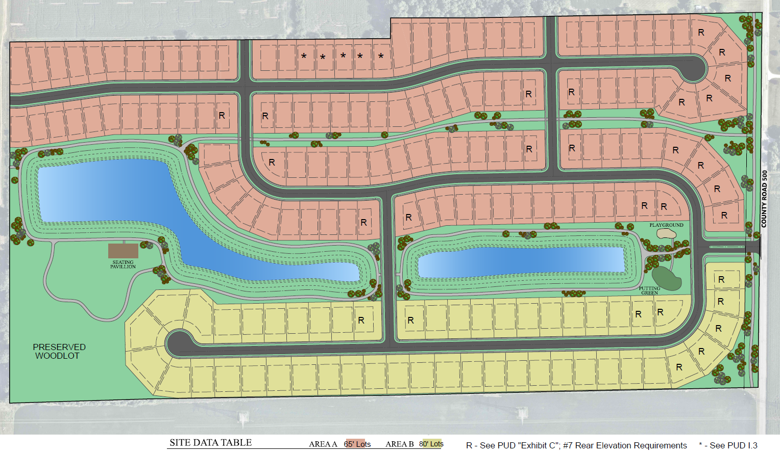

“Exhibit C”

Architectural Standards

All primary structures constructed on the Real Estate shall have the following minimum standards:

- Exterior siding materials are limited to brick, stone (CMU prohibited), glass, wood, LP siding/manufactured wood and fiber cement. Vinyl siding is prohibited.
- Satellite dishes shall not be visible from the front elevation of the home.
- Window A/C units and the like are prohibited.
- The heavier material shall always be used below a lighter material.
- Article VI, Section 6.04 (A)(3)(c - e) of the Town of McCordsville Zoning Ordinance shall not apply to this development. A minimum of fifty percent (50%) of the homes shall have a front elevation of at least fifty percent (50%) brick or stone, exclusive of windows, doors, garage doors, and areas above a roof line. The remaining homes may have less than fifty percent (50%) brick or stone provided they contain a minimum of a brick or stone wainscot that is the lesser of 30" high or to the lowest first floor windowsill height and include at least two (2) other siding materials on the front elevation. Return walls along the front elevation shall include brick or stone consistent with the brick or stone on the front elevation. For example, a recessed front door creates return walls that should carry the materials on the front elevation.
- Corner lots shall have a minimum brick/stone wainscot on all facades. Side elevations facing a street shall also include at least two (2) materials or siding colors, unless said side elevation of the home features either a hip gable and/or a full first floor masonry wrap. This standard shall also apply to lots only separates from the street by a common area.
- Lots marked with a “R” on the Concept Plan shall feature one of the following on the rear elevation: (a) a covered porch (columns a minimum of 6” X 6”(nominal), (b) a screened-in porch, (c) a first floor brick wrap, or (d) a wall plane break of at least 2 feet in depth for a length of at least 10 feet.
- The permitted roofing materials are dimensional shingles, copper, slate, and stone. High quality, standing seam metal roofing is only permitted as an accent roofing material, as determined and approved by the McCordsville ARC.
- Roof Pitch: The primary roof pitch shall be 6:12 or greater. Ancillary roofs may be less than 6:12 if approved by the ARC.
- A minimum of a 24 square foot front covered porch is required on all homes.
- Exhaust vents shall not be visible from the front elevation of a home. Additionally, no wall-mounted vent or louver shall be located on the first floor of a front elevation (excluding gable areas).
- Overhangs are required along all facades. No overhang shall extend less than eleven (11) inches from the exterior façade where the façade consists of siding at the eaves, and a minimum of eight (8) inches from the exterior façade where the façade consists of brick or stone at the eaves.
- Except for large picture windows, casement windows and small accent windows, which do not open, all windows on a façade facing a public street shall have shutters, mullions, or window grids.
- Unless adjacent to masonry, all windows and openings shall have a nominal 1-inch by 6-inch (1"x 6") wood or vinyl surround.
- All ranch homes shall contain a minimum of three (3) windows on the front facade, and one (1) window on the side facades and two (2) windows on the rear facades, with the exception of a side facade facing a public street which shall contain a minimum of two (2) windows. All two-story homes shall contain a minimum of four (4) windows on the front facade and shall contain a minimum of two (2) windows on each side and rear facades with the exception of a side facade facing a public street which shall contain a minimum of three (3) windows.
- The front elevation of all homes must have at least one point of wall plane articulation of at least two (2) feet in depth and a gable.
- All garage doors shall be decorative garage doors that include one of the following elements; 1. Windows, 2. Decorative garage door hardware.
- All homes shall contain a minimum of a two-car garage with a minimum square footage of 440 sq ft.
- Any three-car garage shall have one bay separated from the others and be recessed or projected a minimum of two (2) feet. This point of articulation shall not be counted towards the required front elevation articulation required.
- Any front-loading garage that protrudes eight (8) feet or more in front of the front elevation shall features at least one (1) window on the house side elevation of the garage. This window shall not count towards any other window requirement. No front-loading garage shall protrude more than ten (10) feet in front of the front elevation. Garage protrusion shall be measured by determining the distance from the farthest protruding front façade of the garage and the widest portion of the front façade of the front elevation. Any front-loading garage that protrudes a minimum of eight (8) feet in front of the front elevation shall feature a minimum of eight (8) shrubs along the foundation of the side elevation (nearest the side-yard property line) of the garage. The ARC may approve an architectural feature in lieu of the window.
- Any side-load, courtyard-load, or rear-load garage shall feature a minimum of two (2) windows in the garage façade facing the street. These windows shall not count towards any other window requirement.

- For front-loading garages, the garage doors shall not comprise greater than 51% of the width of the front elevation for a home with a 2-car garage. The garage door width of a 3- car garage shall not comprise greater than 58% of the width of the front elevation.
- All porch columns shall be a minimum of eight (8) inches by eight (8) inches (nominal), unless otherwise approved by the ARC.
- All homes shall feature a covered entry.
- Elevation Approval: The Town's Architectural Review Committee ("ARC"), the ARC reviewed and approved a set of home plan elevations that are on file with the Town's Planning and Building Department (the "Approved Elevations"). The Approved Elevations are hereby incorporated as Exhibit C-1, and while they must meet the standards of the PUD, are approved by the ARC. Homes in the "Approved Elevations" do not need further review by the ARC except for anti-monotony purposes.
  - All homes not included in the “Approved Elevations” shall comply with the standards set forth in Exhibit C of this Ordinance and shall be substantially similar in quality and character to the homes in the “Approved Elevations”. The Director of Planning and Building (“Director”), including his or her designees, shall review home elevations at the time of filing for a building permit for compliance. Such homes shall be approved by the ARC.
  - If a proposed home does not comply with Exhibit C of this Ordinance, then the proposed home may be submitted for review by the ARC. The ARC may approve an elevation if it is determined the elevation is similar in quality and character to the homes in the “Approved Elevations” and is consistent with the spirit and intent of the PUD, as determined by the ARC.
- A single Dwelling Elevation shall not be repeated unless it is separated by at least three (3) different front Elevations along either side of the same street frontage. There shall not be more than ten (10%) percent of the Dwellings with the same front Elevation within the Development. The ARC has the right to consider elevations, with different names, as like­ elevations if they appear similar, which for the purpose of anti-monotony shall be considered the same elevation.
- Lot and foundation plantings shall comply with the Town of McCordsville Zoning Ordinance.
- Basements will be offered in all lots so long as soils are suitable.

“Exhibit C-2” Illustrative Architectural Renderings for 65’ Lots
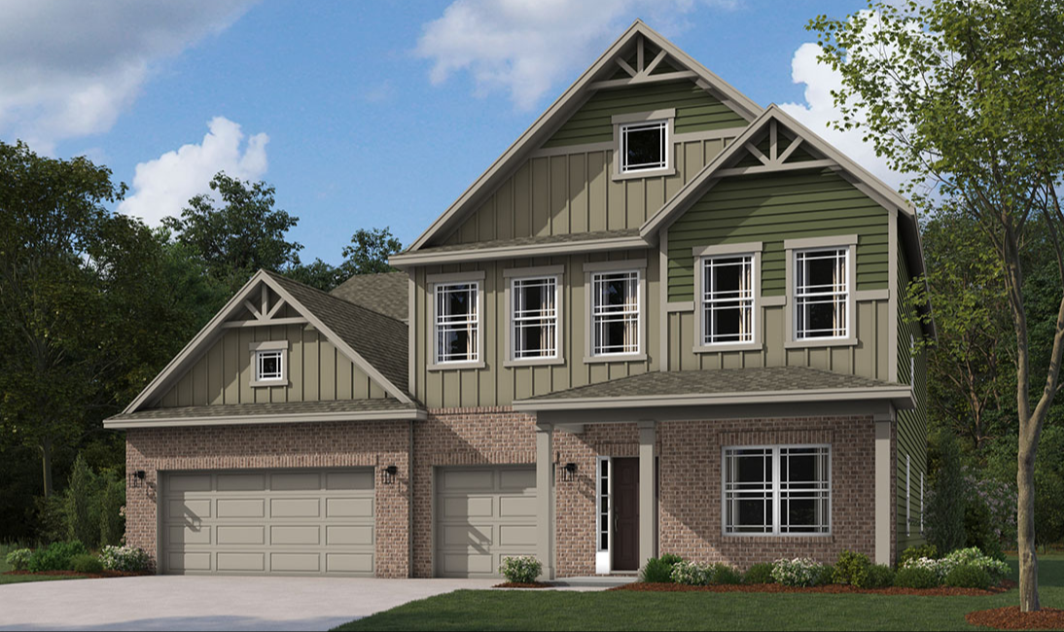

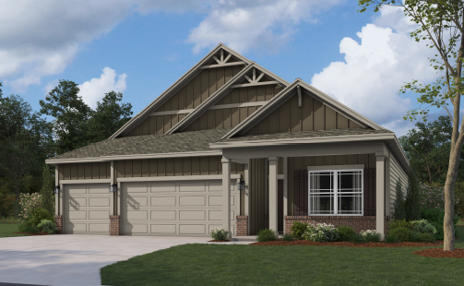
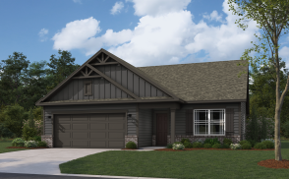

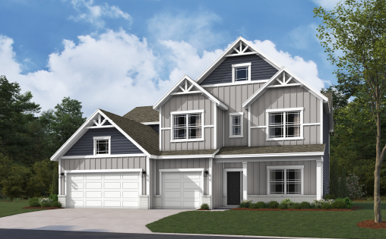

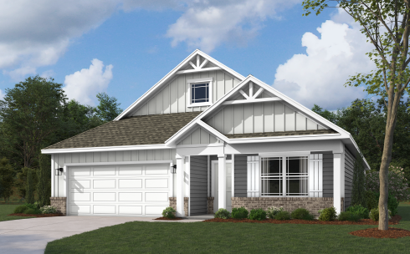

“Exhibit C-3” Illustrative Architectural
Renderings for 80’ Lots

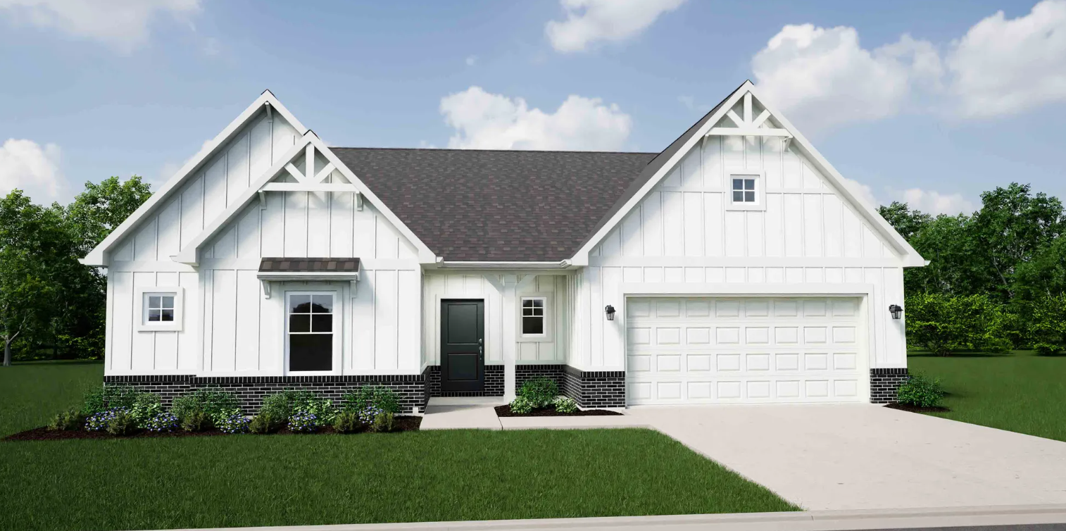

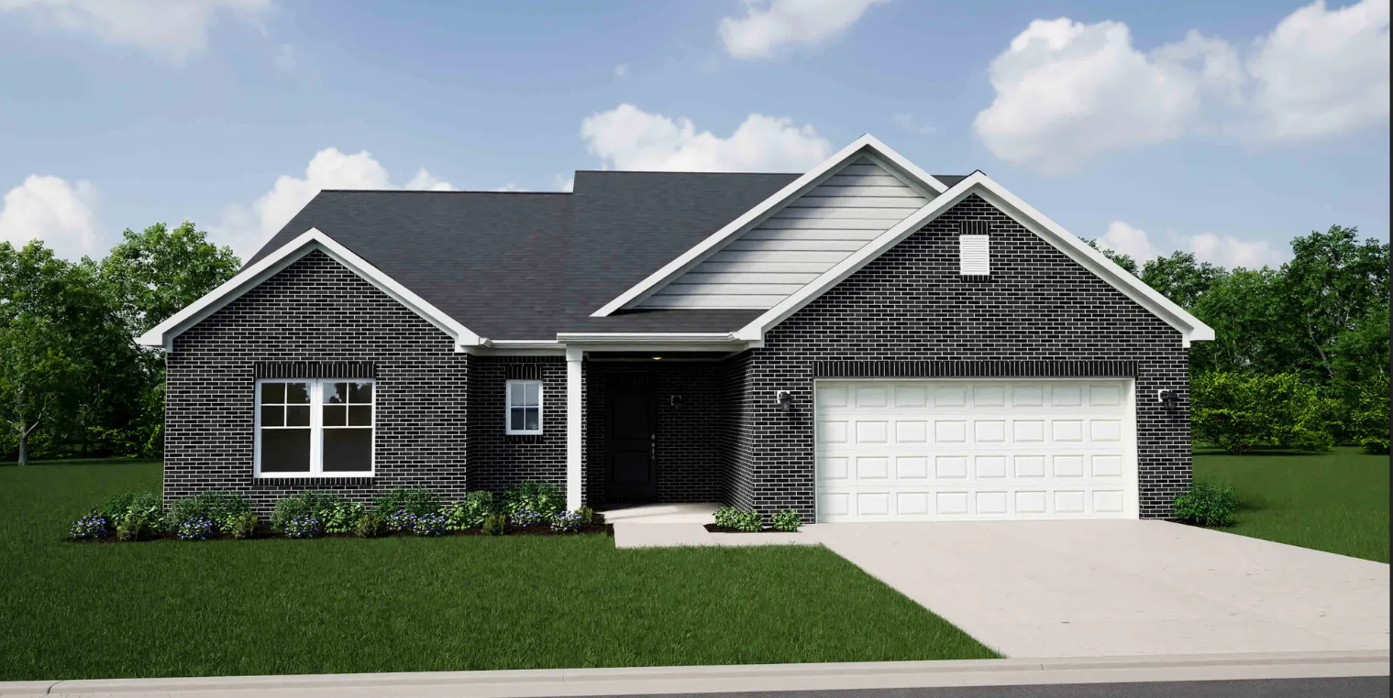

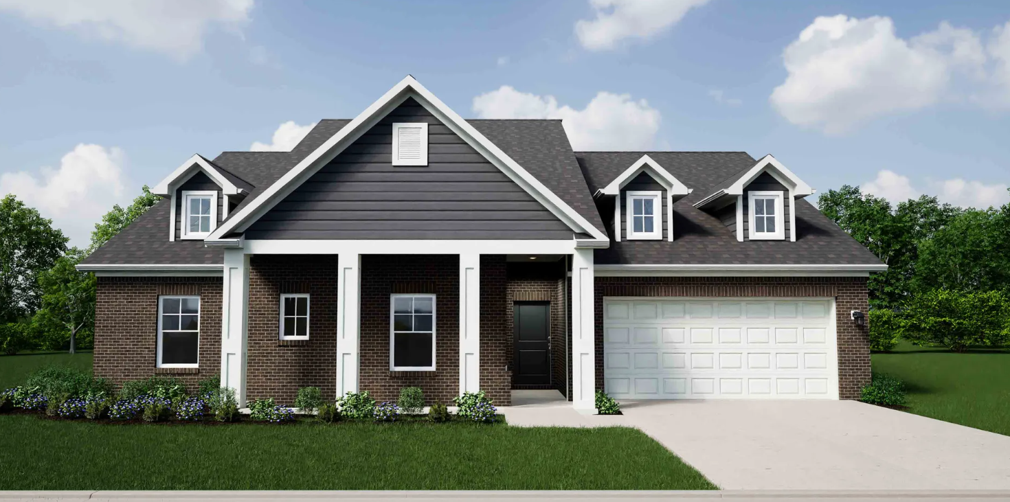

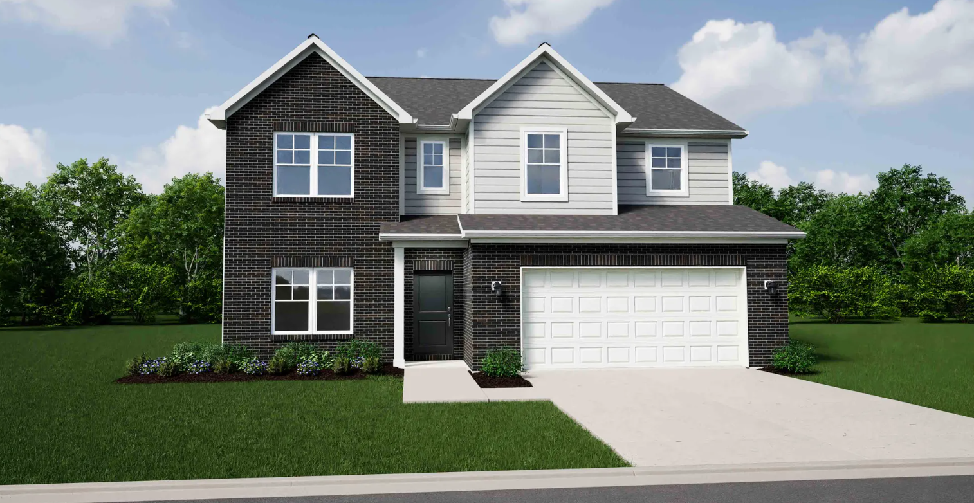

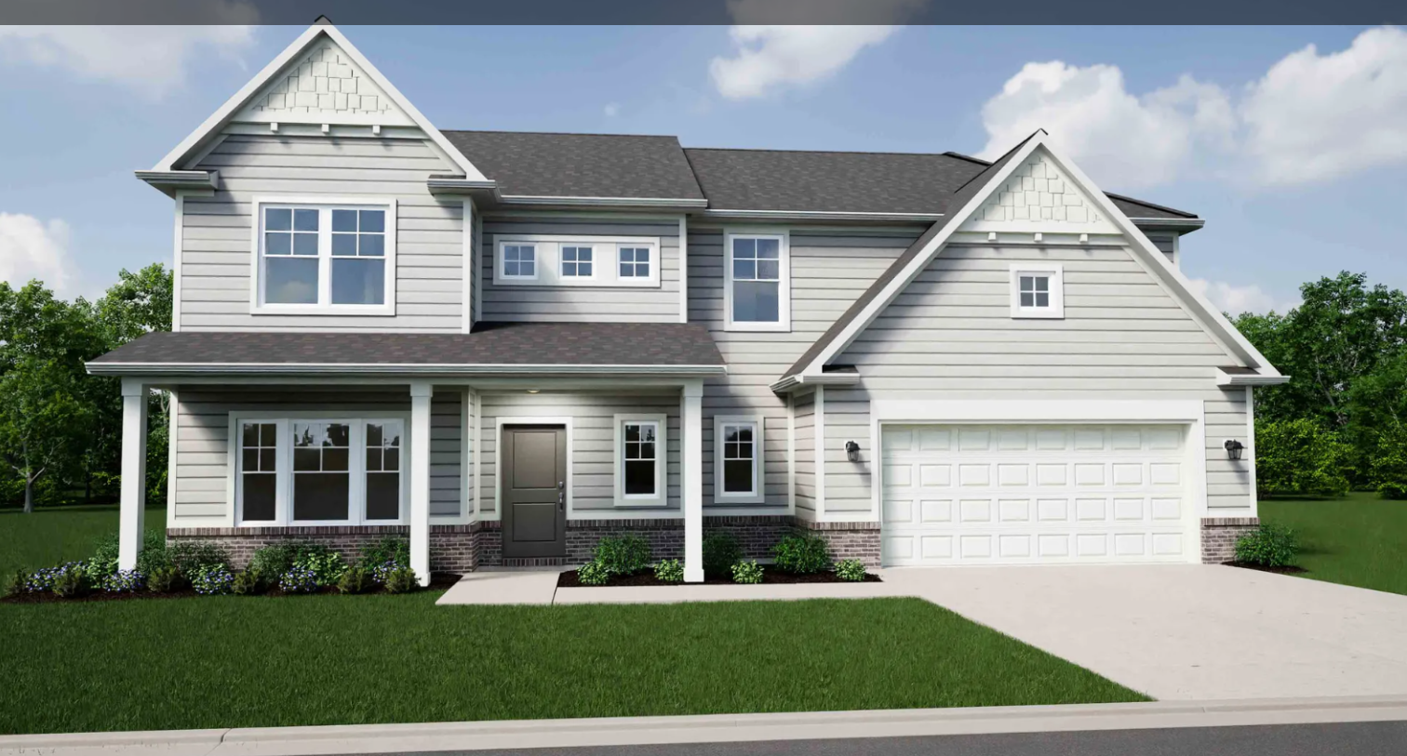

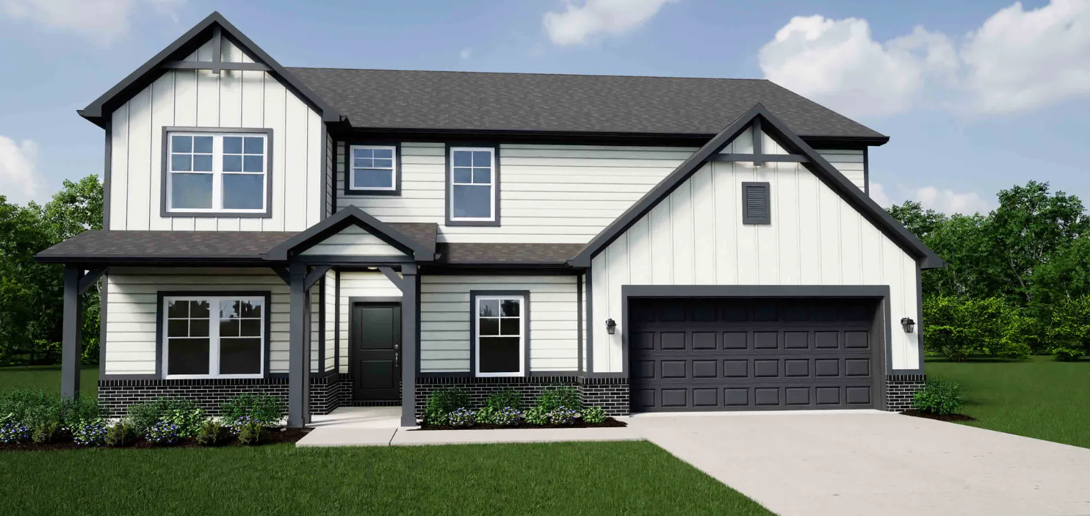

“Exhibit D”

Illustrative Community Amenities

Putting Green

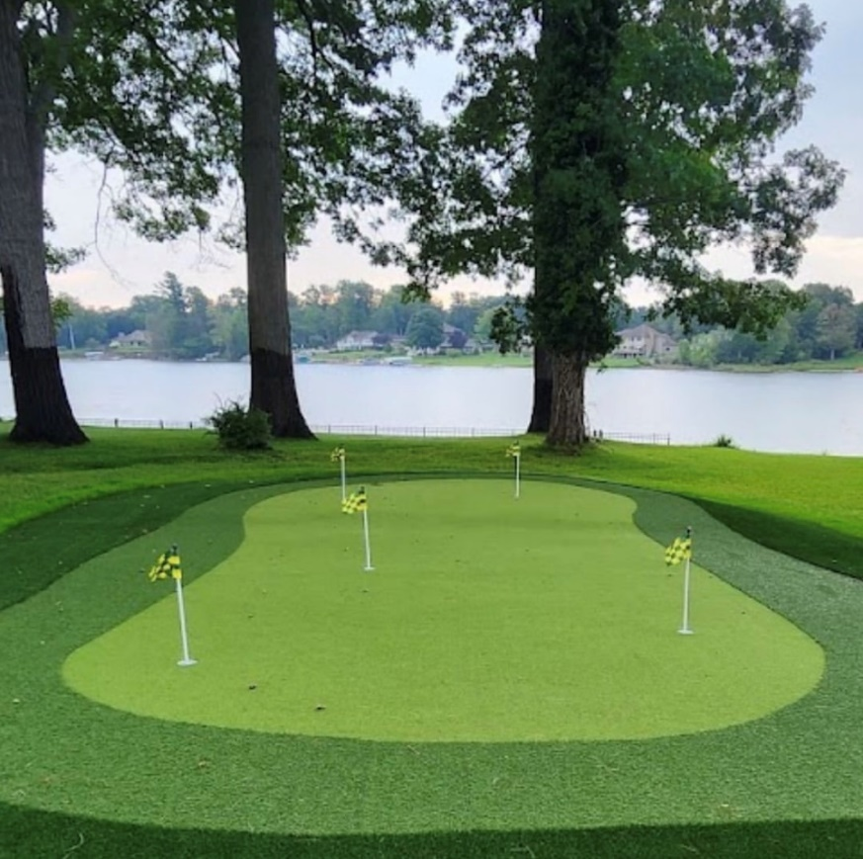

Playground

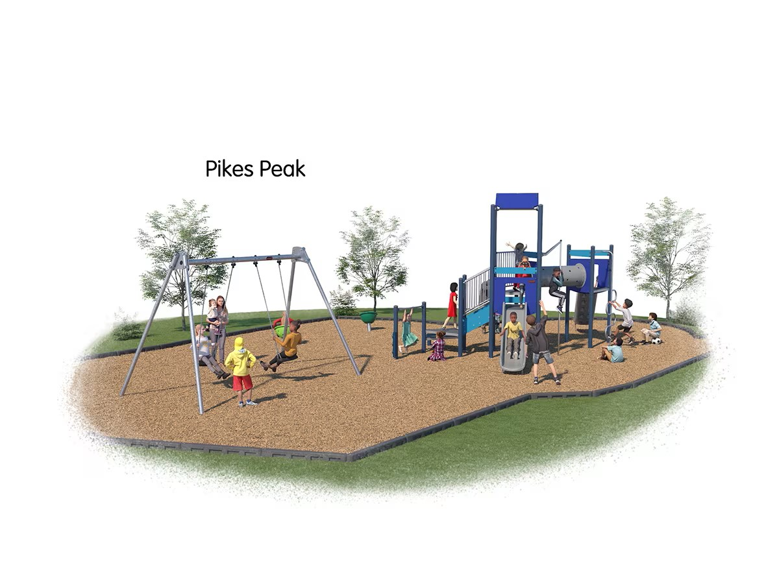

Seating Pavilion

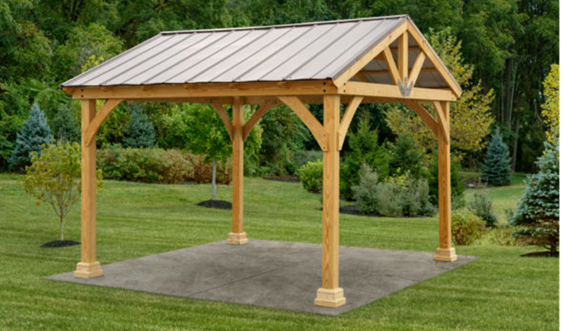

“Exhibit E”

Street Name & Traffic Control Signage Exhibit
