ORDINANCE NO. 021324A

ORDINANCE AMENDING ORDINANCE NO. 121410, THE ZONING ORDINANCE
FOR THE TOWN OF MCCORDSVILLE, INDIANA

WHEREAS, the Town Council of the Town of McCordsville, Indiana, has heretofore adopted Ordinance No. 121410 as the Zoning Ordinance; and

WHEREAS, the Town Council of McCordsville, Indiana has, after a public hearing was held on January 16, 2024, received a favorable recommendation from the McCordsville Advisory Plan Commission requesting an amendment to the Zoning Ordinance in order to adopt the Green Touch Planned-Unit Development (PUD) Ordinance.

THEREFORE, BE IT ORDAINED by the Town Council of the Town of McCordsville, Indiana that Ordinance No. 121410 is hereby amended as follows:

Section 1. The real estate more particularly described in the attached “Exhibit A” (the “Real Estate”) is hereby zoned to the PUD designation. The Development and Architectural standards set forth in this Ordinance shall govern the development of the Real Estate, and these standards shall replace like standards set forth in the Town of McCordsville Zoning and Subdivision Control Ordinances, as amended. Where this Ordinance is silent regarding standards, the standards from the McCordsville Zoning and Subdivision Control Ordinances, dated January 2011, as amended, shall apply.

Section 2. Definitions. Capitalized terms not defined in this PUD Ordinance shall have the meaning ascribed to them in the Town of McCordsville Zoning Ordinance.

- Stone: shall not be interpreted to include concrete masonry units (CMU).
- Dwelling, Second Floor/Upper Level: Separate and complete dwelling unit(s) that is contained on the second floor, or floor(s) above, the first floor. For the purposes of this land use definition, the first-floor uses shall not be residential.
- Family: One or more persons occupying a dwelling unit as a single housekeeping unit and therefore using common facilities for cooking, sanitation, and gathering. A family does not include any society, club, fraternity, sorority; or group living in a boarding house, hotel, motel, bed and breakfast facility, lodging house, rooming house, or club; or any individuals who are in a group living arrangement as a result of criminal activity.

Section 3. Permitted Uses. The permitted uses, as defined by the McCordsville Zoning and Subdivision Control Ordinances, for the Real Estate are described below, all uses not listed below, shall be considered prohibited.

Permitted Primary Uses for Lot 1:
Dwelling, Single-family

Permitted Primary Uses for Lot 2:
Contractor, Commercial
Dwelling, Second Floor/Upper Level
Professional Office

Permitted Accessory Uses, Incidental Uses, and Structures:
Those permitted pursuant to the Town Ordinance

Permitted Temporary Uses:
Those permitted pursuant to the Town’s Zoning Ordinance

Section 4. Development Standards. The Green Touch development shall comply with the following standards:

- The Development Standards

- Maximum Number of Lots 2
- Minimum Lot Area 0.70 acre
- Minimum Lot Width
- a. Mixed-use/Commercial 150 feet
- b. Single-family Dwelling 15 feet
- Minimum Front Yard Setback
  - Mixed-use/Commercial (Depot St) 15 feet
  - Mixed-use Commercial (Railroad St) 10 feet
  - Single-family dwelling 20 feet
- Minimum Side Yard Setback (East Perimeter) 10 feet
- Minimum Side Yard Setback (North Perimeter) 25 feet*
- Minimum Side Yard Setback (West Perimeter) 25 feet
- Minimum Side Yard Setback (between Lots) 10 feet
- Minimum Second Floor/Upper Level
Dwelling Unit Size (Livable Area) 700 square Feet
- Maximum Lot Coverage
  - Mixed-use/Commercial 65%
  - Single-family dwelling 45%
- Maximum Height-Principal
  - Mixed-use/Commercial 45 feet
  - Single-family dwelling 35 feet
- Maximum Commercial Floor Area 4,500 square feet
- Maximum No. of Second Floor/Upper Level
Dwelling Units 4
- Maximum No. of Single-family Dwelling
Units 1
- Maximum No. of Accessory Structures per Lot 1**
*This setback may include trail and trail easement.
**For the purposes of this requirement, future trash enclosures and existing accessory structures shall not count towards the limitation.

- Architectural Standards:

The Architectural Standards for the Real Estate are attached as “Exhibit C”.

- Landscaping Standards:

Standards of the Town’s Zoning and Subdivision Control Ordinance regarding Landscaping shall be applicable to the Real Estate with the following exceptions:

- A perimeter landscape area shall be provided along the rights-of-way as further described below.
- The perimeter landscape areas along Depot Street and S. Railroad Street shall be a minimum of fifteen (15) feet in width, and feature one (1) deciduous canopy tree, with a min. 2” caliper, every fifty (50) feet on center.
- The perimeter landscape area along the north property line (as depicted on Exhibit B) shall be minimum of fifteen (15) feet in width and feature a staggered row of evergreen trees (min. 6’ tall at planting) planted every twenty (20) lineal feet on center. A trash enclosure shall be permitted to extend into the perimeter landscape area by a maximum of five (5) feet. Such an enclosure shall meet the Town’s trash receptacle enclosure planting requirements. A trail easement may be permitted to overlap this landscape area by a maximum of five (5) feet.
- The perimeter landscape area along the east property line shall feature a minimum of one (1) deciduous canopy tree, with a min. 2” caliper, every fifty (50) feet on center. Existing canopy trees conserved within or adjacent to the legal drain easement may count towards this requirement. This requirement is subject to approval by the County Surveyor’s Office and/or County Drainage Board.
- Perimeter Parking Lot Plantings: All off-street parking lots shall feature planting as further described below:
  - Trees: All parking lots shall feature one (1) tree per fifty (50) lineal feet of parking lot perimeter.
  - Shrubs: Shrubs shall be planted at a rate of one (1) shrub for every three (3) feet of parking lot perimeter. A minimum of fifty (50) percent of shrubs shall be evergreen. All species selected shall grow to a minimum height of three (3) feet and shall be at least eighteen inches (18”) tall at time of planting. Shrubs shall be planting in a natural pattern as opposed to a straight line. Plantings shall not be required along the banks of the proposed detention basin where adjacent to an internal drive aisle or parking; however, the plantings along the south edge of the two (2) parking spaces south of the detention area shall be extended along the south edge of the detention area to its east top of bank contour.
  - Where perimeter parking lot landscape areas are adjacent to Depot Street or N. Railroad Street, the perimeter parking lot tree planting shall not be required.
- Internal Parking Lot Plantings: Islands, bump-outs, and/or peninsulas shall be located as shown on the Concept Plan. Each island, bump-out, and/or peninsula shall feature one (1) tree, and ground cover, grass, and/or mulch. Trees may be exchanged for shrubs if utilities prevent tree placement.
- Buffer-yards: Section 6.11(A)(2) shall not apply, and therefore buffer-yards are not required.

- Pedestrian Accessibility:

Standards of the Town’s Zoning and Subdivision Control Ordinance regarding Pedestrian Accessibility shall be applicable to the Real Estate with the following exceptions:

  - Minimum five (5) foot wide concrete sidewalks shall be provided along Depot Street and S. Railroad Street.
  - A connector sidewalk, a minimum of five (5) foot wide, shall be provided from the perimeter sidewalk to the foundation sidewalk.
  - Foundation and internal sidewalks shall be provided in general conformance with the Concept Plan.
  - All truncated domes shall be black in color.
  - A trail easement, a minimum of fifteen (15) feet in width, shall be dedicated to the Town of McCordsville, along the northern property line, as generally depicted on the Concept Plan.

- Lighting, Parking, and Signage:

Standards of the Town’s Zoning and Subdivision Control Ordinance regarding Lighting, Parking, and Signage shall be applicable to the Real Estate with the following exceptions:

- A streetlight, within the right-of-way, shall be provided at the intersection of Depot Street and S. Railroad Street. This light shall be the same streetlight used in McCord Square and consistent with Exhibit D.
- The existing utility pole mounted lighting, adjacent to the Real Estate, shall be removed.
- All lighting fixtures and poles within the Real Estate shall be complimentary in style and compatible with the architecture of the building. In addition, all fixtures shall comply with the following:
  - Comply with the lighting requirements of the Zoning Ordinance
  - Black in color.
  - Full cut off, exceptions: architectural accent lighting
  - LED lighting
  - Light color: 4000k
  - No lighting shall be so intense or brilliant, or projected in a way that it impairs the vision of drivers or pedestrians.
  - All free-standing lighting is limited to a luminaire height of no greater than twenty (20) feet from grade.
  - Shields and other measures to restrict and/or limit backlight, uplight, and/or glare may be required by the Plan Commission.
- All standard parking spaces shall utilize white striping.
- The minimum width of a two-way, internal, drive aisle shall be twenty (20) feet.
- The existing on-street parking along Depot Street and S. Railroad Street shall be removed and shall not be permitted to be re-installed. The gravel area shall be restored to turf grass.
- Parking spaces shall not be used for display or storage of merchandise or services.
- Commercial vehicles that cannot fit within a standard parking space shall not be located on-site.
- The minimum number of parking spaces shall be thirty-five (35).

- Roadway:

Standards of the Town’s Zoning and Subdivision Control Ordinance regarding Streets, Roadways, and Right-of-way shall be applicable to the Real Estate with the following exceptions:

- Rights-of-way shall be dedicated to the Town as denoted below:
  - Depot Street: 27.5’ (half-width)
  - S. Railroad Street: 27.5’ (half-width)
- The Town shall not be responsible for any maintenance or repairs on any alley, nor any roadway which is not built to town standards and/or not dedicated and accepted as public right-of-way.
- The location of all entrances, drives, and driveways shall be per the Town of McCordsville, as determined by the Town Engineer.

- Miscellaneous

- Section 4.17 shall not apply to the Real Estate.
- Kiosks and vending machines are not permitted unless they are located within a building. Examples of such items are beverage/snack machines, photo booths, automated machines, video games, inanimate figures (such as animals, mannequins, or the like), animated characters and other such machines that are internally or externally illuminated, or have moving parts, or make noise, or have flashing lights. Open-air enclosures shall not be considered as being located within a building.
- Outdoor storage of materials, merchandise and the like is prohibited.
- The Mt. Comfort Road and Broadway Overlay (MCR-OL) shall not apply.
- The occupant load of any dwelling unit shall comply with the occupancy requirements of the State of Indiana Building Code.
- The renting of individual rooms, or any portion of the dwelling unit, but not the entirety of the dwelling unit is prohibited. This shall also apply to sub-leases.

Section 5. This Ordinance shall remain in full force and effect from and after its passage and posting as required by the law within the Town of McCordsville, Indiana.

Section 6. Introduced and filed on the 13th day of February, 2024. A motion to consider on the first reading on the day of introduction was offered and sustained by a vote of _ in favor and _ opposed pursuant to I.C. 36-5-2-9.8.

Duly ordained and passed this ___ day of _________, 2024 by the Town Council of the Town of McCordsville, Hancock County, Indiana, having been passed by a vote of _ in favor and _ opposed.

TOWN OF McCORDSVILLE, INDIANA, BY ITS TOWN COUNCIL:

Voting Affirmative: Voting Opposed:

____________________________________
Gregory J. Brewer Gregory J. Brewer

____________________________________
Scott Jones Scott Jones

____________________________________
Bryan Burney Bryan Burney

____________________________________
Chad Gooding Chad Gooding

____________________________________
John Price John Price

ATTEST:

_________________________________
Stephanie Crider, Clerk-Treasurer

I affirm, under the penalties for perjury, that I have taken reasonable care to redact each Social Security number in this document, unless required by law. – Ryan Crum
“Exhibit A”

LEGAL DESCRIPTION

A part of the Northeast Quarter of Section 26, Township 17 North, Range 05 East, Vernon Township, Town of McCordsville, Hancock County, Indiana and being part of the tracts of land as described in Instrument Numbers 9708964 and 070010933 as recorded in the Office of the Recorder of Hancock County, Indiana, and as shown on the plat of an Retracement Boundary Survey as certified by Nickolas M. Schmitt, P.S. No. LS21200004 (Fritz Engineering Services, LLC) project number FES 2308005 - Green Touch Project (all references to monuments and courses herein are as shown on said plat of survey) and more particularly described as follows:

Commencing from the Northeast corner of the Northwest Quarter of the Northeast Quarter of said Section 26; thence South 00 degrees 12 minutes 42 seconds West on and along the east line of said Quarter-Quarter Section with the basis of bearing being NAD83 Indiana State Plane East Zone, 1199.37 feet to the south line of the D&D Vail Trust tract of land as described in Instrument Number 202001289 as recorded in said Hancock County Recorders Office, said point being the Point of Beginning and being marked by a 5/8 inch diameter rebar with pink cap stamped “Fritz Eng. Boundary Firm #0152” (hereon referred to as Fritz capped rebar); thence North 89 degrees 11 minutes 02 seconds East on and along said south line 8.85 feet to the center of the of Stansbury Ditch (Stansbury and Schultz Regulated Drain), with the next five (5) courses being on and along the centerline of said Stansbury Ditch with the courses representing a meander line of said centerline; (1) thence South 38 degrees 40 minutes 12 seconds East 13.85 feet; (2) thence South 16 degrees 30 minutes 16 seconds East 25.17 feet; (3) thence South 24 degrees 27 minutes 17 seconds East 57.96 feet; (4) thence South 33 degrees 55 minutes 21 seconds East 121.40 feet; (5) thence South 32 degrees 23 minutes 00 seconds East 28.04 feet to the northern railroad right-of-way of the CSX Transportation Railroad (formerly C.C.C. & St. L. Railroad) as being marked by a mag nail with washer stamped “Fritz Eng. Boundary Firm #0152” (hereon referred to as Fritz mag nail); thence South 56 degrees 15 minutes 58 seconds West on and along said northern railroad right-of-way 244.86 feet to a Fritz mag nail; thence North 33 degrees 44 minutes 02 seconds West at right angles (perpendicular) to said northern railroad right-of-way 277.71 feet to the south section line of said Quarter-Quarter section (Northwest Quarter of the Northeast Quarter of Section 26), said point being marked by a Fritz mag nail; thence South 89 degrees 11 minutes 02 seconds West on and along said south section line 272.64 feet to the east line of the D&D Vail Trust tract of land as described in Instrument Number 20201288 as recorded in said Hancock County Recorders Office; thence North 00 degrees 17 minutes 35 seconds East on and along said east line 113.80 feet to said south line of said D&D Vail Trust tract of land as described in said Instrument Number 202001289 as recorded in said Hancock County Recorders Office, with said point being marked by a Fritz capped rebar; thence North 89 degrees 11 minutes 02 seconds East on and along said south line and parallel to the south section line of said Quarter-Quarter Section 498.53 feet to the Point of Beginning, containing 2.513 acres (109,466 square feet), more or less.

“Exhibit B”

Concept Plan

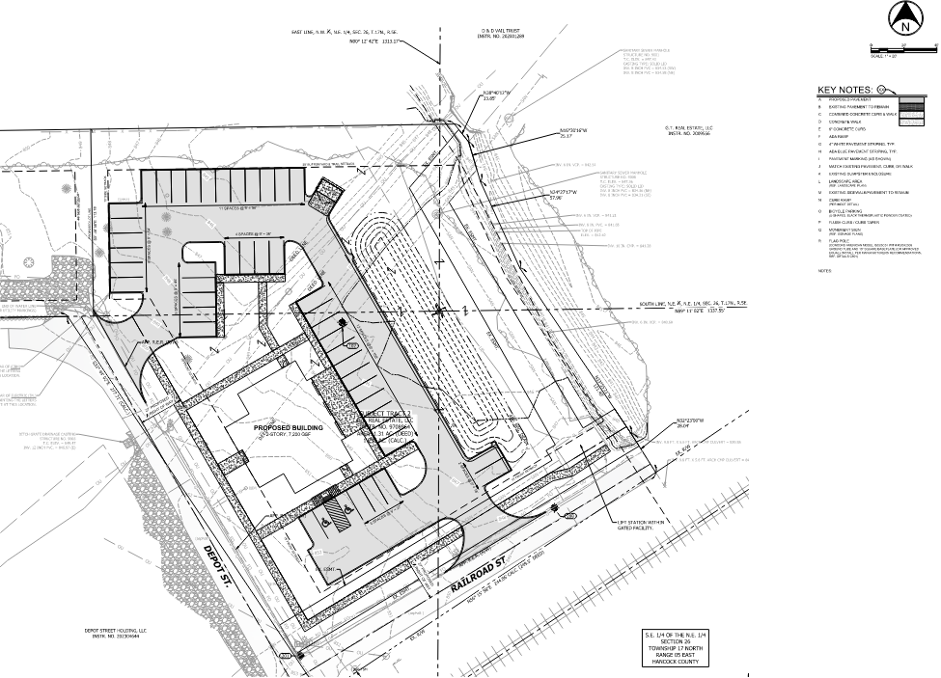
“Exhibit C”

Architectural Standards

- All Mixed-use/Commercial buildings shall comply with the architectural standards of the Town’s Zoning Ordinance Commercial Neighborhood (CN) Zoning District, as amended below:
  - The Illustrative Architectural Exhibit, attached hereto as “Exhibit C-1”, is hereby incorporated to illustrate the elements, character, and materials for the architecture and design of the building on the Real Estate. The building shall be substantially similar in quality and character to the buildings shown in the Illustrative Architectural Exhibit.
  - Architectural metal siding shall be permitted, as shown in Exhibit C-1, so long as exposed fasteners are not used.
  - Standing-seam metal roofing shall be permitted, as shown in Exhibit C-1, so long as exposed fasteners are not used.
  - A minimum of 25% of the west and south facades shall feature brick or stone.
  - Concrete masonry units (CMU) shall be prohibited.
  - Satellite Dishes shall not be permitted.
  - The minimum roof pitch shall be a minimum of 6:12; however, gable pitches shall be a minimum of 10:12.
  - The trash receptacle enclosure shall be constructed of brick or stone matching the brick or stone on the primary structure.
  - Exhaust vents shall not be visible from any front elevation. Additionally, no wall-mounted vent or louver shall be located on a front elevation, unless located in a gable.
  - Except for large picture windows, casement windows and small accent windows, which do not open, all windows on a façade facing a public street shall have shutters, mullions or window grids.
  - The primary entrance, on the west façade, shall have a covered entry. This shall be achieved through the use of an awning, canopy, or other covering permitted by the ARC over the front entrance that projects in front of the wall plane. This canopy or awning shall be permitted to project into the front-yard setback, so long as it is not ground supported.
  - Architectural accent lighting shall be required along the west and south facades.

- All Single-family dwellings shall comply with the architectural standards of the Town’s Zoning Ordinance Residential-Two (R-2) Zoning District.

“Exhibit C-1”

Illustrative Architectural Renderings

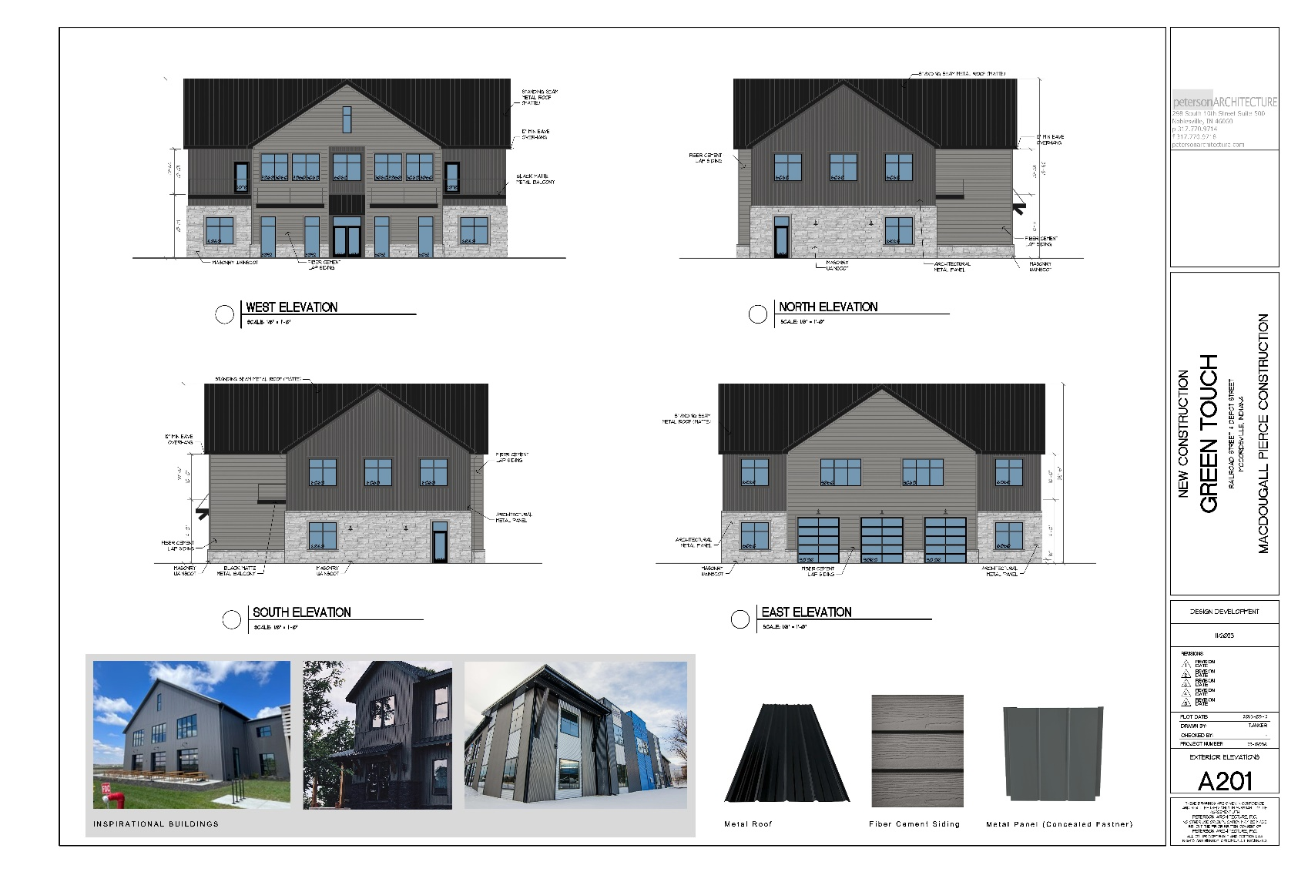

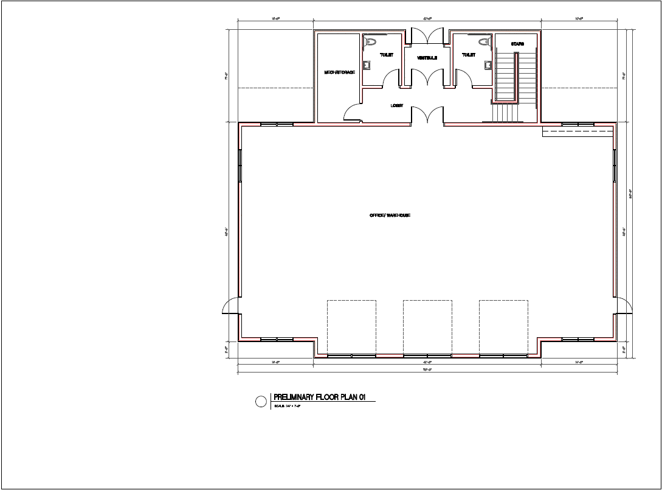

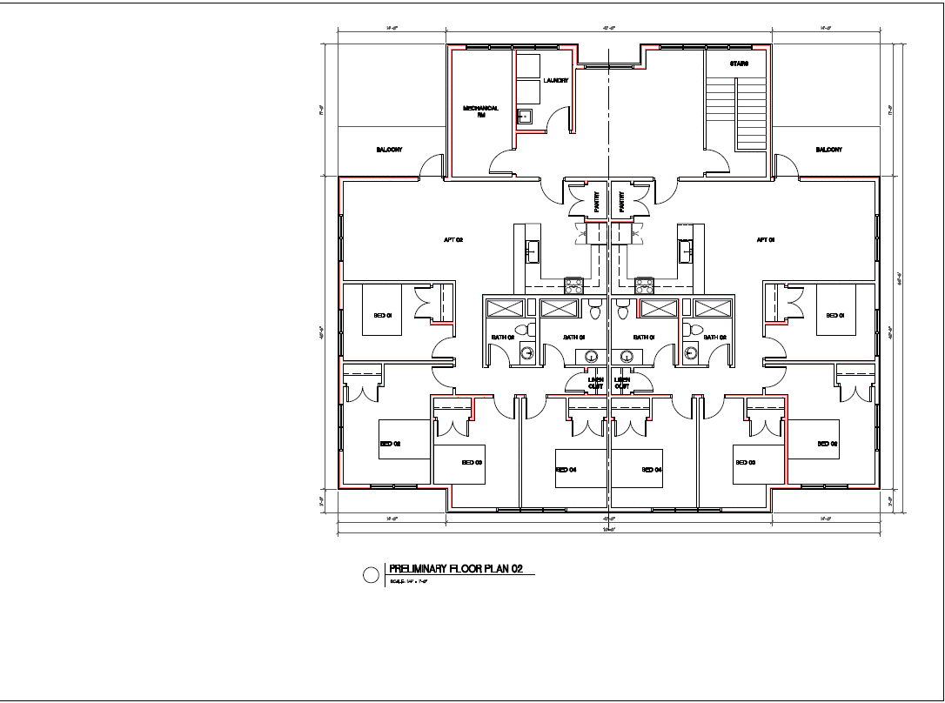

“Exhibit D”

Streetlight Exhibit

