ORDINANCE NO. 021324C

ORDINANCE AMENDING ORDINANCE NO. 121410, THE ZONING ORDINANCE
FOR THE TOWN OF MCCORDSVILLE, INDIANA

WHEREAS, the Town Council of the Town of McCordsville, Indiana, has heretofore adopted Ordinance No. 121410 as the Zoning Ordinance; and

WHEREAS, the Town Council of McCordsville, Indiana has, after a public hearing was held on January 16, 2024, received a favorable recommendation from the McCordsville Advisory Plan Commission requesting an amendment to the Zoning Ordinance in order to adopt the Toler Soccer Park Planned-Unit Development (PUD) Ordinance.

THEREFORE, BE IT ORDAINED by the Town Council of the Town of McCordsville, Indiana that Ordinance No. 121410 is hereby amended as follows:

Section 1. The real estate more particularly described in the attached “Exhibit A” (the “Real Estate”) is hereby zoned to the PUD designation. The Development and Architectural standards set forth in this Ordinance shall govern the development of the Real Estate, and these standards shall replace all other standards set forth in the Town of McCordsville Zoning and Subdivision Control Ordinances, as amended. Where this Ordinance is silent regarding standards the standards from the McCordsville Zoning and Subdivision Control Ordinances, dated January 2011, as amended, applicable to CN Zoning District, shall apply.

Section 2. Intent. The Toler Soccer Park PUD provides strict design requirements which are compiled with the intent to produce the following:

- A destination that creates a vibrant community hub revolving around a modern soccer/sport field complex served by supporting community and commercial services.
- A site design which creates thoughtful pedestrian linkages between points of interest in the Park District and connections to commercial businesses in the Commercial District. Parking shall be strategically located throughout the site to maximize walkability, efficiency of the site, and create opportunities for shared parking.
- The site should highlight the unique history of the property. Opportunities to incorporate some of the original, authentic design and elements of the site should be incorporated into project design as the site is developed.
- Buildings shall be oriented towards the interior of the site creating a unique mixed-use design that engages visitors to stay and experience all the development has to offer. Building design shall feature high quality, durable, timeless materials.

Section 3. Definitions. Capitalized terms not defined in this PUD Ordinance shall have the meaning ascribed to them in the Town of McCordsville Zoning Ordinance.

- Stone: shall not be interpreted to include concrete masonry units (CMU).
- Dwelling, Second Floor/Upper Level: Separate and complete dwelling unit(s) that is contained on the second floor, or floor(s) above, the first floor. For the purposes of this land use definition, the first-floor uses shall not be residential.
- Restaurant, Fast Casual: A commercial establishment where customers order and are served their food at a counter or in a motor vehicle in packages prepared to leave the premises, or which are able to be taken to a table or counter to be consumed. However, unlike fast food the food is not prepared prior to customer ordering.

Section 4. Permitted Uses. The permitted uses for each district of the Real Estate shall be as described below.

- Commercial District
- Those uses permitted in the Neighborhood Commercial (CN) Zoning District of the McCordsville Zoning Ordinance, except as further defined or limited below.
  - Antique Shop – Prohibited
  - Appliance Repair – Prohibited
  - Collection Point, Donations – Prohibited
  - Collections Point, Recycling – Prohibited
  - Confectionery, Commercial – Prohibited
  - Daycare – Permitted
  - Department or Discount Store, Medium Scale – Special Exception
  - Dwelling, Second Floor/Upper Level(s) – Special Exception
  - Dwelling, Two-Family – Prohibited
  - Financial Institution, Payday Loan – Prohibited
  - Golf Course – Prohibited
  - Health or Day Spa – Permitted
  - Library – Permitted
  - Novelty, Gift, Souvenir Store – Prohibited
  - Restaurant, Eat-in – Permitted
  - Restaurant, Fast Casual – Permitted
  - Retail, Medium Scale – Special Exception
  - Bargain Retail – Prohibited
  - Sports Fields – Permitted
  - Recreation Facility, Indoor – Permitted

- Park District
  - Those uses permitted in the Public/Semi-public (P) Zoning District of the McCordsville Zoning Ordinance, except as further defined or limited below.
  - Child Care Center – Prohibited
  - Club or Lodge, Public or Private – Prohibited
  - Collection Point, Donations – Prohibited
  - Collections Point, Recycling – Prohibited as Primary Use, Special Exception as an Accessory Use
  - Community Center – Special Exception
  - Conference Center – Special Exception
  - Daycare – Prohibited
  - Dwelling, Fraternity or Sorority – Prohibited
  - Dwelling, Student Housing – Prohibited
  - Financial Institution, Bank or Credit Union – Prohibited
  - Group Home – Prohibited
  - Medical Hospital, Center or Complex 10,000 SF or greater (GFA) – Prohibited
  - Medical or Dental Clinic less than 10,000 SF (GFA) – Prohibited
  - Mortuary or Funeral Home (w/ or w/out cemetery) – Prohibited
  - Museum – Special Exception
  - Nursing Home – Prohibited
  - Penal or Correctional Institute – Prohibited
  - Post Office w/ or w/out on-site storage of delivery vehicles – Prohibited
  - Recreation Facility, Indoor – Special Exception
  - Recreation Facility, Outdoor – Permitted
  - Religious Place of Worship – Special Exception
  - Residential/Institutional Facility for the Developmentally Disabled or Mentally Ill – Prohibited
  - Retirement Facility – Prohibited
  - School, Commercial, Trade, or Business – Special Exception
  - School, K-12 (including pre-school) – Special Exception
  - School, University or College – Special Exception
  - Studio, Performing Arts – Special Exception
  - Transit Station – Prohibited
  - Utility Facility (as a primary use) - Special Exception

Permitted Accessory Uses, Incidental Uses, and Structures:
Those permitted pursuant to the Town Ordinance

Permitted Temporary Uses:
Those permitted pursuant to the Town’s Zoning Ordinance. Additionally, it is acknowledged that the soccer park holds tournaments and other similar events servicing recreational sports. During such events, temporary uses such as food trucks, tents, and other similar temporary uses and structures, selling merchandise related to recreational sports and/or providing food and drink for consumption on-site, during said event are permitted. This allowance shall not be interpreted to exclude such temporary uses or events from adhering to the Town’s Special Event Policy, other applicable Town Ordinances, and the requirements of the local Fire Marshall. All such events and temporary uses shall be required to comply with all requirements of the State of Indiana, including, but not limited to those required by the State Department of Homeland Security. A public safety plan shall be filed with the Planning and Building Department. The plans shall address such items as emergency vehicle ingress and egress, fire protection, emergency egress or escape routes, emergency medical services, public assembly areas and the directing of both attendees and vehicles (including the parking of vehicles), vendor and food concession distribution, and the need for the presence of law enforcement, and fire and emergency medical services personnel at the event.

Section 5. Development Standards. The Toler Soccer Park development shall have two (2) districts as shown on the District Map attached hereto as “Exhibit D” with the following standards:

- The Development Standards – Commercial District

- Maximum Number of Lots 5
- Minimum Lot Area 1 acre
- Minimum Lot Width 130 feet
- Minimum Front Yard Setback along SR 67 50 feet*
- Minimum Front Yard Setback along any
other street or roadway 25 feet
- Minimum Side Yard Setback 10 feet
- Minimum Rear Yard Setback 20 feet
- Minimum Building Separation 20 feet
- Maximum Lot Coverage 65 %
- Maximum Height-Principal 45 feet
- Maximum No. of Accessory Structures** Not Permitted
- Maximum Size of District 9 acres
- Maximum District Depth from SR 67*** 330 feet
*Inclusive of perimeter common area.
**Trash enclosures shall not be considered accessory structures for the purposes of limiting the quantity of accessory structures.
***Measured from the existing south right-of-way line of SR 67/US 36.

- The Development Standards – Park District

- Maximum Number of Lots 4
- Minimum Lot Area 2 acres
- Minimum Lot Width 150 feet
- Minimum Front Yard Setback* 25 feet
- Minimum Side Yard Setback* 10 feet
- Minimum Rear Yard Setback* 20 feet
- Minimum Building Separation 20 feet
- Maximum Lot Coverage 40 %
- Maximum Height-Principal 45 feet
- Maximum Height-Accessory 24 feet
- Minimum Size of District 20 acres
- Maximum No. of Accessory Structures** 4
*No building, primary or accessory, shall be placed within twenty (20) feet of the south, east, or west property lines of the Real Estate.
**Trash enclosures and buildings dedicated to restroom facilities only shall not be considered accessory structures for the purposes of limiting the quantity of accessory structures.

- Architectural Standards:

Standards of the Town’s Zoning and Subdivision Control Ordinance regarding Architecture and Exterior Materials shall be applicable to the Real Estate. All primary structures shall comply with the standards of the Neighborhood Commercial Zoning District and the Mt. Comfort Road and Broadway Overlay (MCR-OL), with the following exceptions or additions:

- Buildings within the Commercial District shall be oriented so that the primary entrance is located on the south facade of the structure, and therefore facing the Park District.
- Facades facing W Broadway shall appear from the street as a front façade by using architectural detailing, exterior materials, signage, windows, and other architectural elements. Architectural design shall focus on what will be visible above the mounding (along W Broadway), and roof plane articulation shall be required on both the north and south facades.
- The required brick or stone shall be visible above the mounding from W Broadway.
- The heavier materials shall not be located above lighter materials. Example: EIFS located below brick.
- Any daycare structure shall be generally complaint with Exhibit C, as determined by the ARC.

Accessory structures located in the Park District shall not be required to comply with the architectural standards applicable to the Neighborhood Commercial (CN) Zoning District, nor the Mt. Comfort Road and Broadway Overlay (MCR-OL), but shall meet the following standards:

- Vinyl siding and smooth face concrete masonry units (CMU) are prohibited.
- Permitted materials shall be brick, stone, wood, fiber cement, EIFS, and split-face CMU.
- Any other exterior materials not listed herein as permitted or prohibited, shall be presented to the ARC for consideration prior to the issuance of a building permit. The ARC shall have the right to approve or deny any such material(s).
- Pitched roofs shall have a minimum roof pitch of 5:12 and shall be covered with dimensional shingles. The ARC may approve high-quality standing seam metal roofing, with hidden fasteners at their discretion.
- Mechanical units may not be located on roofs of accessory structures.

- Landscaping Standards:

Standards of the Town’s Zoning and Subdivision Control Ordinance regarding Landscaping shall be applicable to the Real Estate with the following exceptions:

- Perimeter landscape areas shall be provided as further described below.
- The perimeter landscape area along SR 67/W Broadway shall be minimum of thirty (30) feet in width, and feature the following plantings per one hundred (100) lineal feet:
  - Two (2) ornamental canopy tree with a min. 2” caliper at time of planting.
  - One (1) deciduous canopy tree with a min. 2” caliper at time of planting.
  - Two (2) evergreen trees with a min. height of six (6) feet at time of planting.
  - These plantings are in addition to other planting requirements, including, but not limited to perimeter parking lot plantings.
  - The existing evergreen trees may count towards the required amount of evergreen tree plantings, at a one-to-one ratio.
- If the existing mounding is altered, the perimeter landscape area shall feature no less than mounding of at least three (3) feet in height, measured from the grade of the centerline of W Broadway.
- The perimeter landscape area along the entrance drive shall be a minimum of twenty (20) feet in width, and feature the following plantings per one hundred (100) lineal feet:
    - One (1) deciduous canopy tree with a min. 2” caliper.
    - Two (2) ornamental trees with a min. 2” caliper.
    - These plantings are in addition to other planting requirements, including, but not limited to lot & yard plantings.
- Any building, primary or accessory, within one hundred (100) feet of the south or east perimeter property line of the Real Estate, shall feature the following plantings per one hundred (100) lineal feet:
- Two (2) deciduous canopy trees with a min. 2” caliper.
- Two (2) evergreen trees with a min. height of six (6) feet.
- Two (2) ornamental trees with a min. 2” caliper.
- These plantings are in addition to other planting requirements, including, but not limited to lot & yard plantings.
- These plantings shall be located between the building and perimeter property line and be designed to act as a natural screen from the adjoining property.
- Doors, loading areas, and other back-of-house elements shall be screened from W Broadway through the use of walls, fences, and/or landscaping.
- Buffer-yards: Section 6.11(A)(2) shall not apply, and therefore buffer-yards are not required.

- Pedestrian Accessibility:

Standards of the Town’s Zoning and Subdivision Control Ordinance regarding Pedestrian Accessibility shall be applicable to the Real Estate with the following exceptions:

- Asphalt multi-use paths a minimum of ten (10) feet in width shall be installed along the following roadways:
- SR 67
- The westside of the entrance drive
- The southside of the access road serving the Commercial District. If there is no access road, the path shall be constructed south of the parking lots servicing the commercial district. This path is intended to be parallel to the access road or parking lots and provide an east-west connection between the Commercial and Park Districts.
- Multi-use paths are encouraged throughout the Park District and may be asphalt or stone, but are encouraged to be asphalt. These paths should connect to the path along the Commercial District creating pedestrian linkages between the Commercial District and points of interest within the Park District. A multi-use path encircling the Park District is also encouraged.
- Sidewalks a minimum of five (5) feet in width shall be installed from the path along the southside of the access drive to the foundation sidewalk of each primary structure. These sidewalks shall be concrete.
- Connector sidewalks from the perimeter path along SR 67 shall not be required to each primary structure.
- Notwithstanding the requirements above, any sidewalk or path which is located back-of-curb, without a grass strip between the pedestrian facility and the curb, shall be concrete.
- All truncated domes shall be black in color.

- Lighting, Parking, and Signage:

Standards of the Town’s Zoning and Subdivision Control Ordinance regarding Lighting, Parking, and Signage shall be applicable to the Real Estate with the following exceptions:

- Street Lighting shall be installed along SR 67 as required by the Zoning Ordinance.
- All lighting fixtures and poles within the Real Estate shall utilize a consistent style. All fixtures shall comply with the following:
  - Comply with the lighting requirements of the Zoning Ordinance
  - Black in color.
  - Full cut off, exceptions: the 30’ tall streetlights required by the Town, and building/sign accent lighting. Such accent lighting shall be directed and contained so as to ensure the light does not project beyond the building or sign and shall utilize the minimum amount of light necessary to light the intended building, building feature, or sign.
  - LED lighting
  - Light color: 4000k
  - No lighting shall be so intense or brilliant, or projected in a way that it impairs the vision of drivers or pedestrians.
  - All free-standing lighting is limited to a luminaire height of no greater than twenty (20) feet from grade.
  - Shields and other measures to restrict and/or limit backlight, uplight, and/or glare may be required by the Plan Commission.
- All standard parking spaces shall utilize white striping.
- Parking spaces shall not be used for display or storage of merchandise or services.

- Roadway:

Standards of the Town’s Zoning and Subdivision Control Ordinance regarding Streets, Roadways, and Right-of-way shall be applicable to the Real Estate with the following exceptions:

- The Town shall not be responsible for any maintenance or repairs on any alley, nor any roadway which is not built to town standards and/or not dedicated and accepted as public right-of-way.
- The Town shall not be responsible for snow plowing of any street or roadway within the Real Estate.
- The following traffic improvements shall be constructed:
  - Acceleration and deceleration lanes, in conformance with town standards, at all access points into the development from any local-collector, collector, and/or arterial roadway.
  - Passing blisters or left-turn lanes, in conformance with town standards, at all access points as required by the Town Engineer.
  - A second entrance, on W Broadway, may be required by the Town Engineer, once the Commercial District reaches at least 50% built-out, or at any point thereafter, until the last Development Plan is approved. This second entrance would be located near the west property line of the Real Estate and may be required to be a shared drive with the owner of the property to the west.
- The location of all internal drives and driveways shall be per the Town of McCordsville.
- Access easements shall be provided across individual lots within the Real Estate to ensure public access.
- Cross access to adjacent properties shall be provided, contingent upon agreements between adjoining properties for maintenance. The petitioner commits to taking all reasonable commercial steps to secure such agreements.
- The entrance drive shall maintain a landscaped median entry. This median shall be no less than fifteen (15) feet wide.

- Miscellaneous

- Section 4.17 shall not apply to the Real Estate.
- Decorative fountains shall be installed in all wet detention/retention facilities.
- Outdoor storage of materials, equipment, vehicles, merchandise and the like is prohibited. This shall not apply to goals, goal posts, and the like associated with a sports field.
- An owner’s association (OA) shall be created for the Commercial District. This OA shall maintain the shared common spaces within the Commercial District. At a minimum these shared common spaces shall include:
  - A minimum of thirty (30) feet wide perimeter landscape area along W Broadway.
  - A minimum twenty (20) feet wide landscape area along the west side of the entrance drive.
- The historic track in the Park District shall be preserved and protected. The track may be improved upon, but shall not be demolished or changed in a manner that removes the track itself, or the history/significance of the track from the site.

Section 6. This Ordinance shall remain in full force and effect from and after its passage and posting as required by the law within the Town of McCordsville, Indiana.

Section 7. Introduced and filed on the 13th day of February, 2024. A motion to consider on the first reading on the day of introduction was offered and sustained by a vote of _ in favor and _ opposed pursuant to I.C. 36-5-2-9.8.

Duly ordained and passed this ___ day of ___________, 2024 by the Town Council of the Town of McCordsville, Hancock County, Indiana, having been passed by a vote of _ in favor and _ opposed.

TOWN OF McCORDSVILLE, INDIANA, BY ITS TOWN COUNCIL:

Voting Affirmative: Voting Opposed:

____________________________________
Gregory J. Brewer Gregory J. Brewer

____________________________________
Scott Jones Scott Jones

____________________________________
Bryan Burney Bryan Burney

____________________________________
Chad Gooding Chad Gooding

____________________________________
John Price John Price

ATTEST:

_________________________________
Stephanie Crider, Clerk-Treasurer

I affirm, under the penalties for perjury, that I have taken reasonable care to redact each Social Security number in this document, unless required by law. – Ryan Crum
“Exhibit A”

LEGAL DESCRIPTION

A part of the Southeast Quarter of Section 24, Township 17 North, Range 5 East, and a part of Southwest Quarter of Section 19, Township 17 North, Range 6 East, Vernon Township, Hancock County, Indiana, described as follows: Commencing at the Southeast corner of said quarter section; thence North 89 degrees 58 minutes 0 seconds West (assumed bearing) 1,323.58 feet (1323.48 feet per Instrument Number 201502660) along the south line of said quarter section to a point lying 22.00 feet, more or less, of the Southwest corner of the East Half of said quarter section; thence North 2 degrees 12 minutes 44 seconds East 43.77 feet to the Southeast corner of a tract of land recorded as Instrument Number 9912409; thence along the east line of said tract, North 2 degrees 11 minutes 40 seconds East 775.32 feet, more or less, to a point on the centerline of the James Shultz Ditch, said point being on the southern boundary of that 29.67 acre tract described in the Warranty Deed recorded as Instrument Number 201502660 and the Point of Beginning of this description; thence along the southern, northwestern, northeastern & eastern boundaries of said 29.67 acre tract the following four (4) courses: 1) South 65 degrees 39 minutes 18 seconds West 13.71 feet along said ditch centerline; 2) North 64 degrees 46 minutes 30 seconds West 929.21 feet along said centerline to the southeasterly boundary of State Road 67; 3) North 58 degrees 4 minutes 6 seconds East 1,342.85 feet along said southeasterly boundary; 4) South 31 degrees 56 minutes 55 seconds East 260.70 feet; thence North 65 degrees 8 minutes 51 seconds East 202.65 feet; thence South 86 degrees 51 minutes 31 seconds East 41.99 feet; thence South 43 degrees 46 minutes 8 seconds East 231.46 feet; thence South 81 degrees 40 minutes 12 seconds East 180.78 feet; thence South 5 degrees 50 minutes 38 seconds West 161.26 feet to the northeastern boundary of said 29.67 acre tract; thence South 74 degrees 6 minutes 5 seconds East 253.45 feet along said northeastern boundary; thence South 49 degrees 23 minutes 55 seconds East 341.01 feet; thence South 27 degrees 6 minutes 43 seconds West 369.45 feet to the southeastern corner of said 29.67 acre tract, said corner being on the centerline of the James Shultz Ditch; thence along said centerline and the southern boundary of said 29.67 acre tract the following four (4) courses: 1) North 46 degrees 43 minutes 38 seconds West 318.25 feet; 2) North 75 degrees 3 minutes 20 seconds West 83.23 feet; 3) South 83 degrees 14 minutes 33 seconds West 670.37 feet; 4) South 65 degrees 39 minutes 18 seconds West 361.48 feet the point of beginning and containing 30.73 acres, more or less.

AND

A part of Southeast Quarter of Section 24, Township 17 North, Range 5 East, Vernon Township, Hancock County, Indiana, described as follows: Commencing at the Southeast corner of said quarter section; thence North 89 degrees 58 minutes 0 seconds West (assumed bearing) 1,323.58 feet (1323.48 feet per Instrument Number 201502660) along the south line of said quarter section to a point lying 22.00 feet, more or less, of the Southwest corner of the East Half of said quarter section; thence North 2 degrees 12 minutes 44 seconds East 43.77 feet to the Southeast corner of a tract of land recorded as Instrument Number 9912409; thence along the east line of said tract, North 2 degrees 11 minutes 40 seconds East 775.32 feet, more or less, to a point on the centerline of the James Shultz Ditch, said point being on the southern boundary of that 29.67 acre tract described in the Warranty Deed recorded as Instrument Number 201502660; thence along the southern, northwestern and northeastern boundaries of said 29.67 acre tract the following four (4) courses: 1) South 65 degrees 39 minutes 18 seconds West 13.71 feet along said ditch centerline; 2) North 64 degrees 46 minutes 30 seconds West 929.21 feet along said centerline to the southeasterly boundary of State Road 67; 3) North 58 degrees 4 minutes 6 seconds East 1,342.85 feet along said southeasterly boundary; 4) South 31 degrees 56 minutes 55 seconds East 260.70 feet to the Point of Beginning of this description: thence North 65 degrees 8 minutes 51 seconds East 202.65 feet; thence South 86 degrees 51 minutes 31 seconds East 41.99 feet; thence South 43 degrees 46 minutes 8 seconds East 231.46 feet; thence South 81 degrees 40 minutes 12 seconds East 180.78 feet; thence South 5 degrees 50 minutes 38 seconds West 161.26 feet to the northeastern boundary of said 29.67 acre tract; thence along said northeaster boundary the following three (3) courses: 1) North 74 degrees 6 minutes 5 seconds West 187.17 feet; 2) North 20 degrees 34 minutes 47 seconds West 234.59 feet; 3) South 90 degrees 0 minutes 0 seconds West 285.90 feet to the point of beginning and containing 1.15 acres, more or less.

AND

A part of the Southeast Quarter of Section 24, Township 17 North, Range 5 East, and a part of Southwest Quarter of Section 19, Township 17 North, Range 6 East, Vernon Township, Hancock County, Indiana, described as follows: Commencing at the Southeast corner of the Southeast Quarter of said Section 24; thence North 89 degrees 58 minutes 0 seconds West (assumed bearing) 1,323.58 feet (1323.48 feet per Instrument Number 201502660) along the south line of said southeast quarter section to a point lying 22.00 feet, more or less, of the Southwest corner of the East Half of said southeast quarter section; thence North 2 degrees 12 minutes 44 seconds East 43.77 feet to the Southeast corner of a tract of land recorded as Instrument Number 9912409; thence along the east line of said tract, North 2 degrees 11 minutes 40 seconds East 775.32 feet, more or less, to a point on the centerline of the James Shultz Ditch, said point being on the southern boundary of that 29.67 acre tract described in the Warranty Deed recorded as Instrument Number 201502660; thence along the southern, northwestern, northeastern & eastern boundaries of said 29.67 acre tract the following eight (8) courses: 1) South 65 degrees 39 minutes 18 seconds West 13.71 feet along said ditch centerline; 2) North 64 degrees 46 minutes 30 seconds West 929.21 feet along said centerline to the southeasterly boundary of State Road 67; 3) North 58 degrees 4 minutes 6 seconds East 1,342.85 feet along said southeasterly boundary; 4) South 31 degrees 56 minutes 55 seconds East 260.70 feet; 5) North 90 degrees 0 minutes 0 seconds East 285.90 feet; 6) South 20 degrees 34 minutes 47 seconds East 234.59 feet; 7) South 74 degrees 6 minutes 5 seconds East 678.43 feet; 8) South 15 degrees 52 minutes 53 seconds West 109.41 feet to the Point of Beginning of this description: thence South 49 degrees 23 minutes 55 seconds East 79.21 feet; thence South 27 degrees 06 minutes 43 seconds West 369.45 feet to the southeastern corner of said 29.67 acre tract, said corner being in the centerline of the James Shultz Ditch; thence North 15 degrees 52 minutes 53 seconds East 395.50 feet to the point of beginning and containing 0.33 acres, more or less.

“Exhibit B”

Concept Plan

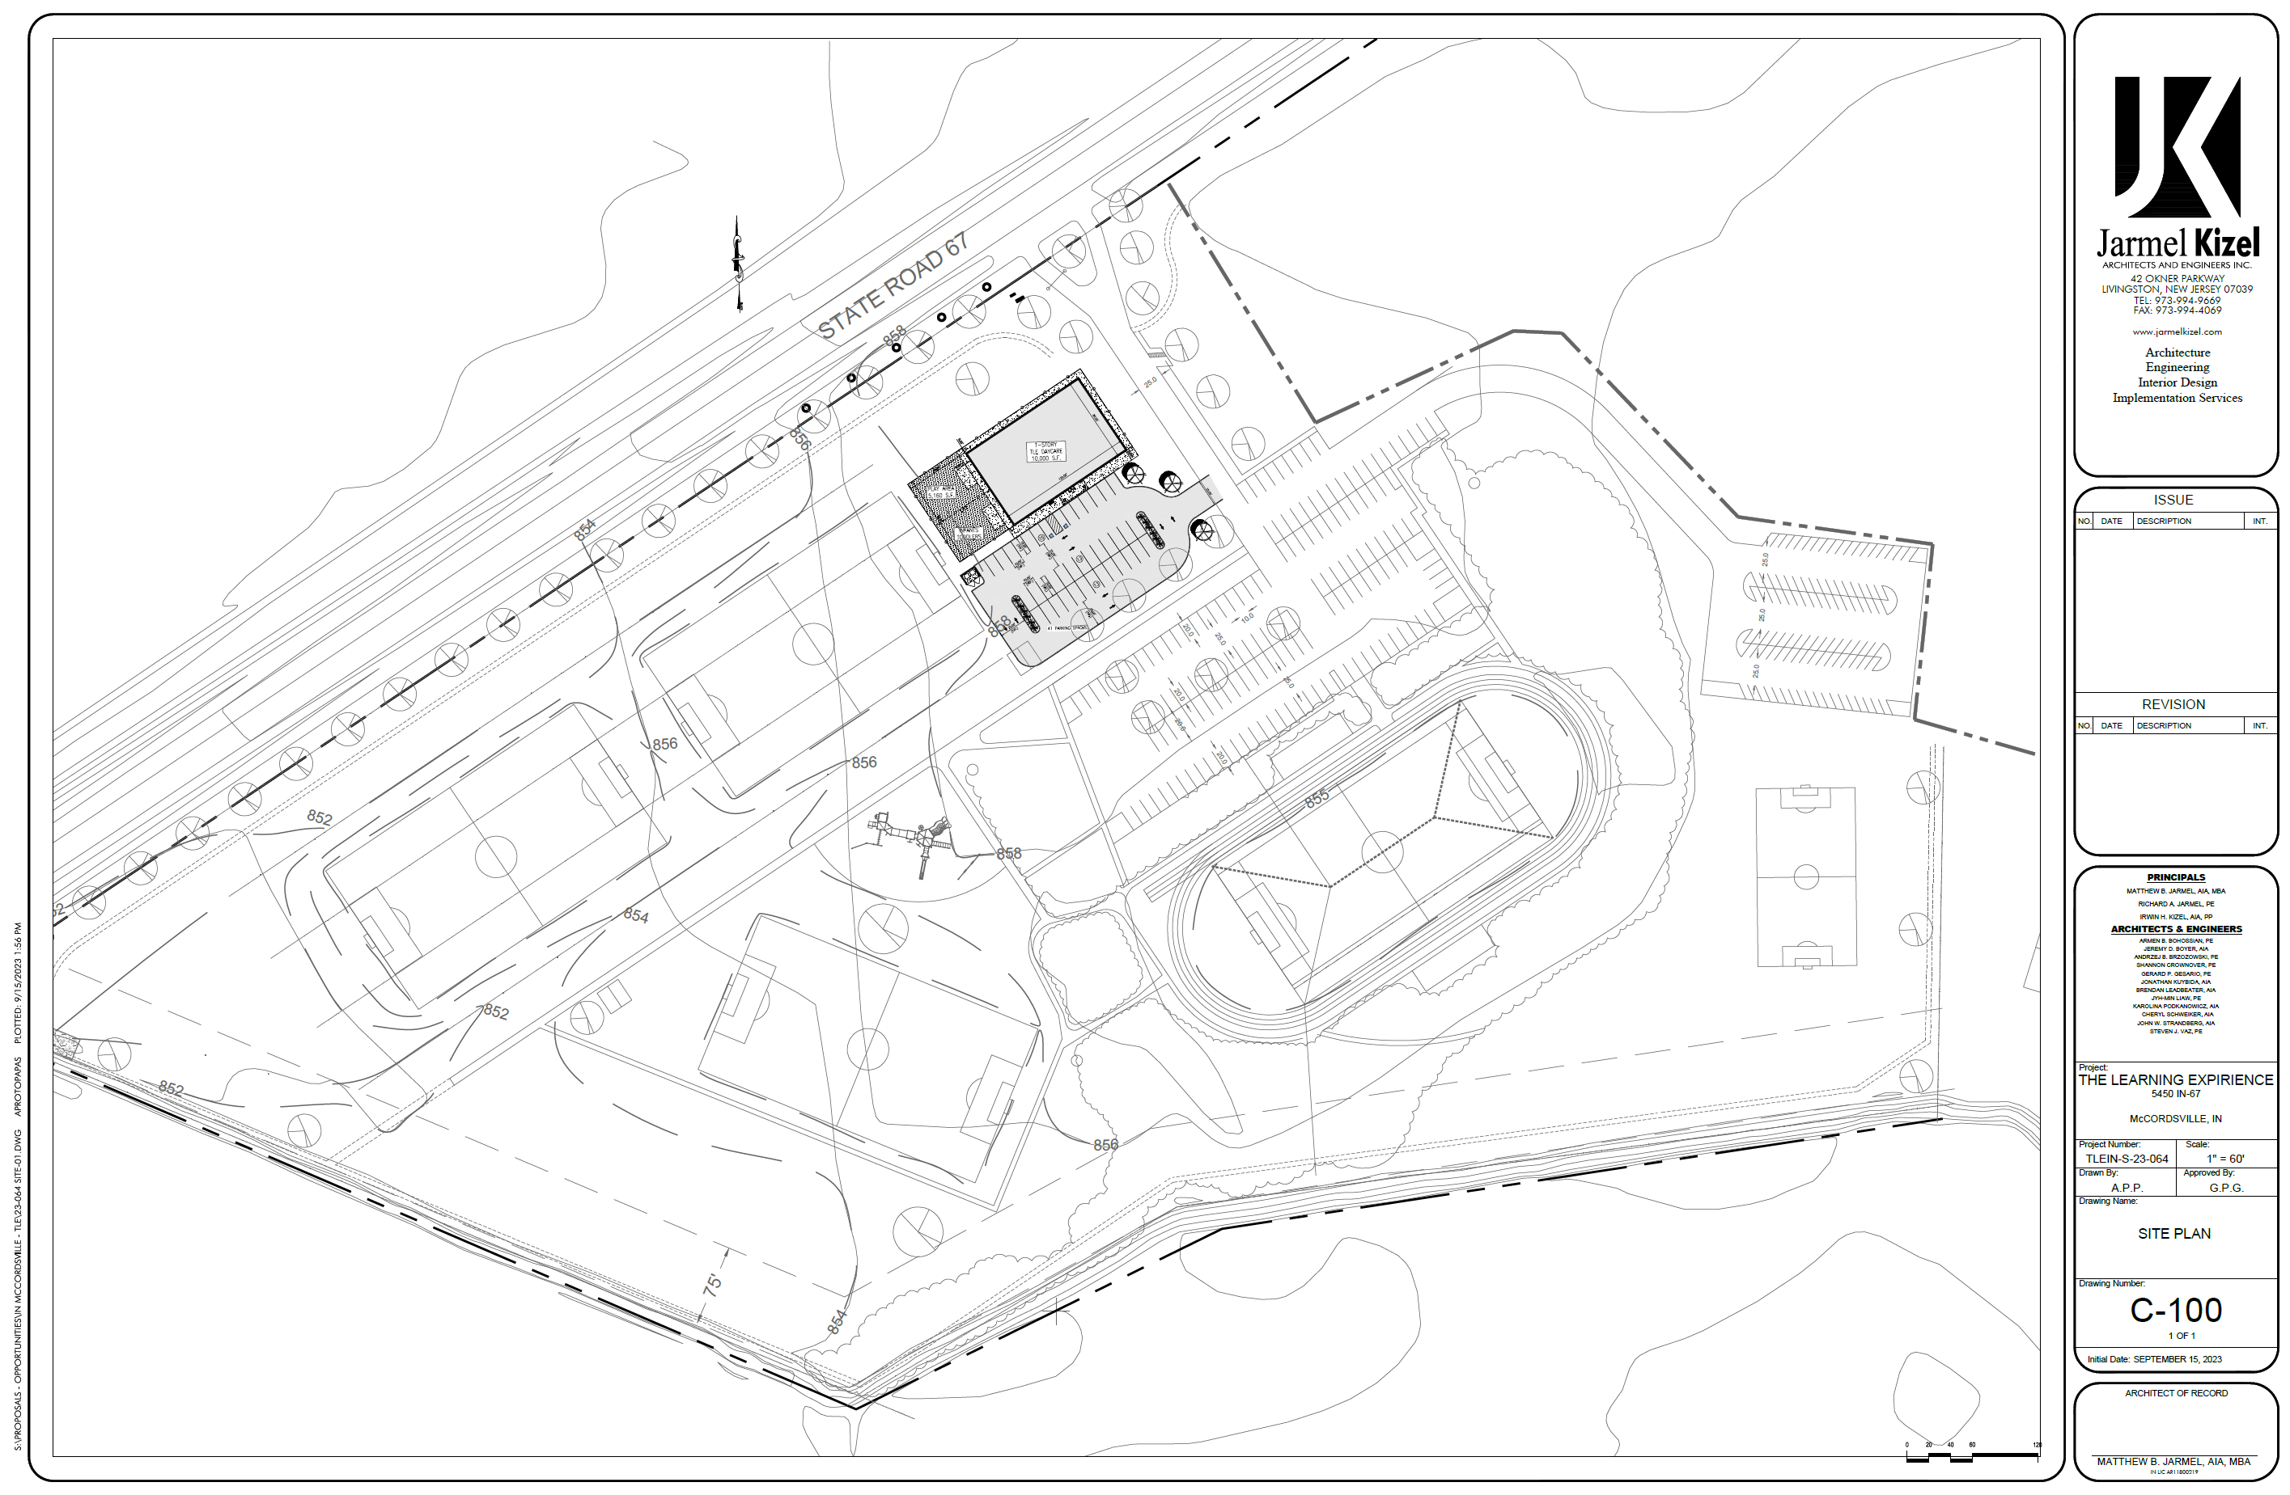
“Exhibit C”

Architectural Exhibit

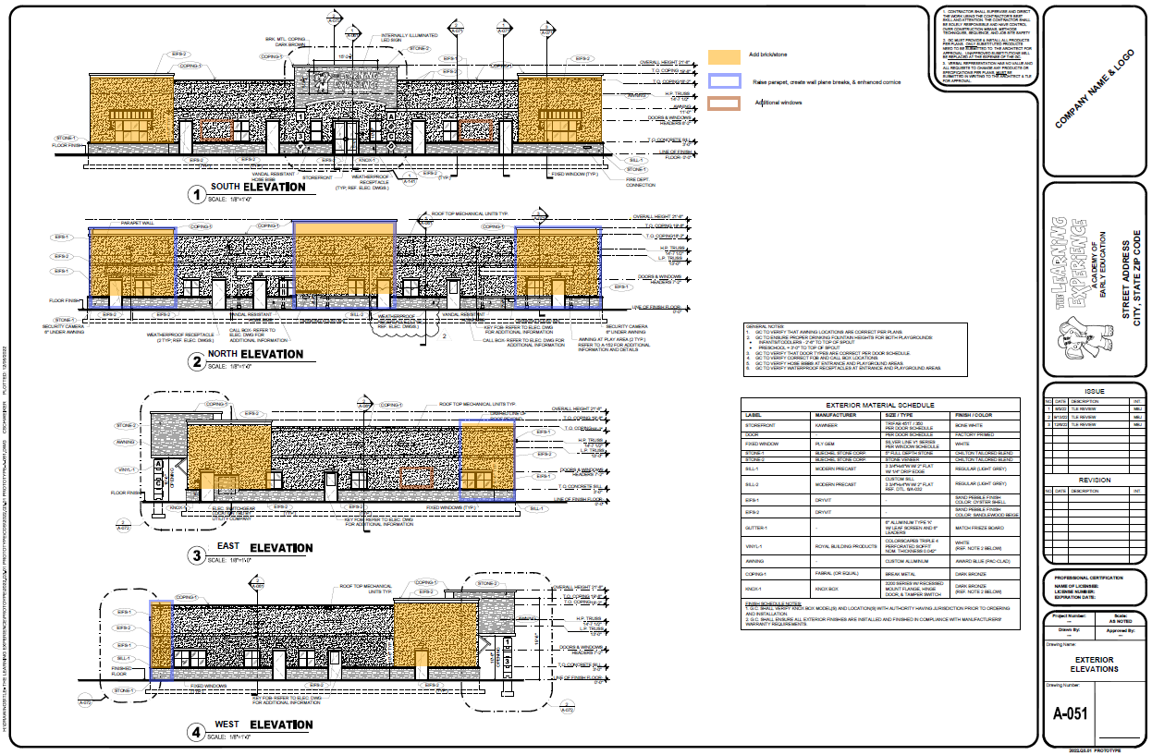

“Exhibit D”

District Map

