ORDINANCE NO. _________________

ORDINANCE AMENDING ORDINANCE NO. 121410, THE ZONING ORDINANCE

FOR THE TOWN OF MCCORDSVILLE, INDIANA

WHEREAS, the Town Council of the Town of McCordsville, Indiana, has heretofore adopted Ordinance No. 121410 as the Zoning Ordinance; and

WHEREAS, the Town Council of McCordsville, Indiana has, after a public hearing was held on ________________, 2019, received a _____________ recommendation from the McCordsville Advisory Plan Commission requesting an amendment to the Zoning Ordinance in order to adopt the Underwood Planned-Unit Development (PUD) Ordinance.

THEREFORE, BE IT ORDAINED by the Town Council of the Town of McCordsville, Indiana that Ordinance No. 121410 is hereby amended as follows:

Section 1. The real estate more particularly described in the attached “Exhibit A” (the “Real Estate”) is hereby zoned to the PUD designation. The standards set forth in this Ordinance shall govern the development of the Real Estate, and these standards shall replace all other standards set forth in the Town of McCordsville Zoning and Subdivision Control Ordinances, as amended. Where this Ordinance is silent, the standards from the McCordsville Zoning and Subdivision Control Ordinances, dated January 2011, as amended, shall apply.

Section 2. Development Standards. Except as modified by these standards below, the Real Estate shall comply with the Town of McCordsville Zoning and Subdivision Control Ordinance, dated January 2011, as amended. For determining applicable Zoning Ordinance standards the base, underlining zoning for the Real Estate is Professional Business Office (CO).

**McCordsville Zoning Ordinance:**

***Section 3.02 Establishment of Zoning District Classifications***

(B) Commercial Districts

1. CO, Professional Business Office

Only the uses listed below are permitted on the Real Estate:

Permitted by Right:

*Agricultural Crop Production*, farm animals prohibited

*Animal Clinic or Hospital (small animals) without outdoor kennels,* outside areas may only be used for bathroom breaks and play-time, dogs must be accompanied by a human at all times in any outside area. Outside areas may not be used simply to keep an animal outside. No animal under any circumstance shall be permitted in an outdoor kennel between the hours of 7pm and 6am.

*Animal Grooming*

*Animal Kennel, Indoor*, outside areas may only be used bathroom breaks and play-time, dogs must be accompanied by a human at all times in any outside area. Outside areas may not be used simply to keep an animal outside. No animal under any circumstance shall be permitted in an outdoor kennel between the hours of 7pm and 6am.

*Animal Pet Store*, as an accessory use to another animal-related permitted use

*Doggy Daycare*

*Nature Center*

*Nature Reserve or Preserve*

*Park*

*Pet-treat Bakery,* only as an accessory useto another animal-related permitted use

*Pet Training*, such training sessions shall be conducted inside a building

*Single-family dwelling*

Special Exceptions:

*Greenhouse, commercial*

*Religious Place of Worship*

*Vineyard or Orchard*

All above uses are permitted with the following limitations:

1. All uses other than, single-family residential, park, nature center, nature reserve or preserve, agricultural crop production, shall only be permitted east of the ditch. No structure shall be closer than 50’ to the western property line.
2. No commercial building shall exceed 8,000 square feet.
3. There shall be no more than 2 non-residential structures on the Real Estate.

***Section 5.25 Highway Corridor Overlay***

This section shall not apply.

***Section 6.04 Bulk Use Standards Standards***

(C) Architectural Standards for Commercial Developments

(1)(c) Shall apply with the exception that renovations and repairs to the existing barn may use materials consistent with the existing design and materials. Additionally, any expansion of the existing barn may utilize any of the materials listed and/or metal siding. A minimum brick or stone (excluding CMU) wainscot, at least 30” in height shall be required along the exterior elevations of the addition in lieu of the 50% requirement. The front facade (north elevation) of the addition shall feature a minimum of two windows and the west and east facades shall feature at least one window each.

(1)(e) Shall apply to any new commercial building construction.

(1)(f) Shall apply to any new commercial building construction.

(1)(g) Shall apply to any new commercial building construction and any building expansion.

(1)(i) Shall not apply.

(1)(j) Shall not apply.

(2)(a-c) Shall apply to any new commercial building construction. Any re-roof of an existing building shall comply with (2)(c). The minimum roof pitch for all new roofs is 5:12. The front entrance to the building addition shall have a covered entrance.

***Section 6.05 Parking Standards***

(E) Non-residential Developments

1. Shall apply with the following exception:
   * 1. The driveway and parking lot, servicing the future animal grooming/daycare center, shown on the Concept Plan shall be permitted to be maintained as gravel for a period not to exceed 3 years from date of commercial occupancy. At this end of this period the driveway and parking lot shall be constructed of asphalt or similar hard surface.
     2. A driveway to a future residential home shall be permitted to be maintained as gravel, so long as there is only one residence on the Real Estate. Subsequent home building shall require all driveways to be constructed of asphalt or similar hard surface.
2. The parking area shown on the Concept Plan shall not be required to provide curbing. However, if the site is redeveloped in manner that installs a new commercial building any new parking area shall meet the requirements of this subsection.
3. At time of commercial occupancy there shall be a minimum of 12 parking spaces for customers and an additional 10 parking spaces for employees.

***Section 6.07 Entrance & Drive Standards***

(C) Curbs

Curbing shall not be required for the existing drives.However, if the site is redeveloped in manner that installs a new commercial the driveway shall be upgraded to meet the requirements of this subsection.

***Section 6.09 Fence & Wall Standards***

The outside dog runs shall be fenced, and generally located as shown on the Preliminary Plan. The primary fence style will be wood privacy fence; however, other fence styles such as lattice and chain-link may be used in conjunction with wood privacy in order to properly secure the area. Additionally, the outside runs may incorporate a roof structure, which features wood construction and a metal or shingle roof covering.

The trash receptacles shall be screened with no less than a wood privacy fence, and shrubs.

***Section 6.10 Landscape Standards***

(B) Landscaped Areas

1. Interior Parking Lot Plantings

This standard shall not apply. However, if the site is redeveloped in a manner that installs a new commercial building, the new parking lot shall be upgraded to meet this requirement.

Perimeter Parking Lot Plantings

This standard shall not apply. However, if the site is redeveloped in a manner that installs a new commercial building, the new parking lot shall be upgraded to meet this requirement.

***Section 6.11 Buffering & Screening Standards***

* + - 1. Buffering Standards

1. In lieu of the standards within the Ordinance, the following shall apply:
   * 1. Western Property Line: The existing tree line shall remain, and trees larger than 4” caliper shall only be removed for the following reasons: the tree is dead, dying, diseased, utility repair or installation, or poses a threat to health, safety, and/or welfare. A conservation easement a minimum of 40’ in width shall be provided along this property line to ensure the existing trees within this area remain.
     2. Northern Property Line: A minimum of 10 trees shall be planted parallel to the street, on a line approximately 10’ south of the ROW line, with equidistant spacing. Tree species subject to approval of the Planning Director.
     3. Eastern Property Line: The existing tree line shall remain, and trees larger than 4” caliper shall only be removed for the following reasons: the tree is dead, dying, diseased, utility repair or installation, or poses a threat to health, safety, and/or welfare. A conservation easement a minimum of 15’ in width shall be provided along this property line to ensure the existing trees within this area remain. Additionally, no new structure shall be closer than 20’ to the property line.
     4. Southern property line: The existing tree are shall remain, and trees larger than 4” caliper shall only be removed for the following reasons: the tree is dead, dying, diseased, utility repair or installation, or poses a threat to health, safety, and/or welfare. A conservation easement a minimum of 100’ in width shall be provided along this property line to ensure the existing trees within this area remain.

***Section 7.08 Sign Standards***

This section shall apply with the following additions: Signage shall not be internally illuminated, and a masonry base shall not be required.

Section 3. Miscellaneous Requirements.

1. Right-of-way in accordance with the Town’s Thoroughfare Plan shall be dedicated at the time of Development Plan approval.
2. A maximum of two driveways onto CR 750N are permitted for the Real Estate. This includes a maximum of one driveway east of the drainage ditch and one driveway west of the drainage ditch.
3. Any loud barking animal shall be immediately taken inside the building.

***Article XII Definitions & Abbreviations***

Doggy Daycare: short-term daycare for dogs that does not include over-night stays.

New Commercial Building: for the purposes of this Ordinance an expansion of the existing barn shall not constitute a new commercial building.

Pet-treat Bakery: a bakery that only prepares items for pet consumption. Such facility shall have no on-site advertising and sales shall be directed to on-line web retail sales and to walk-in customers who are primarily customers of another animal-related permitted use.

Pet Training: both individual and class instructed training sessions for dogs. Class instructed training is limited to no more than 8 dogs per session.

**McCordsville Subdivision Control Ordinance:**

***Section 4.02 Open Space Standards***

This section shall apply with the following modifications:

* 1. A sidewalk along CR 750N shall not be required; however, the petitioner commits to installing said sidewalk, if/when a perimeter sidewalk is constructed on an adjacent property along CR 750N.

Section 5. This Ordinance shall remain in full force and effect from and after its passage and posting as required by the law within the Town of McCordsville, Indiana.

Section ­­­­­6. Introduced and filed on the ____ day of _____________, 2019. A motion to consider on the first reading on the day of introduction was offered and sustained by a vote of ____ in favor and ____ opposed pursuant to I.C. 36-5-2-9.8.

Duly ordained and passed this _____ day of ______________, 2019 by the Town Council of the Town of McCordsville, Hancock County, Indiana, having been passed by a vote of ____ in favor and ____ opposed.

TOWN COUNCIL:

____________________________________  
 Thomas R. Strayer, President

____________________________________  
 Barry A. Wood, Vice President

____________________________________  
 Larry J. Longman

____________________________________  
 Bryan T. Burney

____________________________________  
 Branden D. Williams

ATTEST:

_________________________________  
Cathy Gardner, Clerk-Treasurer

This instrument was prepared by Gregg Morelock, Attorney at Law.

I affirm, under the penalties for perjury, that I have taken reasonable care to redact each Social Security number in this document, unless required by law. – Gregg Morelock

**“Exhibit A” – Legal Description**

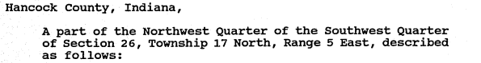

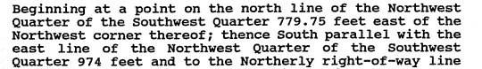

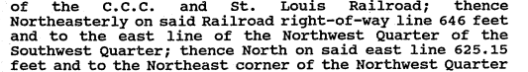



**“Exhibit B” – Conceptual Site Plan**



**“Exhibit C” – Illustrative Exhibits\***

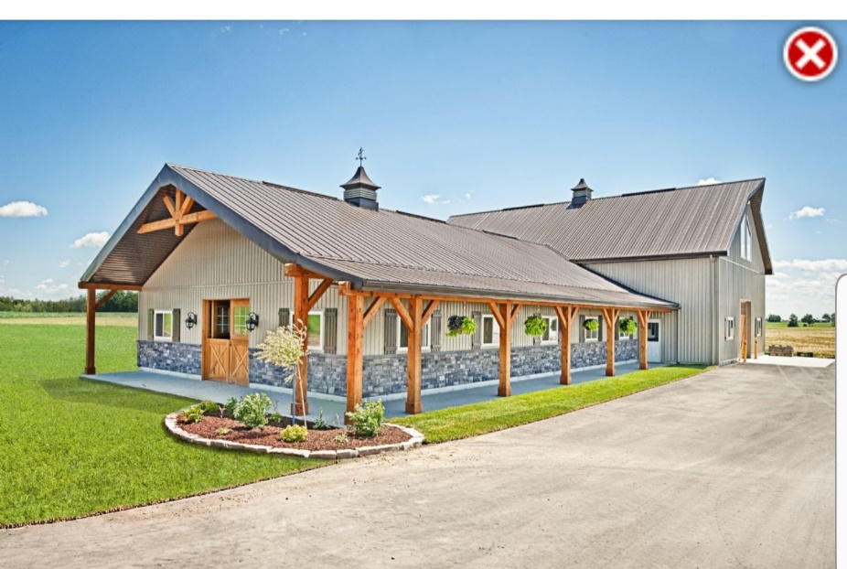

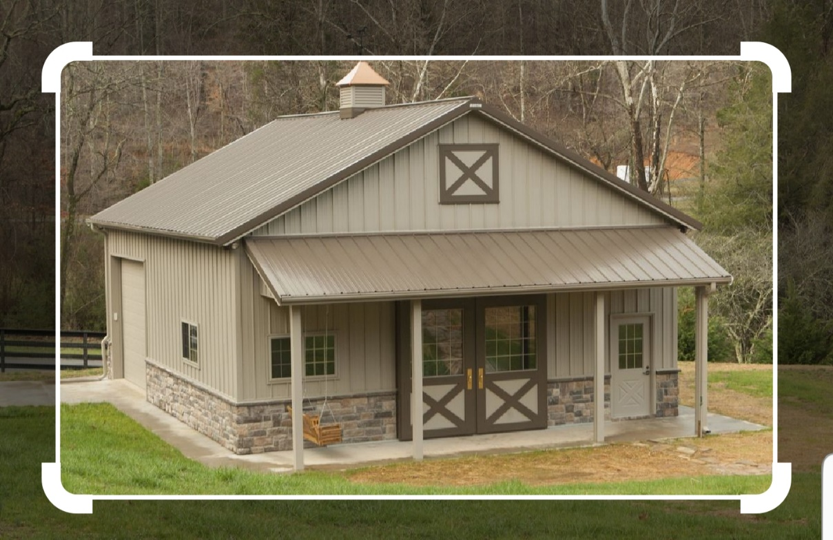

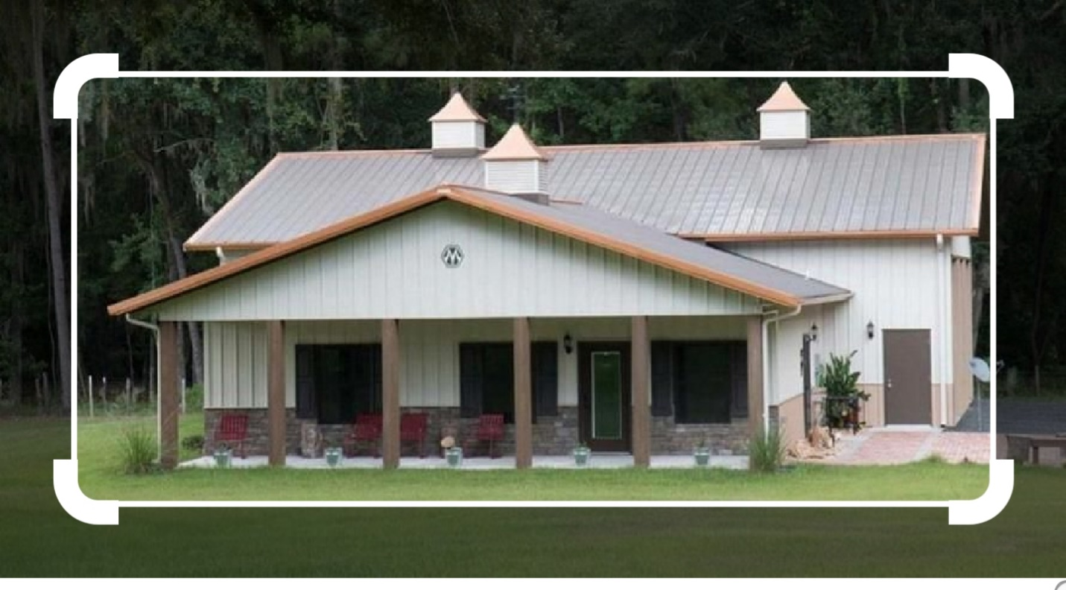

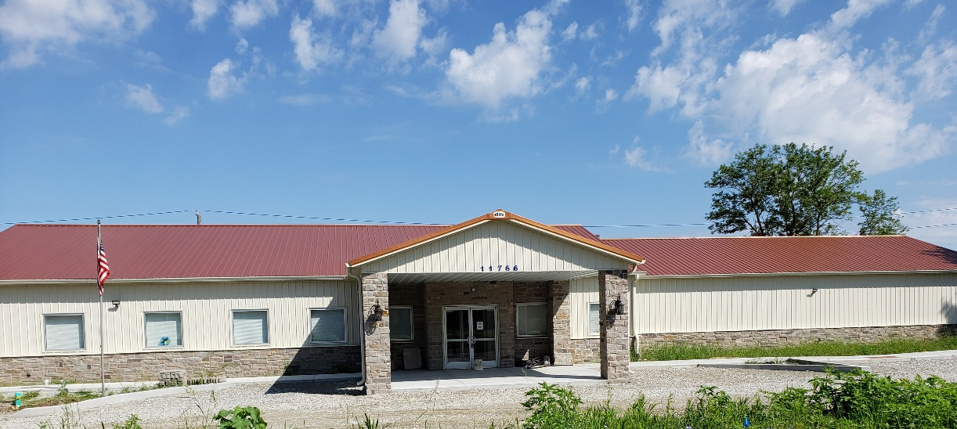

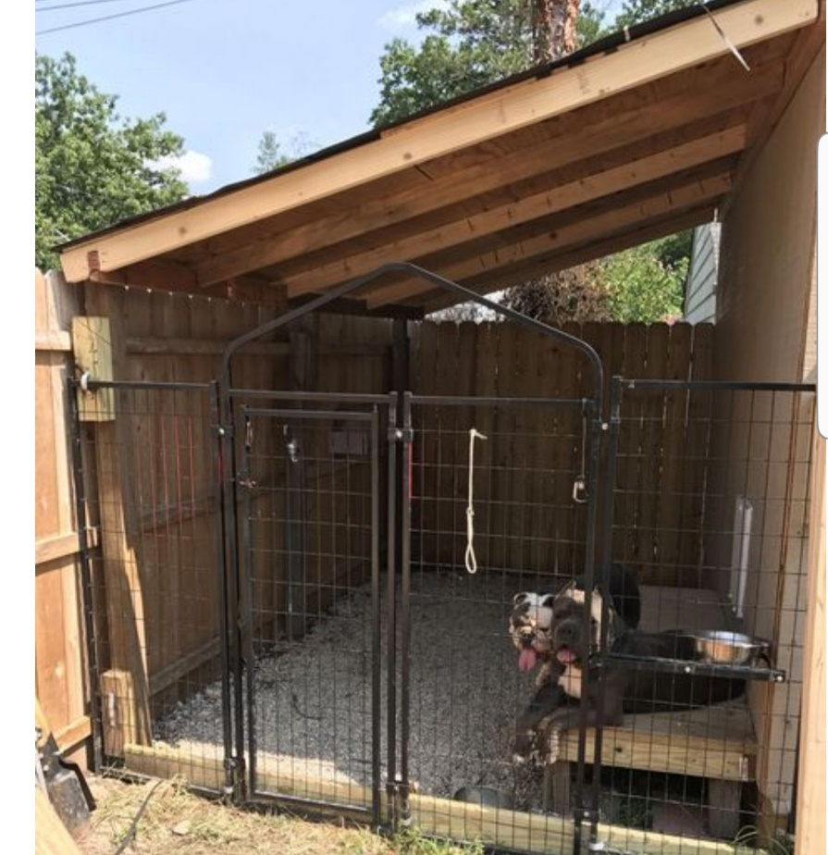

*\*These pictures are illustrative and not an exact depiction of the proposed building(s) or site features. The language of the PUD Ordinance shall rule if there is any discrepancy between these examples and the language of the PUD.*