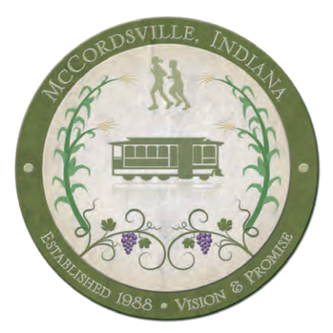
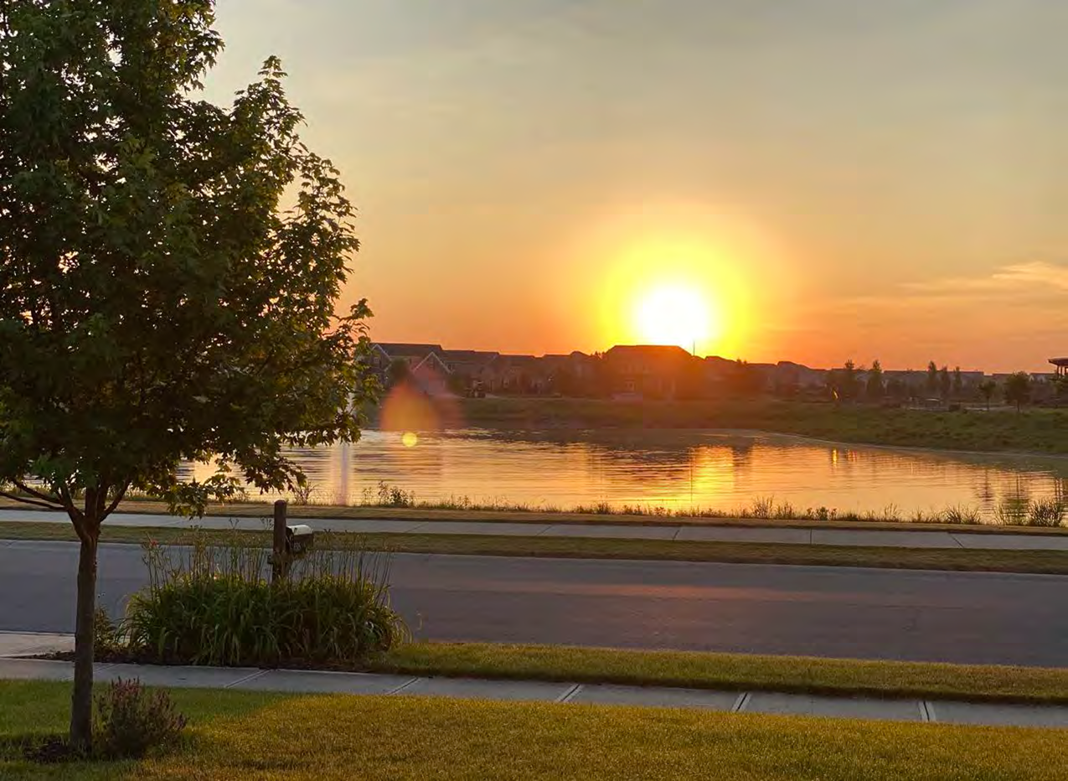
Building Improvement Grant Program

Table of Contents
Program Overview..................................................................................................................................................................3
Program Objectives................................................................................................................................................................... 3
Eligibility Requirements............................................................................................................................................................. 3
Program Boundaries.................................................................................................................................................................. 3
Available Funding.......................................................................................................................................................................... 4
Program Guidelines...................................................................................................................................................................... 5
Eligible Improvements and Expenses.................................................................................................................................... 6
Application Process..................................................................................................................................................................... 9
Timeline...........................................................................................................................................................................................10
Appendices................................................................................................................................................................................... 11

Program Overview
The Town of McCordsville’s Building Improvement Grant Program is designed to stimulate investment and initiate aesthetic improvements to buildings in McCordsville. The program is administered by the Town’s Redevelopment Commission (RDC) whose members in collaboration with the Town Manager and Town staff will work directly with applicants during the grant application process. All completed applications will be reviewed by the McCordsville Redevelopment Commission before being approved for funding.

Program Objectives
The primary objectives of the Building Improvement Grant Program are to:
- Stimulate investment through preservation, rehabilitation, and restoration of commercial
buildings by offering financial assistance for improvements.
- Maintain and improve commercial buildings in the Town to support McCordsville’s economy by providing a pleasing and aesthetically acceptable atmosphere that attracts new businesses and consumers;
- Initiate improvements by helping to offset the cost of rehabilitation of an existing storefront, building, and other select infrastructure that is architecturally consistent with the fabric of our Town.

Eligibility Requirements
To participate in the Building Improvement Grant Program, an eligible property must:
- Be located within the corporate limits of the Town of McCordsville.
  - (See Program Boundaries section for map)
- Have commercial activity as its primary purpose, including but not limited to traditional retail and
specialty shops, services, restaurants, and bars, live entertainment, cultural venues, galleries and professional offices including not-for-profits.
- Not be delinquent in property taxes, Town liens or fines or have any outstanding code compliance issues. This requirement applies to both property and applicant.

Program Boundaries
All eligible properties must be located within the corporate limits of the Town of McCordsville. An up-to-date map can be found on the Town of McCordsville’s website by clicking here.

Available Funding
The Town of McCordsville offers two different levels of grants to assist commercial property and business owners in the Town of McCordsville. Available funding includes a Small to Mid-Size Projects Grant and a Large Improvement Grant. If you are unsure which grant is right for your property, please contact the Town Manager.
Applications are accepted on a rolling basis and are due the fifteenth (15th) calendar day of each month to be considered at the following months meeting. Grant recipients will be notified within 30 days of the monthly application deadline.
Applications will continue to be accepted throughout the year until the Building Improvement Grant Funds are depleted for the award year.
Each building may receive funding only once per year.
All improvements must comply with local and state ordinances and codes.

Small to Mid-Sized Projects Grant
A 75% reimbursement of total approved actual project costs up to a maximum of $1000 per business/building owner.

Large Projects Grant
A 50% reimbursement of total approved actual project costs up to a maximum of $5000 per business/building owner ($10,000 total
project cost).

Program Guidelines
Start of Work: Work related to a Building Improvement Grant cannot begin until authorized by the Economic Re-Development Commission McCordsville Redevelopment Commission. Funds spent before grant approval do not qualify as matching funds and are not eligible for reimbursement.

Distribution of Grant Money: Funds will be allocated on a first come, first serve basis according to the date of application and subject to the availability of budgeted funds.

Changes to Project Plans: Any unapproved changes to project plans will void the grant and result in nonpayment of funds. If recipient decides to change the project after approval, they must immediately contact the Town Manager for additional project review. Funding awards cannot be increased after notification of the initial award.

Ownership of Property: If the applicant is not the owner of the building, written consent detailing the intended improvements must be obtained from the legal owner and submitted with the application. No grants will be awarded to government-owned properties. Non-profit organizations are not excluded from applying
for grant funds; however, priority will be given to privately-owned commercial or mixed-use buildings.

Cost Estimates (Bids): For Large Project Grants, the applicant is required to obtain in writing two preliminary cost estimates for all eligible improvements for which funding is being requested. The bids should be itemized for each portion of the improvement project (exterior painting, window repair, etc.). The RDC reserves the right to request additional bids at any time. All improvements that are not eligible for the Building Improvement Grant Program should be bid separately. The bids submitted to the Program Administrator shall include only those improvements that are eligible for grant assistance. Bids must be made from the same scope of work by each contractor. Projects that are approved for funding will be based on the lowest of the bids; however, the applicant may select and of the submitted bidders to construct the improvement if the applicant chooses to pay the higher cost.

Permits & Fees: The grant recipient is responsible for obtaining any required local and/or state permits. Additional information on permits is available on the Town of McCordsville's Planning Department website. Town and State permit fees may be required and are not eligible for grant funding.

In Addition:
• All construction management shall be the responsibility of the applicant.
• Project costs are not to include the acquisition of real estate property.

Eligible Improvements and Expenses
Design Review
All applications are evaluated by the RDC.
All projects seeking grant funding should follow these standards and guidelines. All projects are subject to approval by the McCordsville Redevelopment Commission who may approve or deny portions of each application and accept the altered project without resubmission.
In addition, each grant is available for a specific set of improvements or related expenses. On the following pages you will find a listing of project expenses that may be eligible for funding and those that are ineligible. If you are unsure, please ask the Town Manager.

Eligible Improvements & Expenses

Awnings - Canvas awnings without signage. Also includes canopies, marquees, and railings where historically and/or architecturally appropriate. May also include the removal of non-conforming or unused awnings and canopies.

Lighting - Restoration, replacement, or new construction of historically and/or architecturally sensitive decorative lighting fixtures for the exterior of the building.

Hardscapes - Hardscapes such as trellis work and fixtures permanently adhered to the façade of the building may be considered on a case by case basis if they are part of a larger design scheme.

Other Small Projects - Miscellaneous small projects that fall beneath the funding limit of $1000 may include window and door repair or replacement, exterior surface cleaning and painting, and small detail work.

Landscape – Landscape improvements which are permanent in nature (trees, bushes, etc.).

Infrastructure-Infrastructure improvements to the privately owned building and premises including but not limited to, repaving private parking lots, curb and sidewalk repairs, and pavement striping.

Doors and Windows– Repair, restoration, replacement and installation of doors and windows, frames, railings, sills, glazing or glass, including storefront display windows. Restoration or reconstruction of original store-front entrance, as well as original window openings, is encouraged.

Exterior Wall Finishes – Cleaning, repairing, or repainting building exterior surfaces, including brick,
stone, wood, cast iron, tile, stucco or other similar exterior finishes and decorative treatments. All exterior wall finishes and improvements will be compatible to the architectural style of the building, and color schemes shall accent the building and harmonize with adjacent buildings.

Cornices and Decorative Detailing – Repairing or replacing cornices and other decorative detailing.

Site Improvements - Including decorative fencing and improved pedestrian amenities such as benches.

Structural Reinforcement – As necessary to rehabilitate the façade(s) and/or roof and chimneys. Costs associated with structural reinforcement may not exceed 25% of the total project cost.

Other Repairs - Repairs and other exterior improvements that may improve the aesthetic quality and historic integrity of the building.

Ineligible Improvements & Expenses

Inappropriate Materials and Treatments - Including but not limited to the installation of aluminum or vinyl siding and the use of sandblasting.

Interior Improvements - Including restoration or rehabilitation work, interior window coverings, furnishings, equipment, and interior window displays.

Electrical Work - Except as related to exterior lighting.

Security Systems

Personal Property - The purchase and installation of furnishings, equipment, or other personal property which does not transfer ownership as part of the real estate.

Permits & Fees - Any local and/or state permitting costs or fees.

Work Prior to Grant Approval-Any work in progress or completed prior to grant approval.

Additions-Any additions to the existing structure.

Application Process
Pre-Application Meeting
All potential applicants are required to meet with the Program Administrator prior to application submission.
Town Manager, building@mccordsville.org (317) 335-3151
Application Submission
In addition to the completed Building Improvement Grant Application, all applications must include:
- Current photographs of the property to be improved.
- Written description of current condition of the building including any significant maintenance issues.
- Detailed project plans and specifications, including a written description of improvements to be made indicating project materials, finishes and colors to be used.
- Samples of all materials and surface applications to be used in the rehabilitation (i.e. paint, awning color/material, and any other finishes or treatments). Samples can usually be obtained from the manufacturer, distributor, or retailer.
- Copies of receipts or other documentation showing personal property, business property and real estate taxes paid in full is required to be eligible for program funding and is to be submitted with completed application. If unable to provide receipts, documentation may be obtained by the applicant from the Hancock County Treasurer’s Office (317-447-1152).
- Bid/Estimate Summary Sheet and two preliminary construction or contractor cost estimates/bids in writing, itemized for each portion of the project.

Application Deadline:
Applications are due the fifteenth (15th) calendar day of each month to the RDC which may be considered at the following months meeting.

Applications should be submitted to:
McCordsville Redevelopment Commission
Town Hall c/o Town Manager
6280 W 800 N
McCordsville, IN 46055

Timeline
Application Received: The McCordsville Redevelopment Commission receives completed application and all supplemental materials by the applicable due date.

Design Review: Application is evaluated by the McCordsville Redevelopment Commission. See above (Eligible Improvements & Expenses) for more information.

Application Presented: The Applicant must present their Building Improvement Grant request in person or virtually at the assigned RDC meeting.

Design Approval: The McCordsville Redevelopment Commission may approve or deny portions of any application and accept the altered project without resubmission.

Notification of Award: Grant recipients will be notified approximately 30 days after the application deadline.

Building Improvement Agreement Signed: A Building Improvement Agreement is signed by the McCordsville Redevelopment Commission and the grantee to verify the approved Scope of Work and reimbursement amount.

Maintenance Agreement Signed: Grant recipient signs a Maintenance Agreement consenting to maintain the improved property for 2 years from the date of receiving grant funding.

Grant Program Recognition: Upon notification of receipt of the grant, each building/business owner is required to display a sign, provided by the McCordsville Redevelopment Commission , stating the project was partially funded by a grant from the Town of McCordsville’s Building Improvement Grant Program. This sign shall be displayed in a prominent location on or near the front façade of the project building during the duration of construction and for three (3) months after project completion, at which time the sign shall be returned to the McCordsville Redevelopment Commission . Failure to return the sign will result in deduction of the cost of the sign from the reimbursement amount.

Work Commences: All improvements must be started within 60 days of project approval.

Work Completed: All improvements must be completed within 6 to 12 months of project
approval, depending on the project/grant size. A 6 month extension may be granted with demonstrated hardship.

Inspection: All improvements must be inspected by the Program Administrator and certified by building inspectors to verify work has been completed according to the Building Improvement Agreement.

Submission of Final Documentation: “After” photos and paid invoices itemizing all eligible costs are submitted to the McCordsville Redevelopment Commission for verification by the Program Administrator.

Reimbursement: After all work has been completed, funds will be dispersed. Funds may be distributed in phases depending upon project cost and funding circumstances. These factors will be analyzed, administered on a case by case basis and incorporated into the Building Improvement Agreement.

List of Appendices
- Grant Application Checklist
- Grant Application and Bid Sheet
- Building Improvement Grant Agreement
- Building Improvement Grant Maintenance Agreement

Appendix A: Grant Application Checklist
Submit all application material to the McCordsville Redevelopment Commission by the fifteenth (15th) calendar day of the month. Please submit, along with this checklist:

o Completed Building Improvement Grant Application with all necessary information and signatures,
including building owner consent (if applicant is not the legal owner).
o Current photographs of the property to be improved.
o Historic photographs of the property to be improved, when available.
o Written description of the current condition of the building including any significant maintenance
issues.
o Detailed project plans and specifications, including a written description of improvements to be made
indicating project materials, treatments, finishes and colors to be used.
o Samples of all materials and surface applications to be used in the rehabilitation (i.e. paint, awning
color/material, and any other finishes or treatments).
o Copies of receipts or other documentation showing all taxes paid.
o Bid/Estimate Summary Sheet and two preliminary cost estimates/bids in writing by contractors of
construction, itemized for each portion of the project.

Appendix B: Building Improvement Grant Application

Appendix C: Building Improvement Grant Agreement

Appendix D: Building Improvement Grant Maintenance Agreement

