RESOLUTION NO. 040419
DECLARATORY RESOLUTION OF THE
MCCORDSVILLE REDEVELOPMENT COMMISSION

WHEREAS, the McCordsville Redevelopment Commission ("Commission") has investigated, studied and surveyed economic development areas within the corporate boundaries of the Town of McCordsville, Indiana ("Town"); and
WHEREAS, the Commission has selected an economic development area to be developed under IC 36-7-14 and IC 36-7-25 (collectively, "Act"); and
WHEREAS, the Commission has prepared an economic development plan ("Plan") for the selected economic development area, which Plan is attached to and incorporated by reference in this resolution; and
WHEREAS, the Commission has caused to be prepared:

A map and plat showing:

the boundaries of the area; and

the location of various parcels of property, streets, alleys, and other features that may affect the clearance, replatting, replanning, rezoning or economic development of the area, if any;

An estimate of the costs to be incurred for the economic development of property; and

List of the various parcels of property that may be affected, other than by acquisition, by the establishment of the plan attached as Exhibit B; and
WHEREAS, the Commission has caused to be prepared a factual report ("Report") in support of the findings contained in this resolution, which Report is attached to and incorporated by reference in this resolution;
NOW, THEREFORE, BE IT RESOLVED BY THE MCCORDSVILLE REDEVELOPMENT COMMISSION THAT:

The Commission has selected as an economic development area an area within its corporate boundaries, which area the Commission is hereby designating as the McCordsville Mt. Comfort Corridor Economic Development Area ("Area"), and which Area is described in Exhibit A.

The Commission finds that the Plan for the Area:

Assists in the promotion of significant opportunities for the gainful employment of the citizens of the Town;

Assists in the attraction of major new business enterprises to the Town;

Benefits the public health, safety, morals and welfare of the citizens of the Town;

Increases the economic well-being of the Town and the State of Indiana; and

Serves to protect and increase property values in the Town and the State of Indiana.

The Commission finds that the Plan cannot be achieved by regulatory processes or by the ordinary operation of private enterprise without resorting to the powers provided the Commission under IC 36-7-14 because of the lack of local public improvements and the costs of construction of road, water, sewer and storm drainage infrastructure improvements needed to serve the Area prevents the improvements from being undertaken solely by private enterprise. There is no regulatory process available to build infrastructure or to provide incentives to encourage economic growth in the Area. Also, the development and implementation of a comprehensive plan for the land use, road and utility infrastructure, and streetscape and signage, is essential to the success of site development in the Area.

The Commission finds that the public health and welfare will be benefited by the accomplishment of the Plan for the Area, specifically by the construction of infrastructure improvements needed in the Area, including road, water, sewer and storm drainage improvements to stimulate private investment in the Area.

The Commission finds that the accomplishment of the Plan will be of public utility and benefit as measured by a reasonable expectation of:

The attraction of permanent jobs;

An increase in the property tax base;

Improved diversity of the economic base; and

Other similar benefits, specifically by providing essential road, water, sewer and storm drainage to support industrial and commercial development in the Area.

The plan for the Area conforms to other development and redevelopment plans for the Town.

The Commission proposes to acquire interests in real property within the boundaries of the Area as shown in the Plan. The list of owners of various parcels of property proposed to be acquired is attached as Exhibit B.
The Commission hereby finds that the property so described in Exhibit B is the property that may be affected by the establishment of the Area because the properties are in the Area and property values would reasonably be expected to increase as a result of creating the Area and implementing the Plan.

The Commission estimates that the costs, if any, to be incurred for the initial economic development of property will be approximately $23,569,000 as set forth on Exhibit C. The costs to be incurred for the acquisition of property will not exceed the average of two appraisals unless specifically approved by resolution of the Commission.

The Commission finds that no residents of the Area will be displaced by any project resulting from the Plan; and, therefore, the Commission finds that it does not need to give consideration to transitional and permanent provisions for adequate housing for the residents.

This paragraph shall be considered the allocation provision for the purposes of IC 36-7-14-39. The entire Area shall be designated an allocation area, as set forth on Exhibit A, to be known as the McCordsville Mt. Comfort Corridor Allocation Area, as defined in IC 36-7-14-39 ("Allocation Area"). Any property taxes levied on or after the effective date of this resolution by or for the benefit of any public body entitled to a distribution of property taxes on taxable property in the Allocation Area shall be allocated and distributed in accordance with IC 36-7-14-39 or any applicable successor provision. This allocation provision shall expire no later than 25 years after the date on which the first obligation is incurred to pay principal and interest on bonds or lease rentals on leases payable from tax increment revenues.

The Commission hereby finds that the adoption of the allocation provision is reasonably expected to result in new property taxes in the Area that would not have been generated but for the adoption of the allocation provision, as shown in the Report.

All of the rights, powers, privileges, and immunities that may be exercised by the Commission in a Redevelopment Area or Urban Renewal Area may be exercised by the Commission in the Area, subject to the limitations in IC 36-7-14-43.

The presiding officer of the Commission is hereby authorized and directed to submit this resolution, the Plan, and the Factual Report to the McCordsville Advisory Plan Commission ("Plan Commission") for its approval.

The Commission also directs the presiding officer, after receipt of the written order of approval of the Plan Commission which has been approved by the Town Council to publish notice of the adoption and substance of this resolution in accordance with IC 5-3-1-4 and to file notice with the Plan Commission, the Board of Zoning Appeals, the Park Board, the building commissioner and any other departments or agencies of the Town concerned with unit planning, zoning variances, land use or the issuance of building permits. The notice must state that maps and plats have been prepared and can be inspected at the office of the Town's department of redevelopment and must establish a date when the Commission will receive and hear remonstrances and objections from persons interested in or affected by the proceedings pertaining to the proposed project and will determine the public utility and benefit of the proposed project. Copies of the notice must also be filed with the officer authorized to fix budgets, tax rates and tax levies under IC 6-1.1-17-5 for each taxing unit that is either wholly or partly located within the proposed Allocation Area.

The Commission also directs the presiding officer to prepare or cause to be prepared a statement disclosing the impact of the Allocation Area, including the following:

The estimated economic benefits and costs incurred by the Allocation Area, as measured by increased employment and anticipated growth of real property, personal property and inventory assessed values; and

The anticipated impact on tax revenues of each taxing unit that is either wholly or partly located within the Allocation Area.
A copy of this statement shall be filed with each such taxing unit with a copy of the notice required under Section 17 of the Act at least 10 days before the date of the hearing described in Section 14 of this resolution.

The Commission further directs the presiding officer to submit this resolution to the Town Council for its approval of the establishment of the Area.

This resolution shall be effective as of its date of adoption.
ALL OF WHICH IS RESOLVED by the McCordsville Redevelopment Commission this 4th day of April, 2019.
MCCORDSVILLE REDEVELOPMENT COMMISSION

_______________________________________
President

_______________________________________
Vice President

_______________________________________
Secretary-Treasurer

_______________________________________
Member

_______________________________________
Member
ATTEST:

Secretary-Treasurer
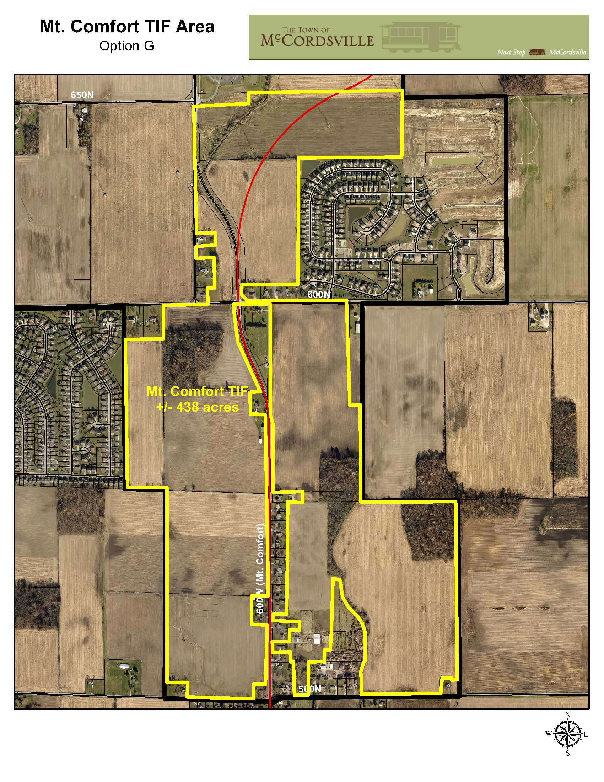
EXHIBIT A
Map of Mt. Comfort Corridor Economic Development Area

MT. COMFORT CORRIDOR ECONOMIC DEVELOPMENT AREA
PARCEL LIST
Parcel Number |  | Owner
30-01-36-600-001.000-018 |  | Abdolaziz M & Masoomeh Ardalan
30-01-36-300-013.000-018 |  | Louise E. Apple Revocable Trust, Sharon Cloyd, Janice  Marie Slunaker & Nancy Lee Thomas
30-05-01-100-007.000-021 |  | Mt. Comfort Road Properties, Inc.
30-05-01-100-009.000-021 |  | DDS, LLC
30-05-01-100-005.000-021 |  | DDS, LLC
30-06-06-200-001.000-021 |  | Marion Hall
30-05-01-400-012.000-021 |  | James Wayne Thomas, Cathryn True,  Rebecca Brannon, Janet Hansen & Sheryl Denny
30-05-01-400-015.000-021 |  | Dennis Fry
30-06-06-300-007.007-021 |  | Mt. Comfort Road Associates, LLC.
30-06-06-200-001.002-021 |  | Paul T. Stone & Life Estate for Thomas W. & Joyce E.

EXHIBIT B
List of Owners of Real Property
Proposed to Be Acquired for, or Otherwise
Affected By, the Establishment of the Area
Acquired Property
Mt. Comfort EDA Area Parcel Value
Parcel ID | Owner | Value
30-01-36-600-001.000-018 | Abdolaziz & Masoomeh Ardalan | $89,500
30-01-36-300-013.000-018 | Louise Apple Revocable Trust | $76,400
30-06-06-200-001.000-018 | Marion Hall | $106,300
30-06-06-200-001.002-018 | Paul Stone Life Estate | $217,800
30-06-06-300-007.007-018 | Mt. Comfort Road Associates | $396,600
30-05-01-400-015.000-018 | Dennis Fry | $62,300
30-05-01-400-012.000-021 | James Thomas, Cathryn True, Rebecca Brannon, Janet Hansen, & Sheryl Denny | $71,700
30-05-01-100-009.000-021 | DDS, LLC | $81,800
30-05-01-100-007.000-021 | Mt. Comfort Road Properties, Inc | $34,700
30-05-01-100-005.000-021 | DDS, LLC | $42,400
30-01-36-300-021.000-018 | Jennifer Whitaker | $68,500
30-01-36-300-022.000-018 | Richard Blaker | $154,700
30-01-36-300-023.000-018 | Stewarts Investments | $181,600
30-01-36-300-024.000-018 | Debra & Scott McCall | $131,100
30-05-01-100-008.001-021 | Travis Cohron | $231,100
30-05-01-100-008.007-021 | Central Indiana Communications | $62,400
30-05-01-100-009.001-021 | Courtney Clardy | $148,200
30-06-06-300-001.000-021 | Donald & Patricia Runyan | $144,400
30-06-06-300-002.000-021 | Timothy & Andrea Miller | $152,400
30-06-06-300-003.000-021 | Noah Phillip & Michelle Woods | $113,900
30-06-06-300-004.000-021 | Olson Irrevocable Trust | $135,400
30-06-06-300-005.000-021 | Terri McCalley | $171,800
30-06-06-300-006.000-021 | Deborah & Smiley Courtney | $130,900
30-06-06-300-007.000-021 | Alvin Jenkins | $132,400
30-06-06-300-008.000-021 | Christopher & Vicki Feltes | $141,100
30-06-06-300-009.000-021 | Robert Rodgers | $118,200
30-06-06-300-010.000-021 | Outback Trust | $133,300
30-06-06-300-011.000-021 | Suzanne Hodgkin | $154,700
30-06-06-300-001.002-021 | Ernest & Celia Borowicz | $63,700
30-06-06-300-002.002-021 | Micheal Rose | $99,300
30-06-06-300-003.002-021 | Timothy & Sharlotte Unroe | $158,300
30-06-06-300-007.002-021 | Donald Fisher | $113,100
30-06-06-301-003.000-021 | Andrew Johnson | $175,400
30-06-06-301-002.000-021 | Mt. Comfort Road Associates | $3,000
30-06-06-301-001.000-021 | Mauro Hernandez | $295,700
30-06-06-300-007.010-021 | Kara Voyles & Nathan Easterday | $232,500
30-06-06-300-008.002-021 | Rudolph & Janet Lee Nylund | $124,200
30-06-06-300-009.002-021 | Charles & Joyce Horning | $134,600
30-06-06-300-010.002-021 | William & William II Bean | $114,700
30-06-06-300-011.002-021 | Alex & Lynn Barrow | $128,300
30-06-06-300-007.006-021 | Alex & Lynn Barrow | $13,400
30-06-06-300-006.002-021 | Charles & Joyce Horning | $54,100
30-06-06-300-007.008-021 | Charles & Joyce Horning | $7,100
30-06-06-300-007.014-021 | Charles & Joyce Horning | $3,100
30-05-01-400-015.004-021 | Christina Kunzman | $112,700
30-05-01-400-023.000-021 | Hegdahl Family Life Estate | $95,700
30-05-01-400-024.000-021 | Hegdahl Family Trust | $200
30-05-01-400-018.000-021 | David Arthur | $157,900
30-05-01-400-017.000-021 | Steven Smith | $159,100
30-05-01-100-005.001-021 | Russell & Shelley Hayse | $198,100
30-05-01-100-005.002-021 | Dennis Apple | $6,600
30-05-01-100-004.000-021 | Dennis Gene Apple | $167,400
30-01-36-300-020.000-018 | Phillip & Beverley Wilson | $141,600
30-01-36-300-018.000-018 | Thomas & Denise McKnight | $6,000
30-01-36-300-019.000-018 | Thomas & Denise McKnight | $171,500
30-01-36-300-017.000-018 | Augusta Keeler, Tambra Bauchert, & Karen Escue | $138,300
30-01-36-300-016.000-018 | Louise Apple Revocable Trust | $124,700
 | Total Value | $6,885,900

Affected Property
All parcels of property in the Area are reasonably expected to be positively affected by accomplishment of the Plan due to an expected increase in property values if the Plan is implemented, including the removal of the legal non-conforming use and the infrastructure constructed.

FACTUAL REPORT IN SUPPORT
OF FINDINGS CONTAINED IN
RESOLUTION NO. 040419 OF THE
MCCORDSVILLE REDEVELOPMENT COMMISSION

The Plan for the Mt. Comfort Corridor Economic Development Area ("Area") will assist in the promotion of significant opportunities for the gainful employment of citizens of the Town of McCordsville, Indiana ("Town") by providing the necessary road, water, sewer and storm drainage infrastructure improvements, streetscaping and signage (collectively, "Corridor Improvements") needed to encourage industrial and commercial development and enhance the Area to encourage new private investment in the Town.

The Plan is reasonably expected to attract new business enterprises to the Town by making the land attractive for development through the construction of Corridor Improvements required to serve and enhance development in the Area.

The planning, re-planning, development, and redevelopment of the Area will benefit the public health, safety, morals and welfare; increase the economic well-being of the Town and the State of Indiana; and serve to protect and increase property values in the Town and the State of Indiana by providing the Corridor Improvements needed to serve the Area and providing for comprehensive planning needed to best utilize land in the Area.

The Plan for the Area cannot be achieved by regulatory processes or by the ordinary operation of private enterprise without resort to IC 36-7-14 (the redevelopment statute) because of the lack of local public improvements and the cost of the construction of the Corridor Improvements that are necessary and contemplated by the Plan, that prevent the improvements from being undertaken solely by private enterprise. Also, there is no regulatory process available to provide funds for such improvements nor to provide incentives to encourage growth in the Area.

The accomplishment of the Plan for the Area will be of public utility and benefit as measured by a reasonable expectation of:

The attraction of permanent jobs;

An increase in the property tax base; and

Improved diversity of the economic base by promoting industrial and commercial development in the Area and the Town.

The establishment of the allocation area and accomplishment of the Plan will reasonably result in new property taxes in the Area that would not have been generated but for the adoption of the allocation provision through the construction of the Corridor Improvements required to make the Area suitable for development which is reasonably expected to create a site that will attract industries and commercial development and put the Commission in a position to partner with companies bringing private investment to the Area as illustrated in the letters attached hereto as Schedule A.

The Commission estimates that it may need to issue bonds or enter into a lease financing in the future to implement the Plan because neither the Town nor the Commission have sufficient funds on hand to complete the projects.

SCHEDULE A

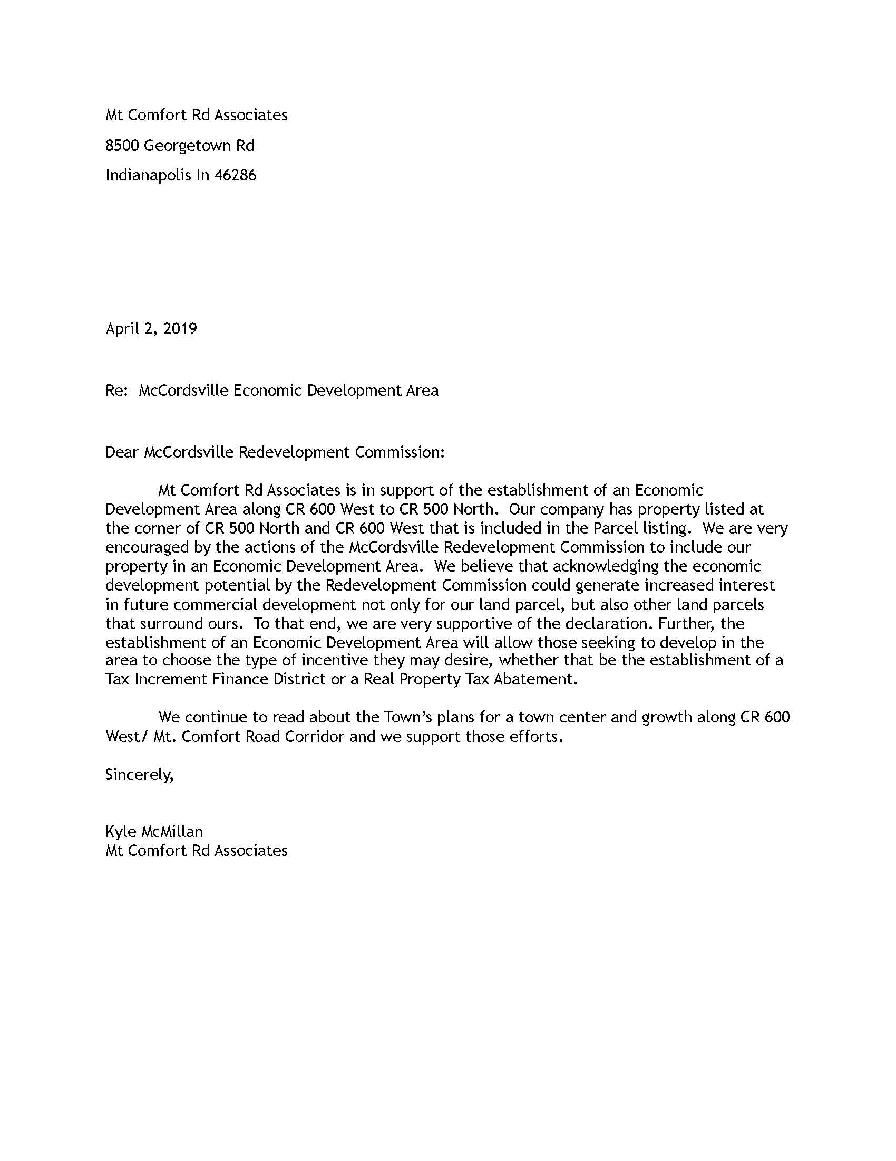

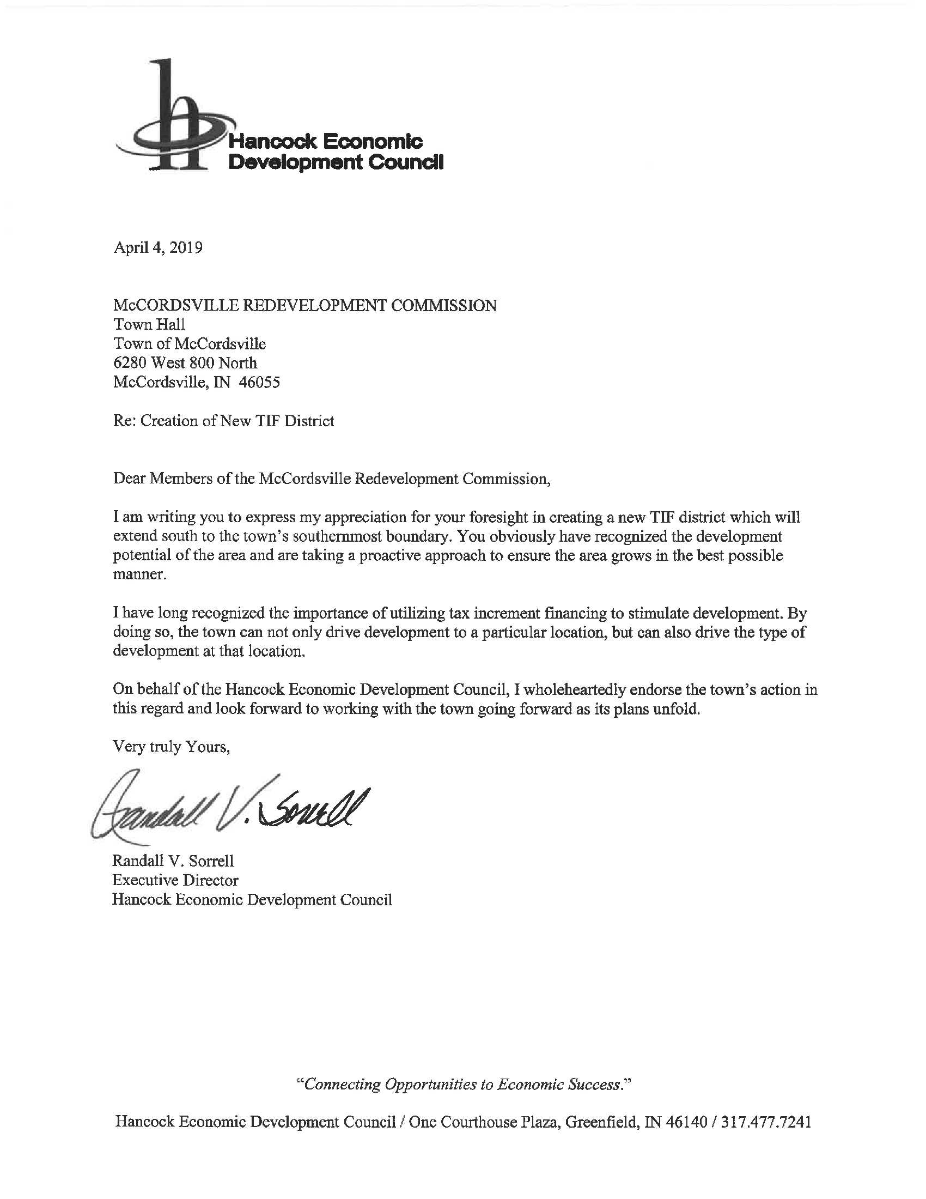

ECONOMIC DEVELOPMENT PLAN
FOR THE MT. COMFORT CORRIDOR ECONOMIC DEVELOPMENT AREA
MCCORDSVILLE REDEVELOPMENT COMMISSION

Purpose and Introduction.
This document is the Economic Development Plan ("Plan") for the McCordsville Mt. Comfort Corridor Economic Development Area ("Area") for the Town of McCordsville, Indiana ("Town"). It is intended for approval by the Town Council, the McCordsville Advisory Plan Commission and the McCordsville Redevelopment Commission ("Commission") in conformance with IC 36-7-14.
Project Objectives.
The purposes of the Plan are to benefit the public health, safety, morals, and welfare of the citizens of the Town; increase the economic well-being of the Town and the State of Indiana; and serve to protect and increase property values in the Town and the State of Indiana. The Plan is designed to (i) assist in the promotion of significant business opportunities for the gainful employment of citizens of the Town, (ii) assist in the attraction of major new business enterprises to the Town, (iii) provide for local public improvements in the Area, (iv) attract permanent jobs, (v) increase the property tax base, and (vi) improve the diversity of the economic base of the Town.
The factual report attached to this Plan contains the supporting data for the above declared purposes of the Plan.
Description of Project Area.
The Area is located in the Town and is described as that area set forth on the map attached as Exhibit A to the Declaratory Resolution.
Project Description.
The initial economic development of the Area will proceed as follows (collectively, "Projects"):
Road Improvements
- 600 N/600W roundabout
- 650 N/600 W intersection improvements
- Improved access to 600 West (mid-block roundabout)
- 600 West improvements
- 500 North improvements
- 600 North improvements
- Local public streets
- Intersection improvements (traffic signal)

Utility Expansion and Improvements
- Sewer extension
- Lift station and force main
- Water extension

Drainage Improvements
- 500N drainage
- Offsite storm sewer
- Detention for north property

Streetscape and Monumentation/Signage
- Street landscaping
- Roundabout landscaping
- Intersection landscaping
- Street lights
- Town monument signage
- Town corridor signage
- Town wayfinding signage

Additional Projects:
Future development may include the capital improvements described as follows (collectively, "Projects"):

Site preparation and excavation;

Construct or repair water towers;

Construct or reconstruct water treatment systems;

Construct or reconstruct storm water drainage systems;

Construct or reconstruct buffer zones/mounding;

Construct or reconstruct beneficial environmental projects;

Purchase or lease of public safety or public works equipment or facilities, which will serve the Area;

Parking and lighting for parking areas;

Equipment that promotes economic development (subject to useful life and financing issues);

Construct or reconstruct facilities to house electronics and the installation of fiber optic cable;

Construct or reconstruct bridges;

Soil reclamation;

Construct or reconstruct railways;

Alternative energy infrastructure; and

Construct, reconstruct and/or extend any and all other utility infrastructure required to support economic development of the Area.

All Projects are in, physically connected to, serving or benefiting the Area.
Acquisition of Property.
In order to accomplish the Projects, the Commission may acquire the interests in property listed in Exhibit B to the Declaratory Resolution.
In the event privately owned parcels are needed, the Commission shall follow procedures in IC 36-7-14-19 in any current or future acquisition of property. The Commission may not exercise the power of eminent domain in an economic development area.
Procedures with respect to the Projects.
In accomplishing the Projects, the Commission may proceed with the Projects before the acquisition of all interests in land in the Area.
All contracts for material or labor in the accomplishment of the Projects shall, to the extent required by law, be let under IC 36-1.
In the planning and rezoning of real property acquired or to be used in the accomplishment of the Plan; the opening, closing, relocation and improvement of public ways; and the construction, relocation, and improvement of sewers and utility services; the Commission shall proceed in the same manner as private owners of the property. The Commission may negotiate with the proper officers and agencies of the Town to secure the proper orders, approvals, and consents.
Any construction work required in connection with the Projects may be carried out by the appropriate municipal or county department or agency. The Commission may carry out the construction work if all plans, specifications, and drawings are approved by the appropriate department or agency and the statutory procedures for the letting of the contracts by the appropriate department or agency are followed by the Commission.
The Commission may pay any charges or assessments made on account of orders, approvals, consents, and construction work with respect to the Projects or may agree to pay these assessments in installments as provided by statute in the case of private owners.
None of the real property acquired for the Projects may be set aside and dedicated for public ways, parking facilities, sewers, levees, parks, or other public purposes until the Commission has obtained the consents and approval of the department or agency under whose jurisdiction the property will be placed.
Disposal of Property.
The Commission may dispose of real property acquired, if any, by sale or lease to the public after causing to be prepared two (2) separate appraisals of the sale value or rental value to be made by independent appraisers. However, if the real property is less than five (5) acres in size and the fair market value of the real property or interest has been appraised by one (1) independent appraiser at less than Ten Thousand Dollars ($10,000), the second appraisal may be made by a qualified employee of the Department of Redevelopment. The Commission will prepare an offering sheet and will maintain maps and plats showing the size and location of all parcels to be offered. Notice will be published of any offering in accordance with IC 5-3-1. The Commission will follow the procedures of IC 36-7-14-22 in making a sale or lease of real property acquired.
In the alternative, the Commission may follow any alternative procedures permitted by law.
Financing of the Projects.
It is the intention of the Commission to issue bonds payable from incremental ad valorem property taxes allocated under IC 36-7-14-39 in order to raise money for property acquisition and completion of the Projects in the Area. The amount of these bonds may not exceed the total, as estimated by the Commission of all expenses reasonably incurred in connection with the Projects, including:

The total cost of all land, rights-of-way, and other property to be acquired and developed;

All reasonable and necessary architectural, engineering, construction, equipment, legal, financing, accounting, advertising, bond discount and supervisory expenses related to the acquisition and development of the Projects or the issuance of bonds;

Interest on the bonds (not to exceed 5 years from the date of issuance) and a debt service reserve for the bonds to the extent the Commission determines that a reserve is reasonably required; and

Expenses that the Commission is required or permitted to pay under IC 8-23-17.
In the issuance of bonds the Commission will comply with IC 36-7-14-25.1.
As an alternative to the issuance of bonds or in conjunction with it, the Commission may enter into a lease of any property that could be financed with the proceeds of bonds under IC 36-7-14. The lease is subject to the provisions of IC 36-7-14-25.2 and IC 36-7-14-25.3.
As a further alternative, the Commission may pledge tax increment pursuant to IC 36-7-14-39(b)(2)(D) to any bonds issued by the Town.
Amendment of the Plan.
By following the procedures specified in IC 36-7-14-17.5, the Commission may amend the Plan for the Area. However, any enlargement of the boundaries of the Area must be approved by the Town Council.

EXHIBIT C
Mount Comfort EDA Area Estimate
