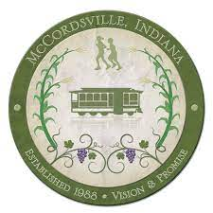

McCordsville Redevelopment Commission Request for Proposals

McCordsville Town Center Redevelopment Area
January 4, 2022

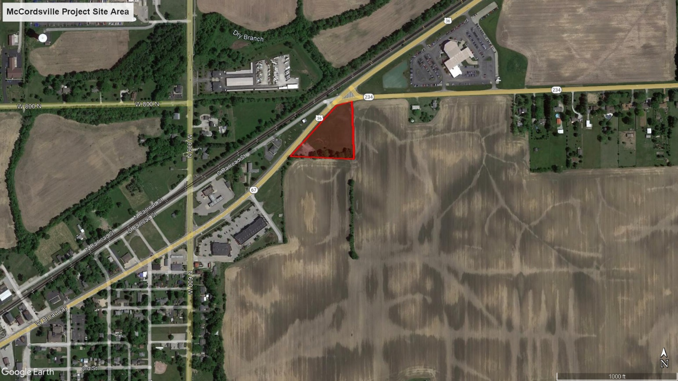

McCordsville Redevelopment Commission 6280 West County Road 800 North, McCordsville, IN 46055
Overview

Introduction

The McCordsville Redevelopment Commission (the “RDC” or “Commission”), pursuant to Indiana Code 36-7-14-22, is requesting proposals (“Proposals”) from qualified parties for the acquisition of land as a part of creating their Town Center. The project being contemplated by this Request for Proposal (the “Project”) is located at the corner of West Broadway (aka SR 67) and W SR 234 (aka 800 North) in the Town of McCordsville, Indiana (the “Project Site” as shown in the cover page).

Proposals are due at the office of the Town of McCordsville at 6280 West County Road 800 North, McCordsville, IN 46055 (the “Town Office”) on or before 12:00pm, January 28, 2022. On February 1, 2022, at 6:30 PM, the RDC will open the Proposals in the Town Office at 6280 West County Road 800 North. The final selection will be made by the RDC on or around March 1, 2022.

Proposal Availability

The Request for Proposals packet may be obtained directly by emailing Marlon Webb, Owner’s Representative, at mwebb@theveridusgroup.com.

McCordsville Redevelopment Commission (RDC) Background

The McCordsville Redevelopment Commission is composed of six members: three members appointed by the Town Council President, two members appointed by the Town Council, and one non-voting school appointment. The Commission was created to make maximum opportunity for rehabilitation, redevelopment or economic developments of areas in the Town. Its primary purpose is to finance projects for the betterment of the community by designating TIF districts in order to capture taxes of new development for the use of constructing these improvements that help benefit the community.

McCordsville Town Center Project Overview

With a population nearing 8,500 people, McCordsville is now the second largest municipality solely in Hancock County. Incorporated in 1988, McCordsville is beginning to feel the effects of being conveniently located in the northwest corner of Hancock County just south of Geist Reservoir, bordering the Cities of Indianapolis and Lawrence in Marion County and the City of Fishers in Hamilton County.
In 2020, the Town Council adopted a conceptual Town Center plan. This project included a planning process to develop a phased concept plan for the development of a Town Center. The primary goal of the work was to develop concept plans for the Town Center area and determined a phased plan approach to development, a possible schedule and determine preliminary costs for each phase.

Through this process, the Town realized that they wanted to accomplish three things:

- Develop a unique identity and character for our community. For far too long, McCordsville has been a residential extension of Lawrence and Fishers. The residents and officials alike want to develop a unique identity and character for McCordsville which will celebrate our history and heritage as a community.

- Form a connected, walkable town center to create experiences for our community. We want to develop a destination in McCordsville which attracts and draws visitors into the core of the Town to experience the culture, enjoy the social events and patronize the local businesses. We want the area to be walkable and connect with our growing trail system.

- Enhance community economic development opportunities while growing a diversified tax base. We need to create opportunities for developments of all kinds in order to continue growing our tax base. Housing, retail and office options are all important to growing our community.

Submittal Information

Project Requirements

The developer’s ability to meet the requirements, as set forth below, will be a primary criterion in evaluating proposals. The proposals shall include (but are not limited to) the following:

- Purchase price and terms for Project Site(s)
- Identify potential use(s) for the commercial space
- Total developer investment anticipated, including financing relationships which demonstrate an ability to finance the improvements contemplated in the proposal
- Total public assistance anticipated (if any)
- Number of jobs created
- Schedule showing construction beginning in less than 24 months
- Sealed financial statement showing ability and capacity to complete the project (this is only reviewed by the Town’s financial advisor and is not considered a public document)

The RDC has an expectation of a design that complements and enhances the commercial corridor, but which also is progressive and innovative in nature. While design is not requested with this proposal, the developer must include the Commission in the design process and the Commission reserves the right to approve any conceptual exterior designs for the project (with such approval not unreasonably withheld).

Proposal Contents

Proposals must include the following information:

Cover Page
- Proposer’s name and mailing address.
- Proposer’s current legal status: corporation, partnership, sole proprietor, etc.
- Contact person’s name, title, phone number, and e-mail address.
- Signature of authorized corporate office for each entity proposing as a partnership or team.
- A Proposal submitted by a trust (as defined in Indiana Code 30-4-1-1) must identify the beneficiary of the trust and the settlor empowered to revoke or modify the trust.

Project Description
- A description (narrative, preliminary schematic plans if available) of the proposed development of the Project Site(s).
- A description of the land use for areas within the development (if more than one use is proposed).
- Identify at least one (1) primary tenant/user.
- If more than one tenant/user is required, provide documentation showing interest from at least two (2) credit tenants.
- A description of the number of jobs, with salary levels, anticipated with this project.
- Description of long-term ownership plans of the project, whether the developer plans on owning or selling the project once complete.
- If known by the developer within the timeframe of this RFP, identify any construction companies or design consultants who will be used for this project.

Project Finances
- Proposed acquisition price for the land (see Offer Price section below).
- Preliminary capital pro forma showing the sources and uses of funds to purchase the Project Site(s) and construct the development. Detail any non-conventional means of financial assistance (federal/state funding, other public/not-for-profit assistance, etc.).
- Sealed financial statement for the developer or equity partner showing the capacity to finance and/or complete the project.

Offer Price
Proposers will need to clearly indicate their offer price and terms for the property. The average of two appraisals for the subject property is as follows:

Project Site Area #1
- The property is located at the corner of West Broadway (aka SR 67) and W SR 234 (aka 800 North).
  - 5759 West Broadway: 30-01-25-200-002.000-018
- Condition: This site is vacant ground.
- Price: $750,000

The cover pages for the appraisals can be found in Appendix B. The offer price is only one of the factors considered by the RDC which reserve the right to accept, reject, or table any and/or all Proposals. Any Proposals received by the RDC are subject to the terms of the offering process described herein and in Indiana Code 36-7-14-22.

Project Schedule
- A proposed timeframe for the implementation of the development, including identification of any conditions which must be met before the proposal can become a reality. The schedule should include the time needed to obtain financing, complete design and secure permits and approvals, prepare Project Site(s), state and complete construction.

Developer Experience
- Provide examples in graphic and/or narrative form of related projects the developer has completed which are similar in nature to the one described in this RFP. Include project references, location, type of development, proposer’s role(s), cost of project, funding sources, status of project, and information about any continued financial or operating interest in each.
- Include previous relevant experience working with the public sector or not-for-profits on joint development projects.
- Summarize any pending or current lawsuits to which the responder or any principals of the responder have been a party which could limit a developer’s ability to perform the work contemplated in their proposal.

Organizational Capacity
- Describe, in detail, what other development projects the developer is currently working on, including project size, scope, timeline, etc. Also, include the number of employees of the firm and brief biographies of firm principals or offices. Experience of firm principals or officers in other positions may be used as a replacement for developer experience.
- Provide evidence of capacity to finance the project. This may be provided in the form of the financial capacity of the firm, and/or the ability of the developer to secure necessary funding sources.
- Specify whether the development entity is or intends to form a corporation, a general or limited partnership, a joint venture, or other type of business association to carry out the proposed development.

Submittal and Deadline
Proposers must submit copies of their Proposals in six bound copies and one electronic copy. All supporting documentation must be on paper no larger than 11” x 17”. Proposals and supporting documentation must be submitted in a sealed envelope labeled “RDC – Town Center Redevelopment Area Proposal”. Proposers may choose to provide additional sets if and when invited to do so for presentation purposes. Submissions will not be returned.

Proposals must be delivered to the Town of McCordsville, Town Office on or before 12:00pm on
January 28, 2022, and addressed to:

To: McCordsville Redevelopment Commission
c/o Tonya Galbraith
“RDC – Town Center Redevelopment Area Proposal”
6280 West County Road 800 North
McCordsville, IN 46055

Evaluation

Review / Selection Process

Once opened by the RDC, the Proposals will be reviewed by a committee comprised of members and staff of the Commission and other Town officials and consultants as deemed necessary by the RDC (the “RDC Review Committee”). Some or all of the proposers may be requested to appear for an interview and present their Proposals to the RDC Review Committee.

The Proposals will be due on January 28, 2022 at 12:00pm. The Proposals will then be opened by the RDC in their public meeting on February 1, 2022 at 6:30pm. Upon opening of the Proposals, the RDC will begin its formal review process through the RDC Review Committee. The RDC Review Committee will then make a recommendation as to the Proposal that best meets the evaluation criteria to the Commission.

Evaluation

Each proposal will be reviewed for quality, content and conformance with the requirements above. The RDC Review Committee will make a recommendation to the RDC for final review, acceptance and approval.

General Information

Schedule

Issuance of RFP January 4, 2022
Questions Due to RDC January 14, 2022
Submission Deadline for Proposals January 28, 2022
Proposals Opened by RDC February 1, 2022
Review / Evaluation of Proposals / Interviews February 1 – February 28, 2022
Selection of Developer March 1, 2022

Inquiries

All inquiries regarding this Request for Proposals should be made through the RDC’s representation, Mr. Marlon Webb, Owner’s Representative. The contact information is as follows:

Mr. Marlon Webb
Owner’s Representation for the Town of McCordsville
(219) 629-9322
mwebb@theveridusgroup.com

General Terms and Conditions

Addenda and Explanations Written and Oral

Should a Proposer find any discrepancy in or omission from these instructions or any other forms in the Offering Packet, or should the Proposer have questions regarding any aspect of this offering, the Proposer shall submit written questions via email to the RDC’s Representative, Marlon Webb, addressed to mwebb@theveridusgroup.com by 12 noon on January 14, 2022. The RDC will respond in writing to all questions at one time and in one document which will be an addendum to the Offering Packet (on or about January 19,2022) and such document will be provided to all interested Proposers. The RDC, its representatives, employees, or agents will not be responsible for any oral instructions and or interpretations.

Project Agreement

The successful Proposer will be expected to enter into a Purchase and Development Agreement with the Commission, which Project Agreement shall contemplate the conveyance of the Project Site, all easement agreements related to the Project Site and set forth the nature of the development and/or improvement of the Project by the developer. By the delivery of the Offering Sheet, Proposer agrees to negotiate the Purchase and Development Agreement in good faith and acknowledges and agrees that if, in spite of good faith negotiations, Proposer and the RDC cannot reach agreement on a form of Project Agreement on or before 45 days following the acceptance of the proposal of such successful Proposer, then such successful Proposer shall have no further rights (development or otherwise) in or to the Project Site and the RDC may re-offer the Project Site or otherwise dispose of the same as permitted by law.

Rejection or Acceptance of Offers

The RDC reserves the right to accept, reject or table any and/or all Proposals. If the RDC accepts or provides notice of acceptance, the successful Proposer shall begin negotiating the Project Agreement within ten (10) days after such Proposer is notified of acceptance.

Applicable Laws

Any contract(s) resulting from the proposal submitted will be developed in accordance with and governed by the laws of the State of Indiana.

Costs for Submitting Proposals

The Town of McCordsville and the RDC will not be liable for any costs incurred by the respondents in replying to this Request for Proposals. The Town of McCordsville and RDC are not liable for any costs of work or services performed by the selected Proposer prior to the award of the contract.

Authority to Bind Submitting Entity

The signatory for the entity submitting a proposal represents that he or she has been duly authorized to execute the proposal documents on behalf of the submitting entity and has obtained all necessary or applicable approvals to make this submission on behalf of the entity before affixing his or her signature to the proposal.

