ORDINANCE NO. 051022
ORDINANCE AMENDING ORDINANCE NO. 121410, THE ZONING ORDINANCE FOR THE TOWN OF McCORDSVILLE, INDIANA
WHEREAS, the Town Council of the Town of McCordsville, Indiana, has heretofore adopted Ordinance No. 121410 as the Zoning Ordinance; and
WHEREAS, the Town Council of McCordsville, Indiana, has, after receiving a favorable recommendation from the McCordsville Advisory Plan Commission on a request to initially zone property from Hancock County R2.5, Hancock County R-3, Hancock County R-4, Hancock County B-2, R-2, R-3, CN to Neighborhood Commercial (CN) and Medium Intensity Industrial (I-2);
THEREFORE BE IT ORDAINED by the Town Council of the Town of McCordsville, Indiana that Ordinance No. 121410 is hereby amended as follows:
SECTION 1. The real estate more particularly described in the attached Exhibit A is hereby rezoned to the CN and I-2 zoning designations.
SECTION 2. Permitted Uses. The permitted uses are those uses listed in McCordsville Zoning and Subdivision Control Ordinances for the CN and I-2 zoning districts, including research and development, and as limited or otherwise permitted by the Commitments attached hereto as Exhibit B.
SECTION 3. Development Standards. The Town of McCordsville Zoning Ordinance, as amended, Subdivision Control Ordinance, as amended, and any other applicable Town Ordinance, as amended, shall apply to this property upon the effective date of this Ordinance.
SECTION 4. Commitments. In addition to the terms and regulations of this Ordinance and the other applicable Town of McCordsville Ordinances, the Commitments attached hereto, as Exhibit B, apply to the Real Estate.

SECTION 5. This Ordinance shall remain in full force and effect from and after its passage and posting as required by the law within the Town of McCordsville, Indiana.
SECTION 6. Introduced and filed on the 10th day of May, 2022. A motion to consider on First Reading on the day of introduction was offered and sustained by a vote of 4 in favor and 1 opposed pursuant to I.C. 36-5-2-9.8.
Duly ordinated and passed this ___ day of ____________, 2022 by the Town Council of the Town of McCordsville, Hancock County, Indiana, having been passed by a vote of _ in favor and _ opposed.

TOWN OF McCORDSVILLE, INDIANA, BY ITS TOWN COUNCIL
Voting Affirmative: Voting Opposed:

______________________________ _________________________________
Thomas R. Strayer Thomas R. Strayer

______________________________ __________________________________
Larry J. Longman Larry J. Longman

______________________________ ___________________________________
Gregory J. Brewer Gregory J. Brewer

______________________________ ____________________________________
Chad D. Gooding Chad D. Gooding

_______________________________ _____________________________________
Branden D. Williams Branden D. Williams

ATTEST:
_______________________________
Staci A. Starcher
Clerk Treasurer

This is instrument was prepared by Briane M. House.

I affirm, under the penalties for perjury, that I have taken reasonable care to redact each Social Security number in this document, unless required by law. Briane M. House

Exhibit A
Legal Description – The Real Estate which shall be zoned I-2, except as otherwise noted:
A part of the Southeast Quarter of Section 1, Township 16 North, Range 5 East, Buck Creek Township, Hancock County, Indiana, being that 38.65 acre tract of land shown on the plat of an original boundary survey of said tract certified by James D. Smale, PS #LS29500020 on January 17, 2022 as The Schneider Corporation's project number 13835 and that 113.54 acre tract of land shown on the plat of an original boundary survey of said tract certified by Steve W. Reeves, PS #LS20400005 on September 6, 2021) as The Schneider Corporation's project number 13482 (all references to monuments and courses herein are as shown on said plat of survey) described as follows:
Beginning at a Mag Nail at the Southwest Corner of the said Quarter; thence North 00 degrees 12 minutes 03 seconds West, a distance of 2662.47 feet along the West line thereof to a 5/8 inch rebar with “SCHNEIDER FIRM 0001” cap at the Northwest Corner of said Quarter; thence South 88 degrees 11 minutes 59 seconds East, a distance of 2713.69 feet along the North line of said Quarter to a 5/8 inch rebar at the Northeast Corner of said Quarter; thence South 00 degrees 13 minutes 42 seconds, East, a distance of 1330.89 feet; thence North 88 degrees 08 minutes 00 seconds West, a distance of 30.02 feet to the West line of a Right-of-way recorded as Instr. No. 930009095, Instr. No. 202200312, and Instr. No. 202200313 in the Office of the Recorder of Hancock County, Indiana; thence along said Right of Way the following 9 courses; 1)South 00 degrees 04 minutes 39 seconds East 200.02 feet; 2) North 88 degrees 12 minutes 33 seconds West 4.01 feet; 3) South 00 degrees 12 minutes 16 seconds East 92.41 feet; 4) South 15 degrees 53 minutes 45 seconds West 21.64 feet; 5) South 11 degrees 05 minutes 22 seconds West 70.59 feet; 6) South 01 degrees 55 minutes 57 seconds West 268.19 feet; 7) South 08 degrees 48 minutes 52 seconds West 318.94 feet; 8) South 00 degrees 12 minutes 16 seconds East 142.00 feet; 9) South 27 degrees 06 minutes 25 seconds West 15.26 feet to the North line of a tract described in Instr. No. 202119978 to Hancock County BOC, recorded in the Office of the Recorder of Hancock County, Indiana; thence North 88 degrees 12 minutes 55 seconds West along the North line thereof, a distance of 84.41 feet; thence South 00 degrees 13 minutes 43 seconds East along the West line thereof, a distance of 102.82 feet to the North line of a Right-of-way recorded as Instr. No. 202200313 in the Office of the Recorder of Hancock County, Indiana; thence along said Right of Way the following 5 courses; 1) South 75 degrees 25 minutes 37 seconds West 166.88 feet; 2) South 43 degrees 12 minutes 15 seconds West 22.67 feet; 3) South 83 degrees 15 minutes 14 seconds West 101.12 feet; 4) North 88 degrees 12 minutes 55 seconds West 136.00 feet; 5) South 01 degrees 47 minutes 05 seconds West 8.45 feet to the North Right-of-way line of County Road 500 North; thence North 88 degrees 13 minutes 08 seconds West, a distance of 737.05 feet along said right-of-way line; thence South 00 degrees 12 minutes 52 seconds East, a distance of 16.50 feet to a Mag Nail with washer stamped “SCHNEIDER FIRM #0001” at the Southeast Corner of the West Half of the Southeast Quarter of said Section; thence North 88 degrees 12 minutes 54 seconds West, a distance of 1357.47 feet along said South line to the Point of Beginning. Containing 162.32 Acres, more or less.
Excepting the following Real Estate, which shall be included, but zoned CN:
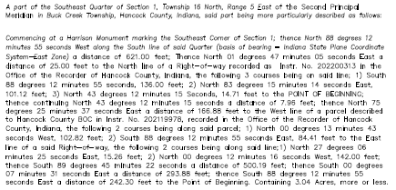

EXHIBIT B

COMMITMENTS CONCERNING THE USE OR DEVELOPMENT OF REAL ESTATE MADE IN CONNECTION WITH A DEVELOPMENT PLAN APPROVAL, ZONE MAP CHANGE OR PLANNED UNIT DEVELOPMENT REQUIRED BY THE TOWN OF MCCORDSVILLE, INDIANA ZONING ORDINANCE

In accordance with I.C. 36-7-4-1015, the owner of the real estate located in the Town of McCordsville, Hancock County, Indiana, which is described below, makes the following COMMITMENTS concerning the use and development of that parcel of real estate:

LEGAL DESCRIPTION:

See EXHIBIT “A” ATTACHED HERETO
(the “Subject Property”)
STATEMENT OF COMMITMENTS:
- . | - The following uses (as described or defined in the Town of McCordsville Zoning Ordinance) shall be prohibited on the Subject Property:  - Agricultural, farm implement sales or service. Storage, shipment, and distribution of agricultural parts and equipment is permitted. *  Auto, Parts Store. Storage, shipment, and distribution of auto parts is permitted. *  Auto, Major Service  Auto, rental  Auto, sales or lease  Auto, storage  Auto, truck or bus rental, sales, or service. Storage, shipment, and distribution of parts is permitted.  Boat or boat trailer sales or service  Boat storage, outdoor  Bottling, beverages  Collection Point, recycling  Collection Point, Donations; permitted if fully enclosed.  Dry cleaning &/or Laundry, Commercial or Industrial. Storage, shipment, and distribution of supplies and materials is permitted in conformance with applicable environmental regulations.  Financial Institution, Payday Loan; provided a bank, credit union or other similar Financial Institution shall be permitted.  Lumber yard. Enclosed fabrication, storage, and shipment of building components is permitted.  Parking as primary use  Penal or correctional facility  Post office with on-store storage of delivery vehicles  Retail Print Shop or Copy Center; Prohibited such as FedX, Kinko’s, PIP, etc. Commercial or Industrial, or wholesale printing permitted if enclosed.  RV sales or service  RV storage, outdoor  Place of worship  Sexually Oriented Business  Tattoo and/or piercing parlor  Truck Stop – a refueling and/or retail store that is designed to cater to semi-trucks. These facilities are typically designed to allow for truck turning movements and have dedicated truck fuel pumps.  Outdoor storage of any material, equipment, product, inventory, or the like is strictly prohibited. Outdoor storage shall mean the storage of anything outside of a 100% enclosed structure; provided, however, outdoor storage of operable and plated vehicles, trucks, and trailers shall be permitted in association with a distribution or warehouse land use.  - The following use shall be permitted only as a Special Exception on the I-2 zoned portion of the Subject Property:  Contractor, commercial  Manufacturing, medium  Self-storage or mini-warehouse  Utility facility  Other uses specifically identified as Special Exceptions in the I-2 Zoning District as of the date of adoption of these commitments, except for any use specifically prohibited above.  - In addition to the Permitted and Special Exception uses of the CN Zoning District, the following uses shall be Permitted or Special Exception, as indicated below, for CN zoned portion of the Subject Property: Conference Center shall be Permitted  Medical hospital, center or complex 10,000 SF or greater (GFA) shall be permitted via Special  Exception  Pharmacy, stand-alone shall be Permitted  Research and Development Facility (including laboratories) shall be Permitted  Restaurant, Eat-in shall be Permitted  Restaurant, Fast Food shall be Permitted  4. No semi-trucks/trailers shall be parked/stored closer than 400 feet from the west right-of-way line of CR 600 W.  5. No primary structure may be located closer than 300 feet from west right-of-way line of CR 600 W.  6. No primary structure may be located closer than 300 feet from the north property line.  7. No semi-trucks/trailers shall be parked/stored closer than 190 feet from the north property line.  8. The half-width rights-of-way for CR 600W, as identified in the Town’s Thoroughfare Plan, is 70 feet. This shall be dedicated to the Town.  9. The half-width rights-of-way for CR 500N, as identified in the Town’s Thoroughfare Plan, is 50 feet. This shall be dedicated to the Town.  10. The half-width rights-of-way for Aurora Way, as identified in the Town’s Thoroughfare Plan, is 35 feet. Any portion of this rights-of-way, located upon the subject property shall be dedicated to the Town.  11. Buffering/screening shall be required as detailed below:  a. Along the south property line an undulating mound, no less than six feet in height, shall be provided. Buffer plantings consistent with those required for a large buffer-yard shall be provided.  b. Along the north property line, from the west property line to the western access road, as shown on Exhibit C, mounding no less than six feet in height shall be provided. This mounding shall also feature a six-foot-tall privacy fence (on top of the mounding) and plantings consistent with those required for a large buffer-yard. Any portion of the above-described buffer that is placed in a tree preservation easement, and said easement is at least 250 feet in depth and preserves an existing mature wooded area, shall not be required to meet the buffer-yard requirements. Additionally, along the north property line, from the western access road, as shown on Exhibit C, to Mt. Comfort Road, undulating mounding no less than five feet in height shall be provided. Buffer plantings consistent with those required for a large buffer-yard shall be provided.  c. Along the east property line an undulating mound, no less than three feet in height shall be provided. Buffer plantings consistent with those required for a small buffer-yard shall be provided.  12. Any wet detention/retention facility shall that is visible from a perimeter roadway shall include an illuminated fountain.  13. B-directional amplification shall be required for all buildings to aide in emergency response radio signals in and out of the buildings. The petitioner commits to working with the Town of McCordsville and Buck Creek Fire Department on the details of this system.  14. Any building adjacent to CR 600W shall not have overhead doors or docks directly facing CR 600W.  15. Road access points shall be as generally shown on Exhibit C. No additional road cuts shall be allowed on CR 600W, unless approved by the McCordsville Town Council.  16. Road improvements, as identified by the Town Engineer, shall be required on CR 500N. These improvements may be phased in conjunction with the construction of road cuts for this development onto CR 500N.  17. The east façade of any building(s) directly adjacent to CR 600W shall have window fenestration and wall plane articulation that is equal to or greater than shown on Exhibit D, as determined by the Architectural Review Committee (ARC).  18. Petitioner agrees that it shall not petition for industrial rezoning north of the Aurora Way Extension.  19. Petitioner agrees that it will not extend Aurora Way west of the site’s proposed western entrance from Aurora Way as approximately depicted on the Preliminary Plan Concept.  20. Petitioner agrees to install a minimum three-foot-tall undulating mound along the west property line. This area shall also be landscaped with the same quantity of plantings as the east property line.
These COMMITMENTS shall run with the land, be binding on the Owner of the above-described real estate, subsequent owners of the above-described real estate and other persons acquiring an interest therein. These COMMITMENTS may be modified or terminated by a decision of the Town of McCordsville Plan Commission or the Town of McCordsville Town Council only after the conduction of a public hearing with proper notice given to all interested parties conducted by the Town of McCordsville Plan Commission or Town of McCordsville Town Council.

COMMITMENTS contained in this instrument shall be effective upon the approval of Petition # PC-22-004 pursuant to the Town of McCordsville Zoning Ordinance, and shall continue in effect until modified or terminated by the Town of McCordsville Plan Commission or the Town of McCordsville Town Council.

These COMMITMENTS may be enforced jointly or severally by:
- The Town of McCordsville Plan Commission;
- The Town of McCordsville Town Council;
- The Town of McCordsville BZA;
- Adjoining and abutting landowners.

IN THE EVENT it becomes necessary to enforce all or any of these Commitments, and where enforcement is by a governmental entity, the entity shall recover its litigation costs and expenses, including attorney’s fees. In all other instances of enforcement by an adjoining landowner, the prevailing party shall pay all costs incurred or on behalf of the prevailing party, which shall include, court costs, reasonable attorney fees reasonable litigation expenses. and damages.

The undersigned hereby authorizes the Town of McCordsville to record this Commitment in the Office of the Recorder of Hancock County, Indiana, upon final approval of petition # PC-22-004 .

IN WITNESS WHEREOF, owner has executed this instrument this day of , 2022.

Printed: Printed

(Owner)
_______________________
By
Printed
Title

(Acknowledgment)

STATE OF INDIANA )
) SS:
COUNTY OF )

Before me, a Notary Public in and for said County and State, personally appeared ________________________________, the Owner of the real estate described above, who acknowledges the execution of the foregoing instrument.

Witness my hand and Notarial Seal this
day of , 2022
Signature
Printed
County of Residence
My Commission expires:

This instrument was prepared by Ryan Crum.

I affirm, under penalties for perjury, that I have taken reasonable care to redact each Social Security number in this document, unless required by law. Ryan Crum

EXHIBIT C
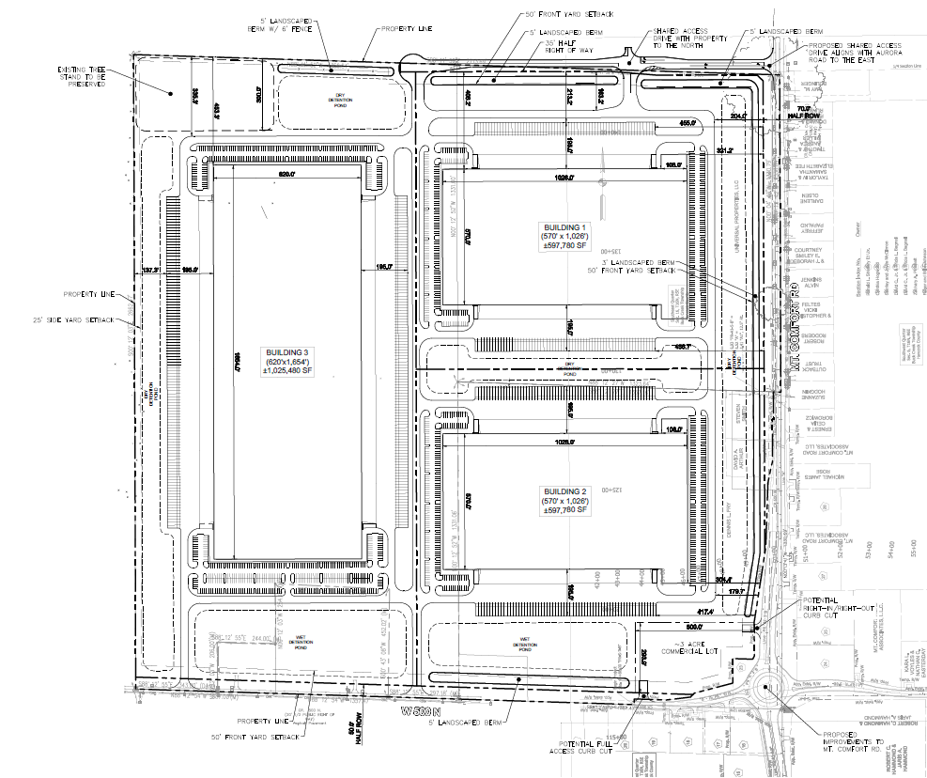

Exhibit D
