

Board of Zoning Appeals Staff Report November 4, 2020
Department of Planning and Building
Town of McCordsville

Project: Family Express, BZA-20-014

Petitioner: Family Express

Location: 5964 W. Broadway (former Village Pantry Station)

Request: The petitioner’s request seeks multiple Development Standard Variances for signage.

Staff Review: Background: This property has been operated as a convenience store and fuel station for decades. Recently, the property was purchased by Additional Real Estate, LLC, and the new owner sought approvals to convert to a Shell/Quickpix branding. Subsequently, the property was sold again, this time to Family Express, who is seeking approvals for their signage and branding.

Existing Conditions: The site features a convenience store, ten (10) fuel dispensers (under canopy), and a carwash on approximately 2.75 acres. The property can be accessed from W. Broadway, CR 600W, and S. Railroad Street. The property is zoned Neighborhood Commercial (CN).

Surrounding Land Use & Zoning: The surrounding land uses are as follows:
- North: Across the railroad tracks is developed as a single-family home, zoned R-3
- East: Developed as a single-family home, zoned R-3
- South: Across W. Broadway is developed as commercial retail featuring a CVS pharmacy and multi-tenant retail center zoned CN
- West: Undeveloped land zoned CN

The petitioner’s specific Variance requests are detailed below.

Development Standards Variance – Section 7.08(B)
This section limits ground signs to a maximum sign area of 36 square feet and 6 feet in height. They can be located no closer than 10 feet to any right of way line. Furthermore, all ground sign structures shall be constructed of decorative brick, stone, or other masonry, stucco, wood or metal, with the base of the structure constructed of decorative brick or stone. The petitioner is proposing a ground sign that exceeds the sign area allowance and does not feature the materials/design required by the Ordinance. The exact location of the ground sign in relation to the right-of-way is not denoted in the petitioner’s packet.

Development Standards Variance – Section 7.08(C)
This section permits wall signs only on primary structures, and therefore since fuel station canopies are accessory structures, a variance to place signage on the canopy is necessary. The petitioner is proposing signs on two of the canopy facades.

Development Standards Variance – Section 7.08(G)
This section includes a number of regulations for electronic message boards (EMB). The petitioner proposes two EMBs, one for gas pricing and one as a true message board. Neither can meet all of the requirements of 7.08(G) and therefore a variance is necessary.

Staff Comments: In addition to the proposed signage, the petitioner is also making other changes to the site. The petitioner plans to make a significant renovation to the interior of the store. Plans also include a complete reconstruction of the carwash and added landscaping. These improvements are long overdue and will benefit both the new owner and the McCordsville community.

Staff comments specifically related to each variance request are denoted below.

Canopy Wall Signage Variance – Section 7.08(C)
Staff has worked with the petitioner to make some alterations to this signage. The result of those discussions is what is proposed to the Board. The petitioner originally requested the fascia be painted completely with the Family Express blue. That request has been scaled down so that the Family Express is now a blue band and the remainder of the fascia is a neutral color. This is consistent with other recent canopy signage requests approved by the Board. Staff is supportive of this request.

Monument Sign Variance Request – Section 7.08(B)
The petitioner’s proposed ground sign exceeds the Town’s ground sign size allowance, features an EMB, and does not meet the material requirements of the Town’s Sign Ordinance. As part of the ground sign variance request the petitioner has committed to removing the existing pylon sign. The removal of the existing pylon size, which is legal, non-conforming is seen as a benefit. However, the petitioner has not been willing to bring the ground sign materials and overall design to staff’s expectations. Staff has requested a masonry base, accompanied by masonry sides, a uniform sign height, and a “cap” to provide a finished top to the sign. This intersection is at the heart of McCordsville. This is busiest and most-trafficked intersection in Town. Both adjacent roadways carry more than 12,000 vehicles per day. The petitioner has asked for sign area more than the Town’s Sign Ordinance, and two EMBs in a location which is not in compliance with the Town’s Sign Ordinance. To support those requests, staff felt its requests for some minor material and design upgrades to the ground sign are appropriate, and in-keeping with the expectations of the community. Thus far, the petitioner has been unwilling to meet these requests. Therefore, staff is not supportive of this request.

EMB Sign Variance Request
The Town has very stringent and restrictive EMB standards. The Town’s perspective is that these dynamic signs should only be used in certain instances, in unique locations, when the EMB standards can be met. The petitioner proposes 2 EMBs, one for gas pricing and another as a true message board. Of the 9 requirements for EMBs included in Section 7.08(G), the petitioner’s proposal only meets 4 of the requirements. The petitioner’s proposed EMB sign requests variances from the following subsections of 7.08(G):
7.08(G)(1) – EMB shall be permitted in Commercial Regional and Public-Semi-public Districts and shall not be within 125’ of a signalized intersection
7.08(G)(2) – An EMB shall be separated from all other EMBs by at least 300’
7.08(G)(4) – When located within 500’ of a single-family residential use where in the said residential use is located within a residential district, all parts of the EMB shall be oriented so that no portion of the sign face is visible from any existing or permitted principle structure on said residential lot.
7.08(G)(6) – When located within 500’ of a residential use, an EMB shall not be illuminated between the hours of 10pm and 6am.
Staff is in support of an EMB for gas pricing, but we are not in support of the message board EMB. If the petitioner were willing to meet staff’s request for material and design upgrades, staff would view this request, in conjunction with the fact that the existing ground sign is being removed, as reason to support the request. Without the material and design upgrades, staff is not in support as we do not see the request as an upgrade over the existing signage.

In summary, staff is in support of the request for wall signage on the fuel station canopy with the following suggested conditions of approval:

      - The fuel center canopy signage is contingent upon the neutral background color being used as shown in the petitioner’s packet.
- The signage, including corporate colors, are limited to the sizes as shown in the petitioner’s packet.
- The petitioner commits to a simple angled awning, instead of a mansard awning style, on the carwash.

Staff is in support of a single EMB for gas pricing only with the following suggested conditions of approval:

- The gas price EMB shall not feature more than 2 colors.
- The gas price EMB shall not flash, twirl, spin, or make movements of any kind.
- Changes to the content shall not occur more than once per 60 minutes.

Staff is not in support of variance from 7.08(B) for ground signage, nor do we support the second EMB for messaging. Staff would support both if the petitioner were to commit to the following:

- A brick or stone (not CMU) base
- A brick or stone (not CMU) sides
- A uniform sign cabinet height
- A “cap” feature, as determined by the Zoning Administrator, is placed on top of the ground sign.
- The sign area is limited to no more than 95 SF.
- The existing ground/pylon sign is removed.
- Ground Sign Landscaping, in accordance with Town Standards is installed.
- The message board EMB shall not flash, twirl, spin, or make movements of any kind.
- Changes to the content shall not occur more than once per 60 minutes.

The BZA may include conditions of approval noted above, and if so, those conditions should be incorporated into the ballots. They may be amended, added to, or removed by the BZA. The petitioner also has the right to request them to be amended, added to, or removed until the time the BZA has made a motion on the conditions.

Decision Criteria: The BZA has four (4) options in considering this request; the Board may approve, approve with modifications, deny, or continue this petition.

Existing Conditions

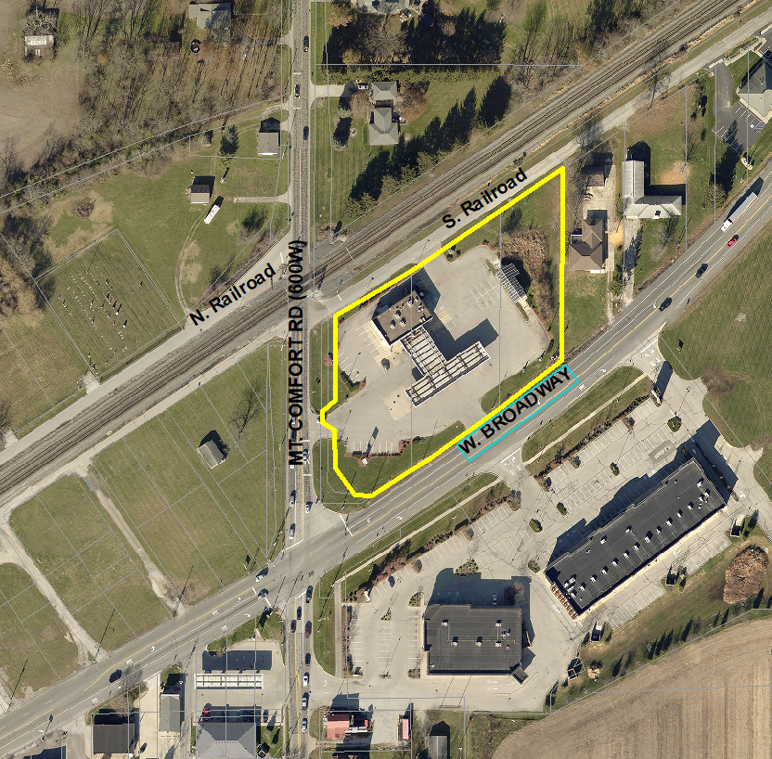

Zoning

