

Plan Commission Staff Report May 21, 2019
Department of Planning and Building
Town of McCordsville

Project: PC-19-007, Mt. Comfort Corridor Economic Development Area Plan Commission Order

Petitioner: Town of McCordsville Redevelopment Commission (RDC)

Request: Petitioner is seeking a determination from the Plan Commission that the Economic Development Area (EDA) drafted for Mt. Comfort Corridor area conforms to the Plan of Development for the Town of McCordsville.

Staff Review: The RDC has been working for the last year to determine ways in which the Town can assist in the growth and development of the southern portion of the Mt. Comfort Corridor. After considering various options, an EDA was ultimately chosen as the leading alternative.

Subject Property
The EDA is shown as Exhibit A of this staff report. It is located along the Mt. Comfort Road corridor from CR 650N to CR 500N.

Land Use & Zoning
The area includes various zoning districts, as noted on Exhibit B.

Comprehensive Plan
The Comprehensive Plan, along with the Zoning Ordinance would form what State Statute considers the Plan for Development. The Town of McCordsville’s Comprehensive Plan was adopted in 2011. The Plan’s Vision statement is:
Guided commercial development and unique
Residential opportunities with valued
Open Spaces and
Well-managed community services and amenities
That compliment a
Healthy local economy
Some strong themes within the Comp Plan include Growing with a Plan and Growing Concurrent with Infrastructure Development. Growing with a Plan is described as striving to provide the best to our residents in terms of housing, employment, recreation, and services. The Growing Concurrent with Infrastructure Development language notes the importance our major infrastructure network in existing McCordsville, and the equal importance of that network to the future of McCordsville. It goes onto say the planning and coordination of utility development, as well as roadway enhancements, will be imperative in helping the Town achieve its long –term growth and development goals.

The Plan also includes a number of goals aimed at public facilities and economic development:

- Public Facilities Goal: Plan for infrastructure and services that support planned future growth.
  - Objective: Facilitate economic development by providing the infrastructure necessary for business expansion and growth.
  - Objective: Seek alternative infrastructure funding sources.
- Public Facilities Goal: Provide infrastructure and services in an efficient and cost effective manner.
- Economic Development Goal: Create a strong and diverse tax base that provides additional revenue and increases the quality of municipal services provided to the residents.

The last element of the Comprehensive Plan addressed in this report will be the Future Land Use Map. The Future Land Use Map is a critical component of any Comprehensive Plan as it provides direction to staff, residents, business owners, and the appointed and elected officials on all land use issues. As a part of the creation of the Comprehensive Plan the Steering Committee and staff spent considerable amount of time debating and ultimately proposing appropriate zoning designations for all properties. With the approval of the Comprehensive Plan in 2011, the Town Council adopted the Future Land Use Map. The Future Land Use Map is attached as Exhibit C. The Map should be used as the basis for all land use discussions and decisions. However, the Comprehensive Plan and the Future Land Use Map should be considered living, breathing documents that need may need to be updated and/or deviated from occasionally. A land use which does not directly correspond to the Future Land Use Map does not necessarily mean it is an inappropriate land use.

Zoning Ordinance
The Zoning Ordinance acts as an implementation and enforcement arm of the Comprehensive Plan. It includes all the standards and requirements applicable to all types of development in the Town. Those standards and requirements were crafted to regulate development in a manner which would produce subdivisions, homes, commercial buildings, streetscapes, public spaces, community identity, etc envisioned by the Comprehensive Plan.

Staff Comments: The Comprehensive Plan’s Vision Statement talks about – “Guided Commercial development”…and…”well-managed community services and amenities”. An EDA is the kind of economic development tool that can do both. An EDA guides commercial development to the EDA District, because it advises interested parties that we are open for business, we have a plan, and we are willing to make a public investment in this area for the right project. It does not however, create a TIF District. A TIF District can be created for this area in the future, but simply the creation of an EDA does not mean there will be an tax increment collected and directed to a TIF fund.
Growing with a Plan is a major theme in the Comprehensive Plan. The Town already has a plan (the Comprehensive Plan), which is supported by the Zoning Ordinance. The EDA, seeks commercial and industrial development. The zoning and Future Land Use Map call for those uses on many of the properties within the EDA, and therefore this EDA expands and accompanies the support the Zoning Ordinance supplies for the Comprehensive Plan. For these reasons, the EDA adds to the Growing with a Plan concept.

Our Comprehensive Plan includes a few main themes which can be found throughout the document. Three of these themes are applicable to this proposal. First, growth is acknowledged and desired, so long as it is planned for and managed. Second, there is clear understanding that there must be a relationship between growth and infrastructure. Third, a strong, sustainable commercial tax base is sought. The proposed EDA is in keeping with all three of these themes, because it promotes growth, provides a funding vehicle for infrastructure, and adds new assessed value to the tax base.

Your packet includes the Plan Commission Order, Declaratory Resolution, Economic Development Plan, and Factual Report. Those items make up the documentation for the TIF District. For the purposes of this report, when we refer to TIF we are referencing all those documents. Below is a brief explanation of each document.

Plan Commission Order: This is the document signed by the Plan Commission stating it has determined the Economic Development Plan conforms to the Plan for Development for the Town of McCordsville.

Declaratory Resolution: This is the resolution signed by the RDC stating its intent, listing the basics of the TIF guidelines, and includes TIF regulations.

Economic Development Plan (EDP): This document includes a description of the project, the location, project objectives, procedural requirements, and how and the manner in which the Plan may be amended.

Factual Report: This document speaks to what the TIF area will do for the Town and provides supporting findings.

Staff believes this EDA proposal is in accordance with the Plan for Development of the Town of McCordsville, and recommends approval of the Plan Commission Order. We will be prepared to answer any questions at the meeting.

Exhibit A
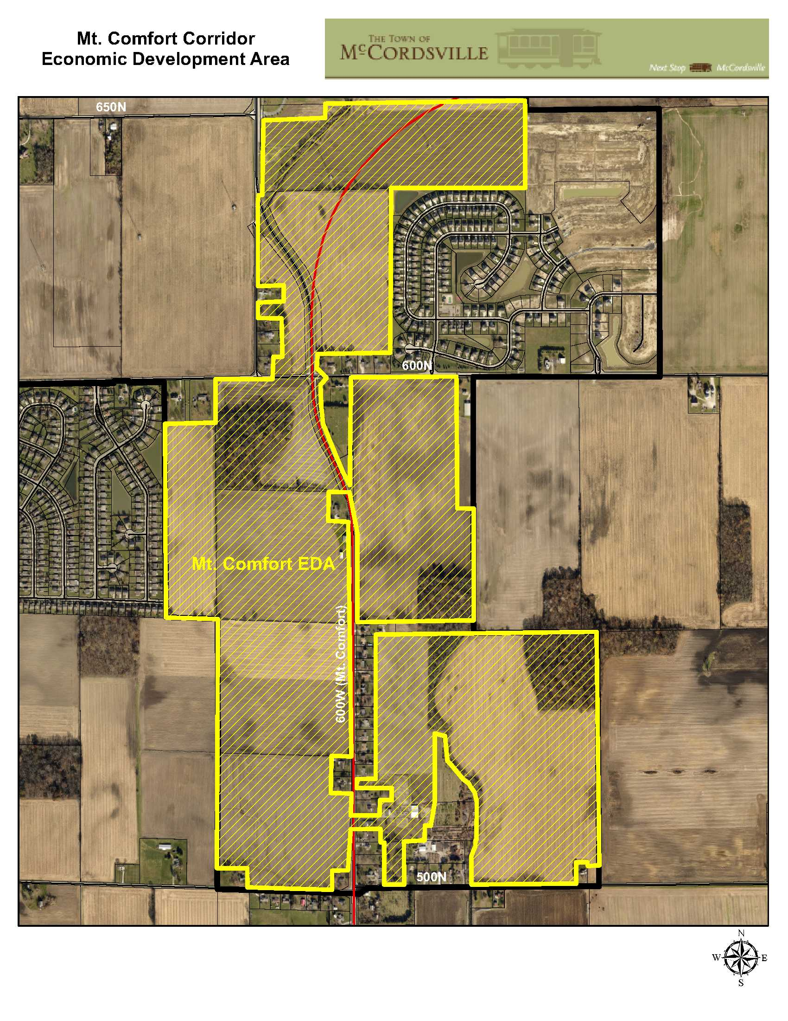

Exhibit B – Zoning Map

Exhibit Forthcoming

Exhibit C

