

Plan Commission Staff Report September 21, 2021
Department of Planning and Building
Town of McCordsville

Project: PC-21-010, Jacobi Legacy Farms PUD

Petitioner: Pulte Group

Request: The petitioner is seeking a favorable recommendation on a rezone from R-1 and R-2 to Jacobi Legacy Farms PUD.

Staff Review: The property is currently agricultural field and is approximately 175 acres spread across six (6) parcels. The assemblage has two frontages – CR 750N and CR 500W.

Existing Land Use & Zoning
The subject parcel is approximately 175 acres and is undeveloped. Adjacent properties are zoned as follows:

- North: Single-family residential lots zoned County R2.5
- East: Across CR 500W, undeveloped agricultural property zoned County R-1
- South: Across CR 750N, undeveloped property zoned County R2.5
- West: Undeveloped land zoned Commercial Regional (CR) and R-1, which is part of the Town Center Master Plan

Infrastructure
The subject property is located within the Town’s sanitary sewer territory. Sanitary service will be provided via a temporary lift station which will pump into the Old Town Basin, until the Woodbury Basin infrastructure can be developed. Water service is provided by Citizens Energy Group. Vehicular site access will be provided via five (5) entrances, three on CR 750N, one on CR 500W, and into the future Town Center. The petitioner has proposed perimeter multi-use paths and internal paths and sidewalks. Drainage infrastructure will be installed in compliance with the Town’s requirements.

Development Proposal
The proposed subdivision proposes a maximum of 525 units on 175 acres for a maximum density of 3 units per acre. The three closest subdivisions feature the following densities (proposed development Colonnade denoted in italics):

- Champion Lake: 1.3 u/a
- Gateway Crossing 4.45 u/a
- Old Town: 4.9 u/a
- Colonnade: 3 u/a

In keeping with many of the Town’s PUDs the petitioner is proposing a number of specific bulk standards that would apply within the PUD. Highlights of those bulk standards are noted below, please note there are four (4) districts or areas proposed within the PUD:

The Development Standards for Area A:

- Maximum Number of Lots 100
- Minimum Number of Lots 50
- Minimum Lot Area 1,000 Square Feet
- Minimum Lot Width 20 feet
- Minimum Front Yard Setback 10 feet
- Minimum Side Yard Setback 7.5 feet
- Minimum Building Separation 15 feet
- Minimum Rear Yard Setback 20 feet
- Minimum Living Area 1,500 square feet
- Minimum Ground Floor Living Area 300 SF
- Maximum Lot Coverage N/A
- Maximum Height-Principal 40 feet
- Maximum Dwelling Units per Lot 1
- Maximum No. of Dwellings per Building 8

The Development Standards for Area B:

- Maximum Number of Lots 125
- Minimum Lot Area 6,600 Square Feet
- Minimum Lot Width 53 feet
- Minimum Front Yard Setback 20 feet
- Minimum Side Yard Setback 5 feet
- Minimum Building Separation 10 feet
- Minimum Rear Yard Setback 20 feet
- Minimum Living Area 1,600 SF/2,100 SF
- Minimum Ground Floor Living Area 1,100 SF
- Maximum Lot Coverage 55%
- Maximum Height-Principal 35 feet
- Maximum Dwelling Units per Lot 1

The Development Standards for Area C:

- Maximum Number of Lots 275
- Minimum Lot Area 7,700 Square Feet
- Minimum Lot Width 62 feet
- Minimum Front Yard Setback 25 feet
- Minimum Side Yard Setback 5 feet
- Minimum Building Separation 10 feet
- Minimum Rear Yard Setback 20 feet
- Minimum Living Area 1,800 SF/2,400 SF
- Minimum Ground Floor Living Area 1,100 SF
- Maximum Lot Coverage 55%
- Maximum Height-Principal 35 feet
- Maximum Dwelling Units per Lot 1

The Development Standards for Area D:

- Maximum Number of Lots 40
- Minimum Number of Lots 30
- Minimum Lot Area 11,000 Square Feet
- Minimum Lot Width 80 feet
- Minimum Front Yard Setback 25 feet
- Minimum Side Yard Setback 7.5 feet
- Minimum Building Separation 15 feet
- Minimum Rear Yard Setback 25 feet
- Minimum Living Area 2,300 SF/2,600 SF
- Minimum Ground Floor Living Area 1,200 SF
- Maximum Lot Coverage 55%
- Maximum Height-Principal 35 feet
- Maximum Dwelling Units per Lot 1

The petitioner’s proposal also includes a number of architectural, landscaping, and other design standards. We will not list all those standards in this staff report. Those items are listed in a matrix comparing the proposed PUD standards to those of the recent PUDs and the Zoning Ordinance. That matrix will be available prior to the meeting.

Staff Comments: The subject property is immediately adjacent to the acreage that is part of the Town Center Master Plan. The site would only be separated from Town Center by an anticipate future roadway. Please see the Exhibit at the end of this report for the relation of this project site to the Town Center Master Plan.

As proposed the majority of that roadway would be fronted by Area A, which will feature either townhomes or a detached, rear-load single-family home product. Illustrative renderings of these products are included in the petitioner’s packet. The Concept Plan also includes three other districts or “Areas”. Area B, which is referred to as the transition area, will feature traditional single-family homes on 53’ wide lots. Area C will feature traditional single-family homes on 62’ wide lots, and Area D will feature traditional single-family homes on 80’ wide lot. A central amenity area is included and is adjacent to a central open space. This was specifically requested by staff to really create focal point, along the main thoroughfare, for the neighborhood. There was a clear desire to make a strong linear connection throughout this neighborhood to Town Center. It was important to have a central, focal point somewhere along that thoroughfare to create a place for people to be, recreate, and engage with others. All of the various common areas are connected via internal sidewalks and trails. The proposed amenity package is substantial and includes a pool, among other features.

At the time of this report, staff is still working through a number of items with the petitioner, those items include but are limited to: brick percentages, driveway depths in Area A, and concern that the product or streetscape of Area B, which is the transition area between the Townhome area and the more traditional suburban single-family areas, does not have a neo-traditional/new urbanist feel that staff feels is necessary this close to Town Center.

At the time of this report, staff has not received any remonstrance letters.

For all rezones, Indiana Code Section 36-7-4-603 states that reasonable regard shall be paid to the following items:

- The Comprehensive Plan
- Current conditions and the character of the current structures and uses
- The most desirable use for which the land is adapted
- The conservation of property values throughout the jurisdiction
- Responsible growth and development

The Future Land Use Map envisions the westernmost 30 acres be developed as Neighborhood Commercial and the remaining acreage as Medium Density Residential. According to the Comprehensive Plan Neighborhood Commercial is intended to be developed to serve adjacent neighborhoods with commercial opportunities. These areas should be located immediately adjacent to residential areas and should be designed at the human scale. Medium Density Residential is intended for moderate density residential development in the 2-3 units per acre range. The classification strives to create an attractive, stable, and orderly residential environment for citizens desiring average lots sizes and/or two-family dwellings. While the Comprehensive Plan contemplates Neighborhood Commercial on a portion of the property, since the adoption of the Comprehensive Plan in 2011 the Town has significantly altered its approach to commercial development in central McCordsville. The Town has completed a master plan for a town center, which will be located immediately adjacent to the subject site. Additionally, the Town Council has approved an Economic Development Agreement for a significant portion of the Town Center site. The Town Center will serve as the commercial center for this adjacent residential site, thus the concept of placing neighbor services adjacent to residential is accomplished.

The Plan Commission can motion to provide (a) a favorable recommendation, (b) no recommendation, (c) unfavorable recommendation, or (d) continue the petition.

Staff will provide a recommendation following resolution of the outstanding items.

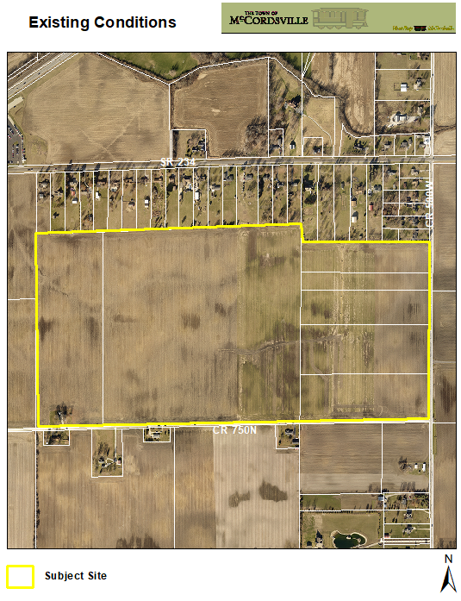

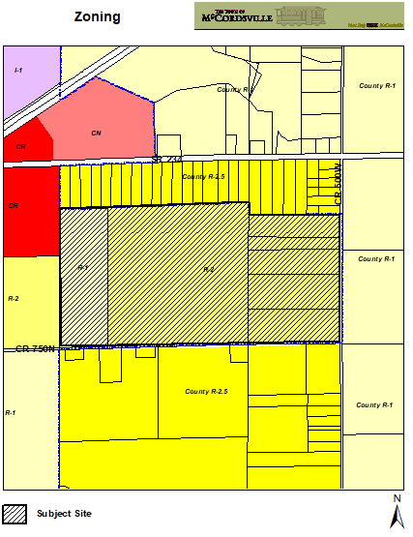

Town Center Layout

