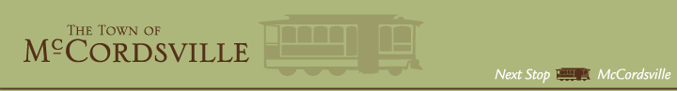

September 14, 2021

Secretary of Commerce Brad Chambers
Chief Executive Officer
Indiana Economic Development Corporation
1 North Capitol Avenue, Suite 700
Indianapolis, IN 46204

Dear Secretary Chambers,

As the Town Council President of the Town of McCordsville, a proud member of the White River Regional Opportunity Initiative (WR-ROI), this letter is written to express our support of the recent collaboration to develop a Regional Development Plan as a part of the READI program. This program will help grow the population and attract, develop, and retain talent throughout Indiana, by enhancing the quality of life throughout the WR-ROI Region, supporting our innovation and entrepreneurship ecosystems, especially in our rural communities, and investing in smart economic development to support ongoing population and economic growth.

We recognize the opportunity that READI presents to help catalyze nearly $500 million of new projected investment into the WR-ROI that aligns with the vision, goals, and priorities of our state and region. We welcome a financial partnership with the state to promote strategic investments aligned with the IEDC’s objectives for the Indiana READI program and are committed to meeting and exceeding a 1:1 match of local public funding to support the portfolio of programs and projects submitted in the WR-ROI’s READI regional development plan. The Town of McCordsville is directly committed to its signature project – McCord Square. We look forward to making this project a reality for our region.
Thank you for this opportunity and ongoing support as we work together to transform our communities and the state’s economy for now and in the future.

Sincerely,

Barry Wood
Town Council President
Town of McCordsville

