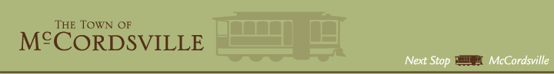

2019 Town Hall Parking Lot Rehab

Brooks Striping

Total Cost = $4,204.15

Reece Seal Coating Inc.

Total Cost = $5,359.00

Pavement Solutions Inc.

Total Cost = $14,357.50

