

Architectural Review Committee Staff Report June 18, 2019
Department of Planning and Building
Town of McCordsville

Project: Oakcrest

Petitioner: Pulte Group

Request: The petitioner is seeking approval of their product line-up for the new community of Oakcrest.

Staff Review: The proposed models/elevations are as follows:

- Amberwood – Heartland 1W, Heartland 2S, Heartland 2T, Heartland 2W, & Northern Craftsman 2S
- Greenfield – Heartland 1S, Heartland 1T, Heartland 2N, & Heartland 3S
- Hilltop – Euro Country 2G & Heartland 3S
- Riverton – Heartland 1S, Heartland 3W, Heartland 3X, & Heartland 3Y
- Westchester – Heartland 2S, Heartland 3S, Heartland 3T, Heartland 3U, Heartland 3V, & Northern Craftsman 2S

Staff has conducted an architectural review of all of the submittal elevations based upon the Oakcrest PUD Ordinance. The list below denotes the basic requirements and indicates whether or not the submittal is in compliance:
- Indicates compliance
- Indicates non-compliance
- Indicates further discussion needed or a building permit review requirement

- The minimum SF of a ranch home shall be 1,600 SF, and the minimum SF of a 2-story home shall be 1,800 SF;
- A minimum of 75% of the homes shall feature a front elevation with at last 50% brick or stone, exclusive of windows, doors, garage doors, and areas above the roof line. The remaining homes may have less than 50% brick or stone provided they contain a minimum of a 30” brick or stone wainscot and contain a minimum of 2 of the following siding materials on the front elevation: horizontal lap siding, vertical siding, board and batten, and shake;
- Vinyl siding is prohibited. All siding shall be brick, stone, wood, cement fiber, or stucco;
- The main roof pitch for 2-story homes shall be 6:12 or greater, ancillary roofs may be less than 6:12. 1-story homes, the main roof pitch roof pitch shall be 5:12 or greater. The ARC may approve a home with a lesser roof pitch if the roof pitch is in keeping with historical architectural style;
- Architectural shingles;
- The front elevation of any home shall contain 1 two-foot or greater step-back and 2 ridgelines or 1 gable;
- The minimum roof overhang shall be 11” on all sides of a home as measured from the exterior wall framing to the fascia board;
- Unless approved otherwise by the ARC, all front porch columns shall be a min. of 6” x 6”;
- All ranch homes shall contain a minimum of 1 window on all 4 sides with the exception of the front façade which shall feature a min. of 2 windows;
- All 2-story homes shall contain a minimum of 2 windows on all 4 sides with the exception of the front façade which shall feature a min. of 3 windows;
- With the exception of large picture windows, casement windows, and small accent windows, which do not open, all windows facing a public street shall have shutters, mullions, or window grids;
- Unless adjacent to brick or stone wrap, all windows, doors, and corners shall have a minimum nominal 1” x 6” wood or vinyl surround, shutters, decorative trim, or headers;
- All homes shall contain a minimum of a 2-car garage with a min. width or depth of 20’ or shall incorporate an additional interior garage space a min of 4’ x 4’;
- Front loading garage shall contain a decorative garage door similar to those depicted on Exhibit E of the PUD;
- For any 3-car garage that faces a street, at least one of the bays shall have a separate door and be recessed a min. of 2’ from the other bays;
- Front-loading garage doors shall not comprise greater than 50% of the width of the front elevation for a 2-car garage and 60% for a 3-car garage;
  - A single front elevation shall not be repeated unless it is separated by at least three different front elevations along either side of the street; and
  - No more than 10% of the homes shall be the same front elevation.

Lot Specific Requirements: To be reviewed for by staff on individual building permits, noted in this report for the petitioner’s reference:

  - The rear elevation of homes identified on Exhibit C of the PUD shall contain at least 1 of the following features: (i) four sides 1st floor brick wrap, (ii) four sided brick wainscot, (iii) screened-in porch, (iv) three season room, (v) morning room, and (vi) covered porch;
  - The side elevation of homes facing a public street, also denoted on Exhibit C of the PUD shall feature a minimum 30” brick or stone wainscot; and
  - Exterior chimneys or fireplaces shall be made entirely of brick or stone.

Staff Comments: Staff has completed its review of the submittal and finds that it meets all requirements of the PUD. However, staff is still conducting its anti-monotony review, and will have it complete on the 17th.

Exhibit C (of the Oakcrest PUD)

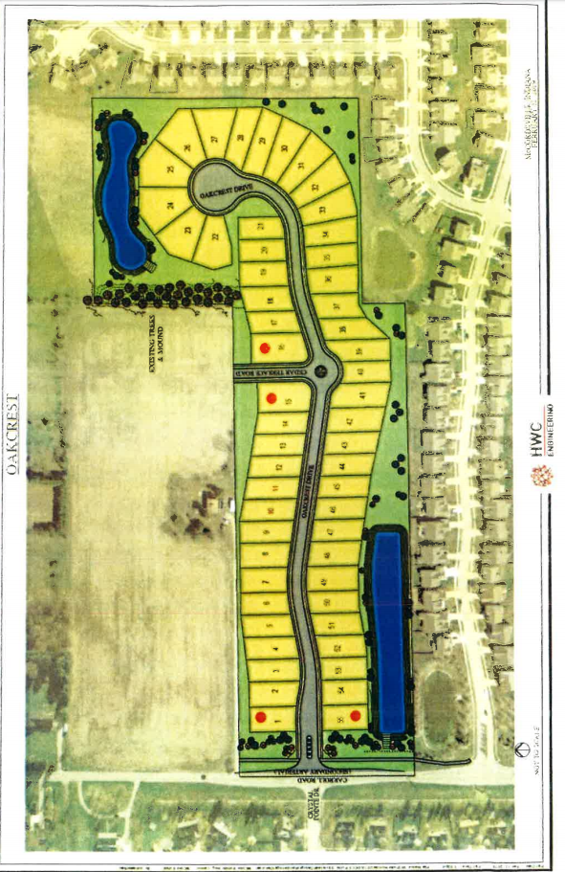

Exhibit E (of the Oakcrest PUD)

